This week’s homework

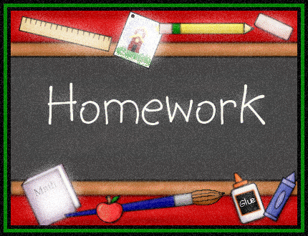 |  | - Primary 3  Homework + News  - 06.11.2017
 | Other | Other news and information

Spelling
M: Write all words twice and clarify them (orally)
T: Shape words first half of words
W: Vowel circle second half of words
Th: Ball toss
Reading
M: Read + discuss last week’s text
T: Read first third of new text
W: Read second third of text
Th: Read to the end

Maths
Please log in to Education City (personal details in HW diary cover) where you will find selected tasks to complete. Once logged in go to My Features (on the left of the page) then Homework. The children know and enjoy this resource from class. 5-10 minutes each evening.
Other
Talking + Listening
Planning our Learning
Please click on second link on this blog post to find further details.

DAILY MILE
We feel good after introducing the daily mile (with Miss Turner’s help) on a Tuesday and Friday morning.
CLASS ASSEMBLY
We will be the next class to share our learning at an assembly. Please come and join us on Wednesday 22nd November at 9:15am.
PARENTS’ EVENINGS
These will take place on Wednesday and Thursday this week, 3:30pm-6:30pm.

THIS WEEK…
- Book fair slot in hall Tuesday 11:35am-12:00pm
- Music with Mrs Carey on Tuesday afternoon
- Old P2 work going home this week. Please keep it and be proud of your progress!

