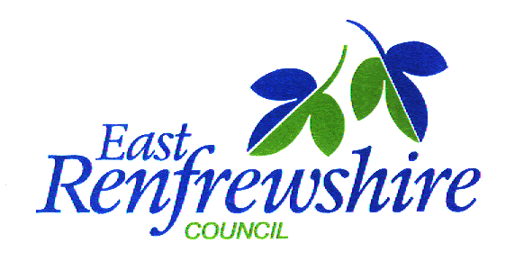

School Improvement Partnership Programme (SIPP)

**Paperwork**



Establishments

____________________________________

____________________________________

____________________________________

|  |  |
| --- | --- |
| **Phase One: Performance Information Analysis and Outcome Focussed Planning** | |
| **Step One: Analyse pupil performance information**  Through analysis of pupil performance information identify a *small* group *(4-6)* of **vulnerable** learners to target in order to improve outcomes (attendance, attainment, exclusion/inclusion, engagement, participation). | |
| Target Group |  |
| Number of Pupils |  |
| Detail the rationale for selection (SIMD, gender, LAC, ethnicity, lowest performing 20%) |  |
| **Step Two: Identify SMART outcomes for the target group**  Following intervention, what improvements would you expect to see? *It might be helpful to review these outcomes following completion of phase 2.* | |
| Expected SMART outcomes (attendance, attainment, exclusion/inclusion, engagement, participation):  *e.g. a 10% increase in attendance*  eg By June 2019, there will be a 10% increase in attendance of targeted P4 boys. | |

|  |  |
| --- | --- |
| **Phase Two: Exploring and Understanding the Target Group’s Performance** | |
| **Step One: Explore the strengths of and pressures on your target group**  What are the factors that impact (positively/negatively) on this identified group of learners? You may want to consider the following (please note these are examples and not an exhaustive list).   * + School learning environment – e.g. expectations of pupils, staff/pupil relationships, peer relations, quality and deployment of teaching and support staff, pedagogy, parental engagement   + Parental factors – e.g. engagement with pupils learning, relationships with school staff, value for education, parental educational experiences, parental physical, mental and cognitive health, parenting skills   + Pupil factors – e.g. SHANARRI, Aspirations for future, motivation for learning, pupils physical, emotional/mental and cognitive health, pupil involvement in their learning | |
| **Strengths/positive factors** | **Pressures/negative factors** |

|  |  |
| --- | --- |
| **Phase Three: Intervention and Evaluation Planning** | |
| **Step One: Identifying evidenced based interventions through research/professional enquiry**  Through professional enquiry and reviewing the research literature, explore relevant evidence based interventions? | |
| Evidence based interventions considered  (highlight the selected intervention) |  |
| What actions could you take to build on the identified strengths of the target group? |  |
| Are there areas where the evidence base for improvement is weak? |  |
| **Helpful tips:**   * multifaceted interventions tend to be the most successful (i.e. they target child, family and school/class factors) * consider other groups that are performing well despite similar ‘risk factors’ and how can you learn from their success | |
| **Step Two: Action Planning** | |
| Research question(s) |  |
| Aims statement |  |
| Timescales  *When?*  *How long?* |  |
| Who will be involved?  *Specific staff/parents/pupils* |  |
| Control Group?  *a group of pupils who have similar needs who do not receive the intervention but take part in the pre and post evaluation for comparison purposes* | Yes / No |
| **Helpful tips/reflective questions:**   * A research question is a clear, focused, concise and arguable question around which to centre your research. * What are the resource implications? * Do you need to plan CLPL? * What might get in the way of the intervention being successful? If possible, how are you going to avoid this? * Do you need to plan time for pre and post information/data gathering and analysis?   **Appendix 1 may be helpful to plan the actions required to implement your intervention** | |

|  |
| --- |
| **Phase Four: Action (Implement intervention)** |

|  |  |
| --- | --- |
| **Phase Five: Evaluation and Reflection** | |
| **Step One: Measuring impact and outcomes**  Following evaluation of the intervention (as planned in phase 3): | |
| What impact has the intervention had? |  |
| Did you achieve your aims statement(s)?  *Please describe* |  |
| Have the SMART outcomes been achieved?  *Please describe* |  |
| **Step Two: Critical Reflection** | |
| What have you learned? |  |
| What went well? |  |
| What didn’t work so well? |  |
| What changes would you make if you were to go through the process again? |  |
| **Step Three: Planning for Improvement** | |
| What are you going to do now? | |

**Phase Three: Intervention and Evaluation Planning Appendix 1**

**Action Plan**

|  |  |  |  |
| --- | --- | --- | --- |
| **Research question/s** | | | |
| **List the actions/tasks needed to implement the intervention and evaluation** | **By Whom** | **When** | **Where** | | **Notes/Comments** |
|  |  |  |  | |  |
|  |  |  |  | |  |
|  |  |  |  | |  |
|  |  |  |  | |  |
|  |  |  |  | |  |
|  |  |  |  | |  |
|  |  |  |  | |  |
|  |  |  |  | |  |
|  |  |  |  | |  |
|  |  |  |  | |  |
|  |  |  |  | |  |
|  |  |  |  | |  |