Pupil’s Restorative Diary
I found it difficult because… | I could tell it was difficult because I experienced… | I chose to… | The outcome was… | Things I can do to manage this better in the future… | Things staff could do to help me manage this better… | A better outcome from this would be…
(Scenario) | (Symptoms e.g. fear, anxiety, anger, too warm) | (Behaviours) | (Consequences) | (Strategies / Preferred behaviours) | (Supports) | (Preferred consequence)
The routine changed
I felt pressured / trapped
I felt alone

I felt / thought that people were looking at me
I could hear / see coins
I felt that others were being unkind
People were being too loud
The work was too hard
I wasn’t happy with my work
I had trouble thinking / I was confused
I was hurt
I needed help
I was told no
I felt that others were being unfair

Pupil’s Restorative Conversations
What happened? | How did this make you feel?
What did you do and who was affected? | What do we need to do to now to make things better?

What happened?

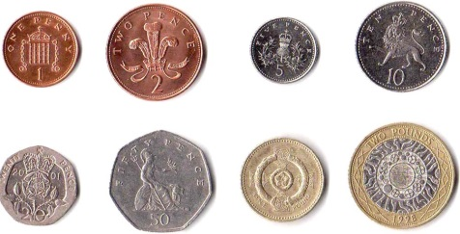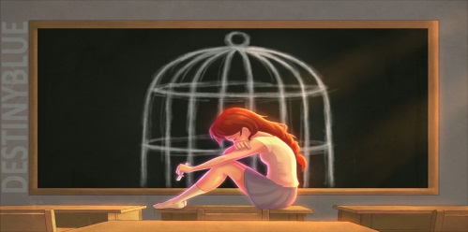
Coins Change of Plan / Routine Feeling Trapped / Under pressure

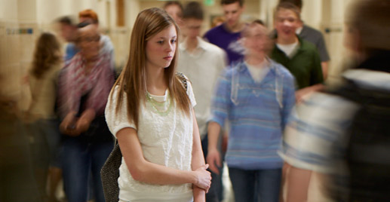
Alone People looking at me People being unkind

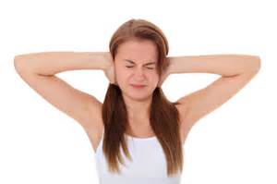
Too loud Work is too hard Not happy with work

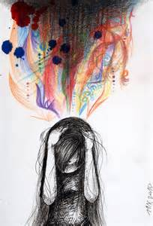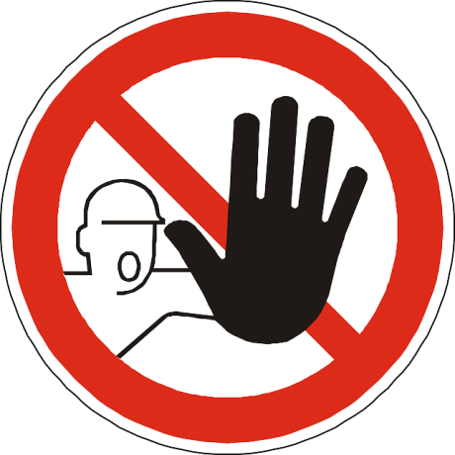
Trouble thinking / confused Hurt Not allowed / Told no

Someone is being unfair

How did this make you feel?

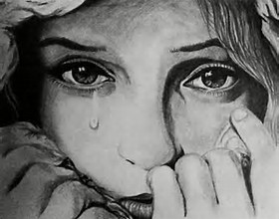
Sad Angry Annoyed

Anxious / Afraid

What did you do and who was affected?
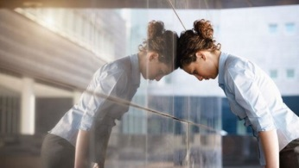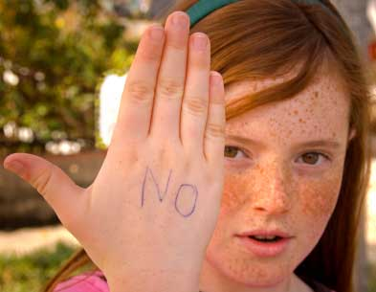
Screaming / Shouting Head Banging Crying Defiance

(Insert pictures of Pupil and pictures of staff)

What do we need to do now to make things better?

(Agree upon restorative solutions with Pupil and create pictures)

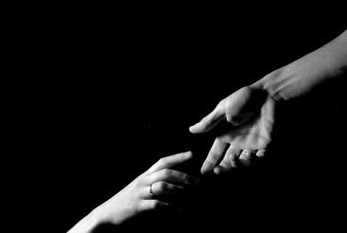
Apologise Catch up on work Make amends / reach out

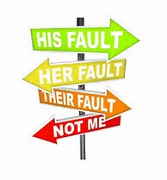
Accept responsibility

Emotional Zones

Green | Blue | Yellow | Red
Happy, Calm, Ok | Sad, Worried, Unsettled | Anxious, Fearful, Annoyed | Frustrated, Angry, Raging
I can stay here by…  Playing music  Stretching  Using Safe Spot  Relaxation / Breathing Exercises  Movement breaks  Keeping busy – doing some work  Practising CBT | I can get to Green from here by…  Using my words – talking to friends / staff  Taking a short break  Getting a drink of water  Distraction techniques and games  Relaxation / Breathing Exercises Movement breaks  Keeping busy – doing some work  Moderate Exercise  Using Safe Spot  Practising CBT | I can get to Blue from here by…  Using my words – talking to friends / staff  Asking for time out  Taking a short break  Getting a drink of water  Distraction techniques and games  Relaxation / Breathing Exercises Movement breaks  Keeping busy – doing some work  Moderate Exercise  Using Safe Spot  Practising CBT | I can get to Yellow from here by…  Time out  Deep breathing  Mindfulness exercises  Distraction  Time to talk  Rigorous exercise  Practising CBT
Where am I right now?

Feelings Thermometer

This can be used to support solution focussed conversations. Where are you now? How do you get from 7 to 6 etc.

