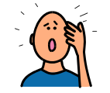**TRY AGAIN TICKET**

Student Name: ___________________ Date: _________

Which one did I have trouble with?

What happened?

I am Respectful.

I can remember that the “right thing” to do is….

I am Responsible.

I am Safe.

I am Kind.

Teacher: _________________

**TRY AGAIN TICKET**



Student Name: ___________________ Date: _________

Which one did I have trouble with?

What happened?

I am Respectful.

I can remember that the “right thing” to do is….

I am Responsible.

I am Safe.

I am Kind.

Teacher: _______________