Hands to yourself 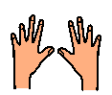

Most human beings have two hands. We use our hands every day for many different things.
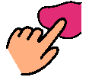
We use our hands to touch things, to pick up things and to work with.
I make the choice how to use my hands.
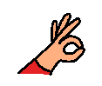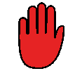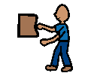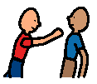Sometimes I have trouble keeping my hands safe and use them for other things.
Sometimes I use my hands to touch things that are not mine.
Sometimes I use my hands to touch people when they don’t want me to. It is not okay to touch people and hurt them. It is not okay to touch people when they have asked me to stop.
I must try hard to use my hands for the right things. I must try hard not to touch others and things that are not mine.
My teacher, the adults and my friends will be happy when I try hard to use my hands for the right things.
