Hands to yourself 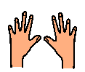

Most human beings have two hands. We use our hands every day for many different things.
We use our hands to touch things, to pick up things and to work with.
I make the choice how to use my hands.
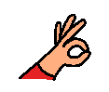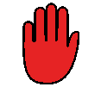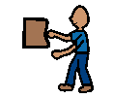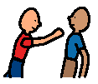

Sometimes when I am feeling angry or upset I use my hands to touch and hurt people.
It is not okay to hurt people when I am angry or upset.
If I am angry or upset I can;
Tell an adult
Walk away and have some time out
Use my words to tell someone I am angry or upset.
The adults will be very happy if I tell them, or walk away or use my words to tell someone I am angry and upset and keep my hands safe.
