In my family is me, mummy, daddy, Marley and Nicholas.
Nicholas is my baby brother.
Nicholas is very small. Nicholas needs help from mummy and daddy. He does not use words to speak. He will cry if he wants to tell mummy or daddy something.
- He might cry because he is hungry.
- He might cry if he is tired.
- He might cry if he needs his nappy changed.
- He might cry if he has a sore tummy.
- He might cry if he wants a cuddle.
I don’t like it when my brother cries. I don’t like the noise he makes.
If he starts to cry I can;
- Put my fingers in my ears.
- 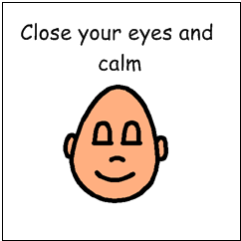I can close my eyes.
- I can put on my ear defenders.
- 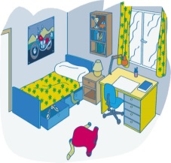I can go to my room for a break.
- 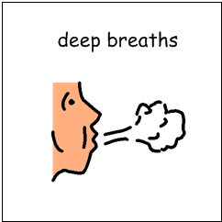I can do some deep breathing.
- I can put on my headphones if I can’t hear the game I am playing.

When Nicholas has stopped crying I can go back into the same room as he is in. I may be worried that he might start to cry again and that is okay. If he starts to cry I can use one of my strategies.

