Using kind words

Talking is usually good. People like to talk to each other. Most words are good but sometimes people use bad words.
Sometimes when I am upset, angry and messing about, I use bad words.
Bad words are words that upset other people and are rude. I have a list of words that I have used which are bad words.
I make the choice how to use my words. 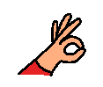

When I get upset or angry, instead of using bad words, I can
1. Stop and think about what to say before I say it. 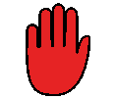
2. Count to 10 before I say
3 ask for a break to get away and calm down
4. talk to someone I trust about what is making me angry or upset

I must try hard to use kind words at school.
My teacher, the adults and my friends will be happy when I try hard to use my kind words.
If I use a bad word the adult will tell me that this is a word I should not use. The word will be put on my list. If I use the word again I will lose 5 minutes of playtime.

