Making Mistakes
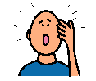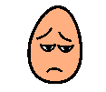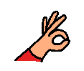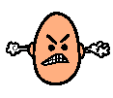
Everyone is different. Everyone tries hard to do the right thing.
Even though we try hard we sometimes we can make mistakes.
Adults make mistakes. Children make mistakes.
It is okay to make mistakes.
Sometimes people feel upset when they mistake as they think that they have made other people upset. Sometimes people feel angry as they wanted to get it right. Sometimes our mistakes do upset others for example whe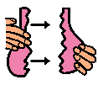n we have done the wrong thing and hurt someone or broke something by accident.
Mostly when we make a mist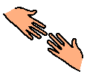ake no one will be cross or upset. We can always do something to make things better.
Everyone will know that we tried hard but we made a mistake.
When we make a mistake we can fix it. We can remember next time how to do something for example how to write a number or say a word or ask a question. We will use the mistake to learn.
When we make a mistake we can learn and move on. We do not have to stay feeling upset or cross.
Sometimes when we make a mistake and we have upset someone we can say sorry to the person. The person will know we have made a mistake and will try harder next time to do the right things.
Mistakes are not always a bad thing as they can help us learn and try harder.
I must try not to get upset when I have made a mistake. It is okay to make a mistake.
The adults will help me when I have made a mistake and will be happy that I am learning. 