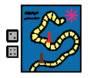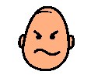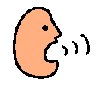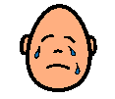

|  |
| --- |
| It is okay not to win |

I like to play games with others.

Sometimes I am the winner and I feel happy.

Sometimes I do not win and that makes me upset. It is my friends time to win.

It is okay to say that I am upset that I did not win it is okay to say that I hope I will win next time.

I must try hard not to get angry, shout or cry if I have not won. I must try not to say unkind things to my friend for winning.