Keeping our teeth healthy
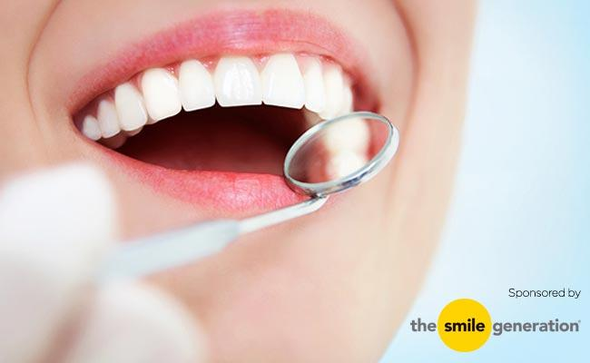
Most people have teeth which help us to be able to chew food. It is important that we look after our teeth by brushing them at morning and night. We must try to visit a dentist twice a year for them to check our teeth are healthy.
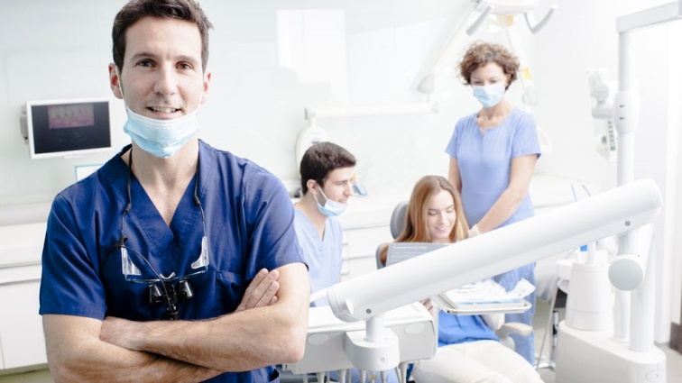
On Thursday I will go to the dentist with mum for them to check that my teeth are health.
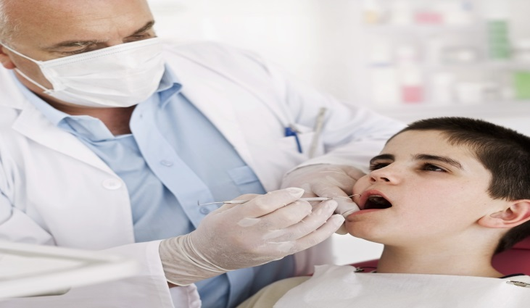
Dentists will look in our mouths with a little mirror and may use tools to touch our teeth gently. The dentist will ask me to open my mouth. I will only need to open my mouth for a short time.
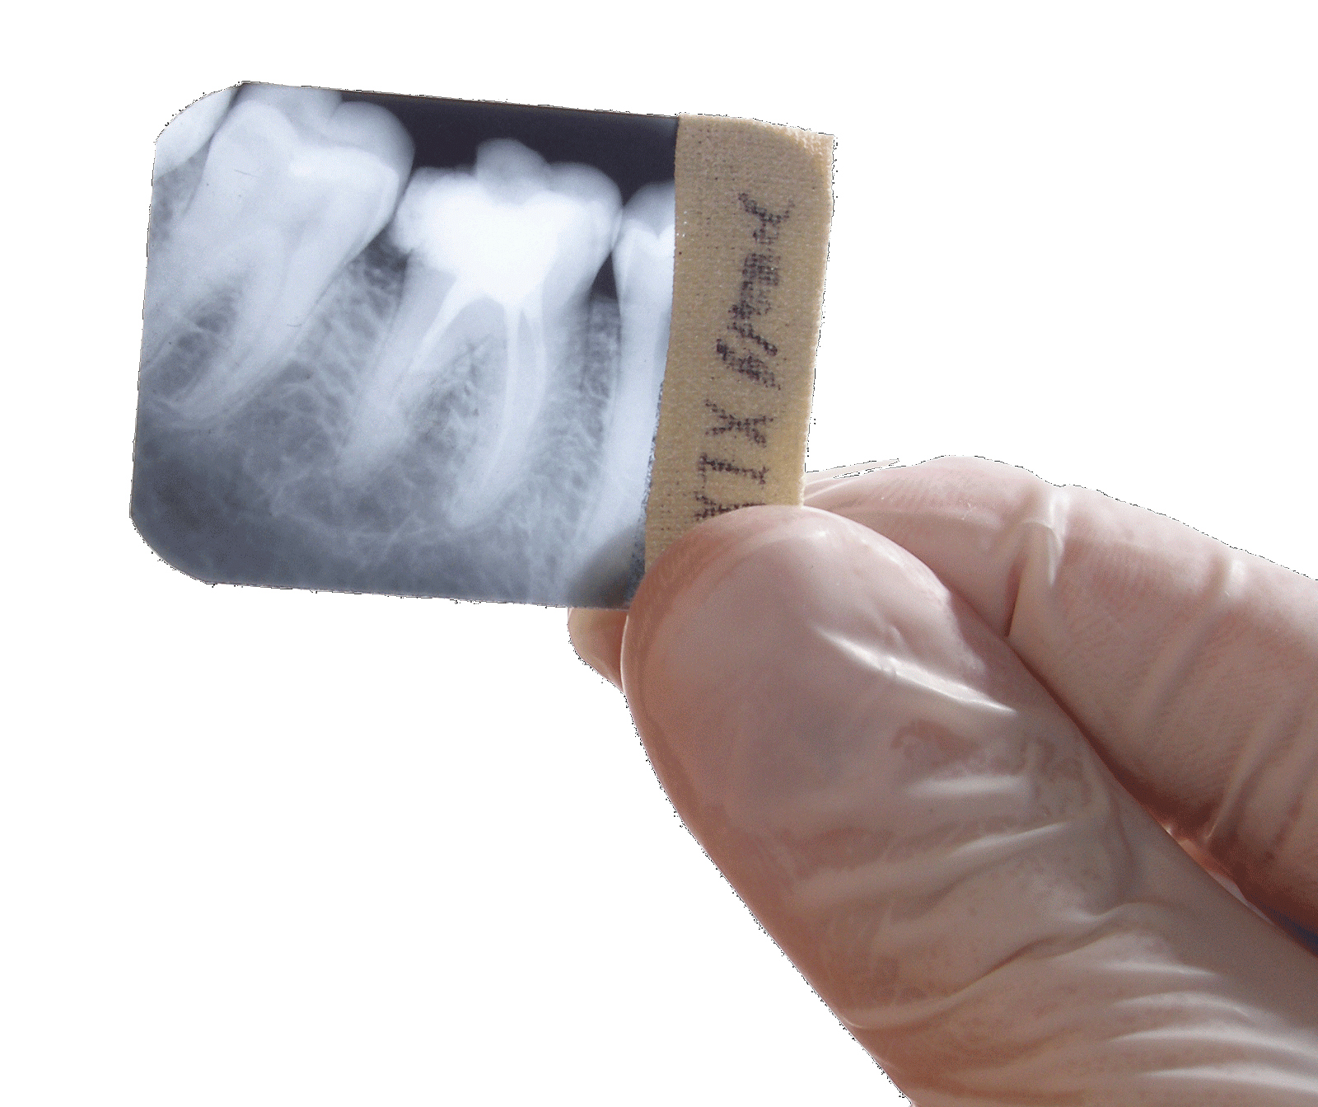
Sometimes dentists need to look at parts of our teeth they cannot see. The dentist will do this by taking a photograph of my teeth. This is called an X-ray.
On Thursday the dentist will take an X-ray of my teeth.
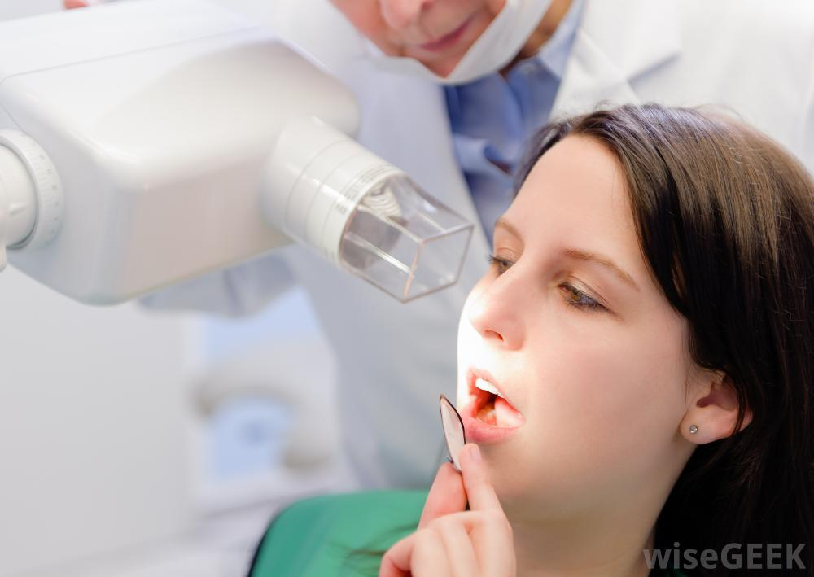
The dentist will put something in my mouth for me to bite on. Sometimes it can feel a bit uncomfortable but it is not sore. I must try hard to keep it in my mouth until the dentist is ready to take it out.
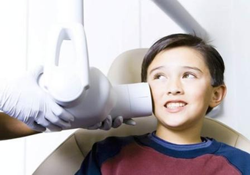
They will put a camera on my cheek to take the photo. This will only be for a very short time.
Then the dentist presses a button and it takes a photograph of my teeth.
After he has pressed the button he will take out the small picture out of my mouth and will look at it.
It is not noisy.
Mum will be really happy with me if I try hard to keep the picture in my mouth until the dentist takes it out. Mum will be very happy if I don’t get upset and cry when the dentist is looking at my teeth.

