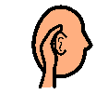Being a Good Listener
Being a good listener means listening to other people for information.
Being a good listener means looking like I am listening. I must face towards the person is speaking. I must try to look at the face of the person who is speaking. I must try not to look all around when the person is speaking.
I can nod my head while the person is speaking and say things like “okay” and “yes”. I can ask questions about what they are talking about.
If I have been a good listener then people will like talking to me more.
Rules for Listening

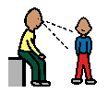 | I must try to listen to face towards the person is speaking.
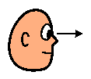 | I must try to look at the face of the person who is speaking.
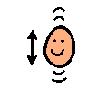 | I can nod my head.
 | I can say things like “okay” and “yes.”
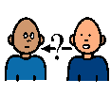 | I can ask questions about what they are talking about.

