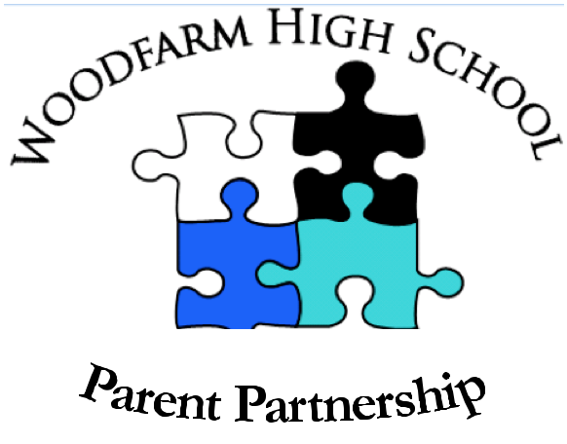

Woodfarm High School Parent Partnership

Annual Report

September 2021

Contents

- Introduction

- Meetings held

- Representation at other meetings/events

- Parent Partnership Cluster activity

- Sub-groups

- Communications

- Fundraising

- Contributions to the school

- Training and Development
1. Introduction

I would like to thank all parents, elected members, office bearers and staff at Woodfarm High School for their help and support during the past year. This has been & continues to be a very difficult year for the school due to the Covid pandemic. From March 2020 onwards, society went into lockdown & the school was closed, with on line learning being the main method for education delivery for a period of time, followed by a gradual re opening of schools. At the time of writing this report it is the intention for schools to re open in August 2021.

The Parent Partnership (PP) has the responsibility of ensuring that the voices of the parents and carers of the Woodfarm Community are heard and also supports the school management in improving the quality of education provided. To this end, members have worked towards these goals and the following is an overview of what we have done to achieve this.

I would like to thank Mrs MacGlashan for all her effort & commitment to the school over the last 7 years. We wish her well in her new post as Headteacher at Williamwood High School. At our final PP meeting in May 2021 we had the opportunity to welcome the new acting Headteacher, Mrs Gillian Boyle, in her new role. We wish her well.

I would also like to thank Labiba Ghafur, Eileen Cabuk & Lorna Griffin for all their hard work over the years for the PP. Thank you guys, you are fantastic people! This is also my final year as chair of the PP. I have enjoyed being the chair over the last 4 years. Karen Gurling has been Co chair & has agreed to take over the Chair position. I know that Karen will do an excellent job as Chair.

2. Meetings held

Due to the Covid pandemic, the format of the Parent Partnership meetings changed. The meetings were via Zoom. Instead of the usual business & workshop format, they consisted of an update from the Headteacher, Mrs MacGlashan, on the impact the pandemic was having on the delivery of education, followed by discussion. Attendance at the meetings was very good with over 15 people regularly attending the meetings. There was good discussion amongst the group at each meeting. Meetings were held on the dates below. An agenda was circulated before each meeting. Minutes were taken at each meeting & circulated after the meeting for approval.

16th September 2020 AGM

4th November 2020

13th January 2021

24th March 2021

19th May 2021

3. Representation at other meetings/ events

Throughout the year, the PP had representation at the following additional online (Zoom) meetings:

- East Renfrewshire Council Equalities Forum meetings
30 September 2020, 20th January 2021, 16th March 2021, 12th May 2021
- East Renfrewshire Council PC Chairs meeting
2nd September 2020, 25th November 2020, 3rd February 2021, 26th May 2021

Two members of the PP were involved in interviews for senior management positions in the school.

In contrast to a normal year, there was no PP representation, due to the Covid pandemic, at the following meetings:

- Woodfarm HS P7 Learning Festival
- Woodfarm HS Careers evening
- Woodfarm HS S2/S4 Curricular Choice Evening
- Woodfarm HS Graduation Ceremony
- P7 Induction afternoon June 2021

4. Parent Partnership Cluster activity:

Before the summer break, a welcome letter from the Chair was sent to all P7 parents from our Cluster primary schools. This letter introduced Woodfarm PP, directed parents to our website pages, promoted fundraising through the purchase of uniforms and the Rag Bag and encouraged parents to attend meetings for the next session. We also contacted the chairs of the cluster primary schools via WhatsApp inviting the parents of pupils in P7 to attend our Parent Partnership meetings in the next school year.

5. Subgroups

We continued to have subgroups within the Parent Partnership to raise the awareness of the PP, to improve communications and engagement with parents/carers and to promote our fundraising streams.

Both groups carried out the following during the school year:

- Letter to P7 parents
- Rag Bag fundraising related tweets
- Schoolwear Made Easy related tweets

6. Communications

- Parent Partnership newsletter — normally this would be issued in June but due to the Covid pandemic none was issued this year.
- Presence at various school events — no face to face representation occurred this year due to the pandemic.
- Website – news items were published on the home page and PP pages are kept up to date with minutes of meetings, funds raised and newsletter updates.
- Twitter – increased use of tweets for PP meeting reminders.

Thanks to Nathalie LeMarrec for offering to help with communications.

7. Fundraising

The PP have two main ways of raising funds for the school:

Rag Bag: This recycling scheme is completely free, with the school being paid for every kg recycled. Not only is it a regular and easy way of fundraising for the school, it increases awareness about textile recycling and helps the environment by ensuring less material goes to landfill.

The collection ‘bin’ has been placed in the car park at the rear of the school, making it easy and convenient for items to be deposited any day of the week/any time of the day.

Over the year, Rag Bag raised the following: £682

Schoolwear Made Easy: This on-line uniform supplier pays the school 5% commission on all items purchased. Currently, you can buy badged Woodfarm blazers, PE kit and ties from the comfort of your own home, at competitive prices and they will be delivered free of charge, directly to you.

Thanks to Jacqui Grant for offering to help with this.

Over the year, Schoolwear Made Easy raised the following: £265

8. Contributions to the school

We authorized the school to spend £1258 of PP funds on priority areas of need in the school. The funds were used to buy Christmas presents for 50 young people, gifts for members of the local community nominated by pupils & food parcels for local families.

9. Training & Development

Due to the pandemic we didn’t hold any workshops this year.

We continue to use the resources of Connect (formerly the Scottish Parent Teachers Council).

Jonathan Edgar
Co chair
Woodfarm High School Parent Partnership

September 2021

