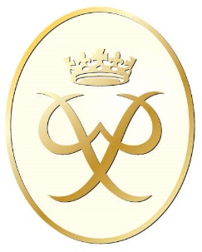The Gold Award is also an option for individuals 16 or over who often start the award as an extra-curricular activity in their S5/6 year and go on to complete this award whilst at work, college or university. The award must be completed before their 25th birthday. Similar to the Silver award above the school provides support at mutually agreed times during lunch, free periods or afterschool as well as being able to communicate via google classrooms as required. There is also assistance in completing this award from the local authority DofE staff team in advising / training for their expedition and residential sections. The volunteering, physical and skill sections are completed independently by the award participant with little assistance. There are also community run services which participants at any level can attend within the local authority.
Timeframes for completing this award if Bronze and Silver have been completed:
