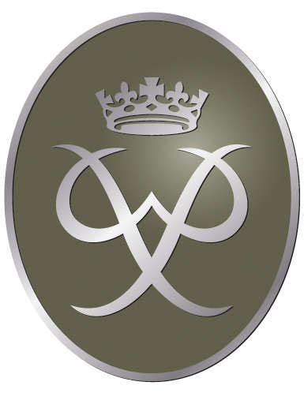The Silver Award is offered to individuals who have worked independently to fulfil and achieve the bronze award before finishing their third year at Woodfarm. This level of the award is completed as an extra-curricular activity with some support and input from staff at lunch and afterschool agreed mutually with the individuals and staff. Assistance is provided where needed in refreshing camp craft skills, advancing their map work knowledge and understanding along with organising their expedition with an external provider. The young people are encouraged to be more independent in completing their volunteering, physical and skill sections with some guidance and support but are expected to take the lead and be responsible in completing this. A google classrooms page is available for resources and communication with staff.

Timeframes for completing the Silver award if the Bronze award has been completed:

