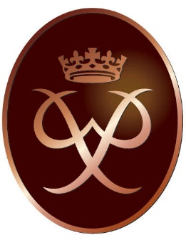The Bronze Award is offered as an S3 elective alongside dance and sports coaching picked during the S2 options period. In S3 all training is provided during their 50 minute timetabled class each week during the school day. During this period all skills and knowledge are developed to assist the young person to successfully achieve the award. They will be provided with the information and support in
Understanding what the award involves
Knowing what the timeframes are and making the best choices for them when picking activities for their sections
How to go about setting up and starting their activities along with appropriate choices for their volunteering, physical and skill sections
Setting up, navigating and recording appropriate evidence on their own EdofE profile
Becoming equipped in camp craft skills (e.g. tents, cooking with trangias, packing bags, basic first aid, safety etc)
Gaining the appropriate map reading, navigation and compass skills for their walking expedition
Building fitness and improving team work skills
HOMEWORK is to complete the volunteering, physical and skill sections in their own time and record a summary of what they did in their online profile.
The award will be gained once the appropriate timeframes have been completed by uploading the required minimum evidence along with a submitted assessor report.
Timeframes for completing the Bronze award:
