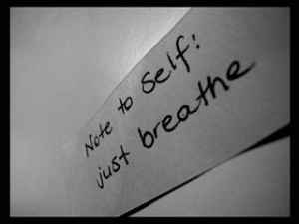


Apps for Relaxation:

Relax Lite
5 Minute Relaxation Lite – Guided meditation (Olsen Applications)
Total Relaxation Darren Marks
Relax App (relaxing music which may chill out you and your baby)
Sleep App (relaxing music which may help you and your baby get down to sleep)

Websites for Relaxation Exercises/CDs:

http://www.innerhealthstudio.com/ (free relaxation scripts which you can read to yourself to de-stress)

www.llttf.com (1 -2 – 3 Chill Relaxation CD can be purchased for £2 – Living Life Shop, multimedia)

https://blogs.glowscotland.org.uk/er/PsychologicalService/school-staff/resilience-to-stress/ (free booklet with further information on resilience to stress and relaxation scripts)

Quick Relaxation

Inhale slowly to the count of four (count slowly; to the pace of one-one-thousand, two-one-thousand....). Pause to the count of three.
Exhale slowly to the count of five.
The breathing process goes like this:
Inhale... two, three, four...pause...two, three....exhale...two, three, four five....
Inhale... two, three, four...pause...two, three....exhale...two, three, four five....
Repeat for a minute or two.

