Woodfarm High School

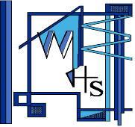

Home Learning Guide

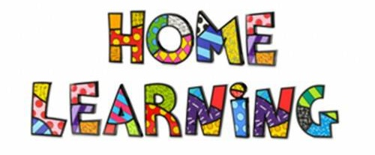

Table of Contents

Pupil Guide: Google Classroom 1

Pupil Guide: Show My Homework 6

Additional Resources 9

Useful Tips 11

Pupil Guide: Google Classroom

What is Google Classroom?
Google Classroom is a cloud based forum style school focused service that allows a student (or students) to interact with the teachers or particular classes.
As a Student you can view assignments set by your teacher. You are then able to complete and submit work for the teacher to mark, the teacher can also leave feedback for you to read.

How to access Google Classroom
You access Google Classroom through your GLOW account. Log into your GLOW account and select the Google Classroom tile.

Forgotten Password
There are two ways in which your Glow password can be reset:
- Any teacher is able to reset your account for you when you are at school.

- If you are at home you can use “Forgotten your password?” link. The steps to complete this are located here: https://glowconnect.org.uk/help-with-glow/glow-launchpad/accounts-and-passwords/resetting-your-glow-password/

Accessing Google Classroom app via a mobile device?
Step 1: Sign in using Google Account, for pupils this will be their glow username followed by @er.glow.scot as shown below.
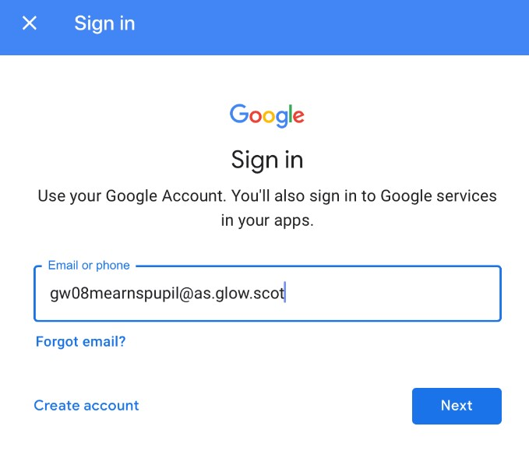

gw08woodfarmpupil@er.glow.scot

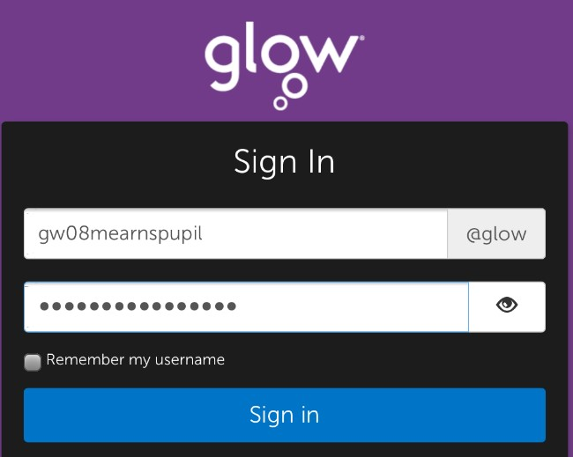

Step 2: Enter your Glow username and password.
gw08woodfarmpupil

How to join a class
There are two ways to join a Google Classroom.
- Your teacher may give you a code to join the class
- Your teacher sends you an invite to join a class.

- Google Classroom Code
If your teacher provides you with a code to join the Google Classroom, follow these steps:

- Click the + on the top right of the page to Join Class.
- Enter the Class Code given to you by your teacher, and click Join.
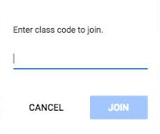
- Your teacher invites you to join the classroom
If your teacher invites you to join a Google Classroom, follow these steps:
- Go to your Google Classroom homepage.
- Accept the invitation to join the class.

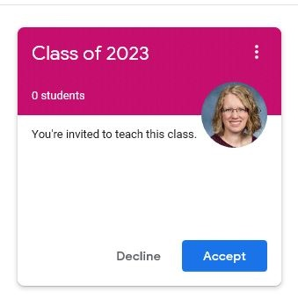

How to view tasks set by a teacher
To view homework or tasks set:
1. Once logged in to Google Classroom
2. Click on the class that you wish to view

Stream
The stream works similarly to a social network page. The most recent post that a teacher has added to the Google Classroom will be at the top and the oldest will be at the bottom. Each post will be associated with the subject that you are learning with that teacher.
Make sure to read all the posts in the stream.

Your teacher may post videos, tasks, PowerPoints or notes.

Classwork
The classwork page is where you will find a very clear and easy list of all your current set assignments with their due date visible to see.
You will need to upload your completed work in this section for your teacher to see.
IMPORTANT: Google Classroom will automatically mark your assignment as late if it is submitted after the deadline.

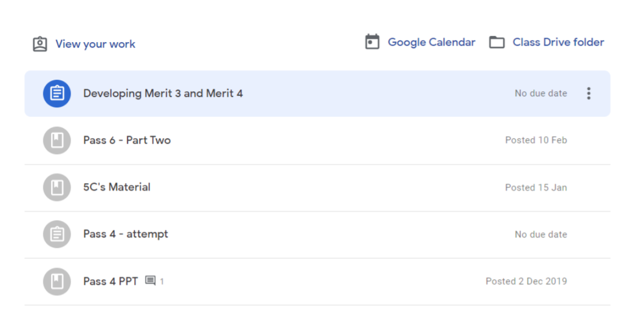

Google Calendar
You will see the due dates for all your assessments here.
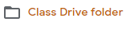
Class Drive Folder
Your teacher may upload PowerPoints or course notes here.

Submitting an assignment
Google Drive
If you have already created your work, then by selecting this you can attach the work directly from your Google Drive.

File
If you have chosen to upload a file from your device you will need to re-upload the file if any changes are made to the file from your device, as these changes will not be saved to the already uploaded document.

Create new
If you have chosen to create a new document from the "Create" section, then simply click on the file and then you can start working. The file will open in a separate tab and will save automatically until closed. You are able to go back to this document to work on it as many times as you wish before submitting it, from your original assignment or Google Drive.

The Turn In Button:
If the teacher has assigned a student their own copy of a Google file type (Docs, Slides, Sheets, or Drawings) as part of the assignment, there will also be a Turn In button (top-right) in the Google file next to the share button.
(Note: The Turn In button changes the ownership of the file from the student back to the teacher, and the student can no longer edit the file.) Students should submit their work using the Turn In button, NOT by sharing with the teacher. The teacher already has the right to view and edit the file.

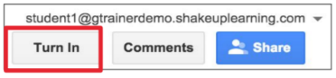

Pupil Guide: Show My Homework

How to access Show My Homework
You access Show My Homework through your GLOW account. Log into your GLOW account and select the Show My Homework tile.

Show My Homework App
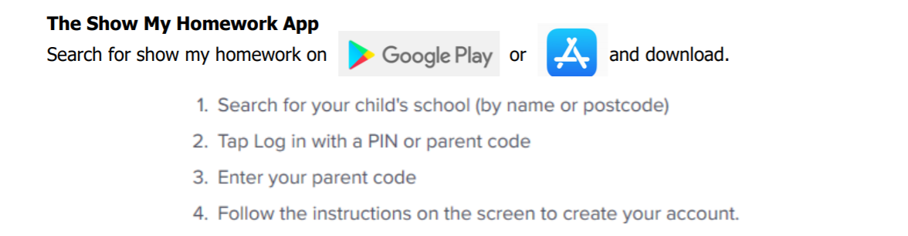

To Do List
The To Do List shows a list of the homework you have outstanding.
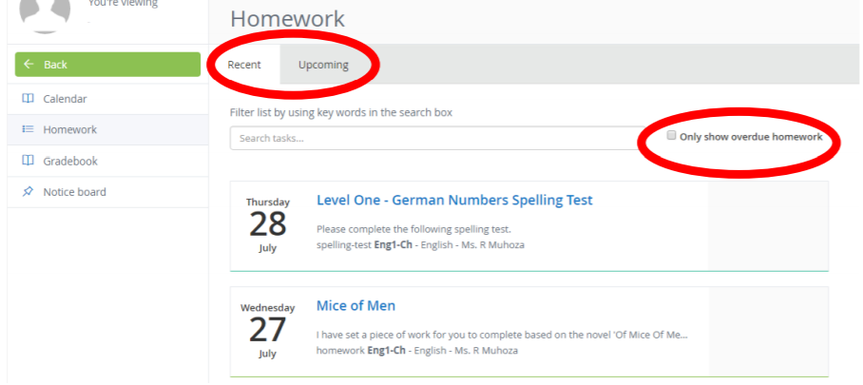

Homework Calendar
The calendar shows an overview of your homework and due dates.
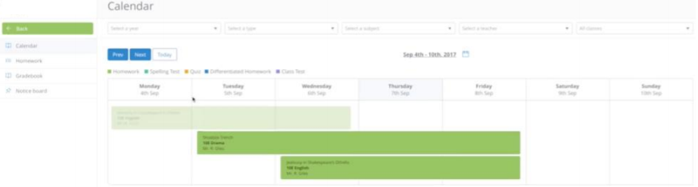

You can view more information by clicking on each piece of homework assigned in the calendar section.
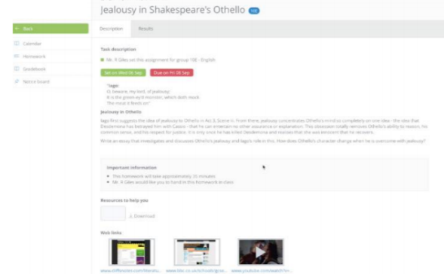

Home Screen
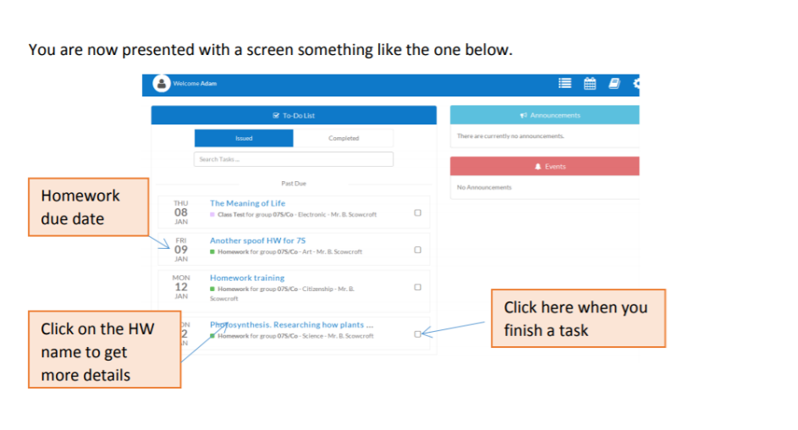
This student has 4 homework tasks outstanding. The due date for each homework task is listed on the left hand sound.

When you finish a homework, click on the little box on the right. This will move the homework from ‘issued’ to ‘completed’.

NOTE: Your teacher may note that you need to upload your homework to Google Classroom or Show My Homework. Be careful – make sure you upload your homework using the correct channel.

Additional Resources

The resources below are useful for building on learning at home:
SCHOLAR
Pupils should be able to access Scholar through Glow without needing a username or password.
Staff can also access Scholar through Glow but need to sign in on the first access.

BBC Bitesize – BGE and National Courses
BBC Scotland TV channel is running educational documentaries for courses.
Up to date content for courses which also offer:
- Notes
- Media content
- Diagrams
- Quizzes and Tests

SQA
All S4 - S6 pupils should have their Scottish Candidate Number (SCN) so that they can sign up for the MySQA app – this app gives updates from the SQA and also SQA results in August.
Senior Phase pupils can access past papers from the SQA website.
Faculties across the school are preparing appropriate learning activities for pupils. Information will be shared via Glow with pupils, on our school website and through Show My Homework.

A list of online materials to support children and young people at home
https://kidsactivitiesblog.com/135609/list-of-education-companies-offering-free-subscriptions/

Skills Development Scotland

Our school Careers Adviser is Jennifer Whelan.

Here are her contact details: Jennifer.whelan@sds.co.uk and 07887955628.

Study Skills
This section of the school website provides study techniques for all young people in the Broad General Education and Senior Phase. Study tips are also provided from each faculty to further support learning.
The study skills booklets can be located here: https://blogs.glowscotland.org.uk/er/Woodfarm/pupils/

Hemat Gryffe
Our HG outreach worker is Sandra McArdle who is available to support young people and their families.
sandra.mcardle@hematgryffe.org.uk
Mobile Number: 07879898261
East Renfrewshire Educational Psychology Service
Educational Psychology Services across Scotland have been sharing documents with each other for parents and carers to help reassure their children and young people regarding the current situation. Most of these are for young children or children with ASD but some e.g. helping children and young people manage in unsettling times, are relevant for older children and young people.

Useful Tips

Tip 1: Using iPhone or iPad to scan documents and upload PDF files rather than pictures to Show My Homework or Google Classroom. Check the screenshots below:

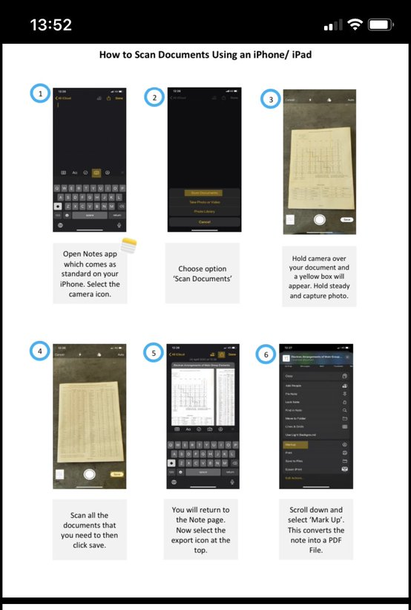

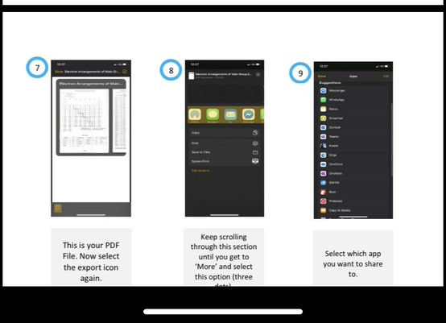

Tip 2: Downloading MS Office to devices including PC and MACs

Step 1: Go to Glow: Woodfarm HS Launchpad

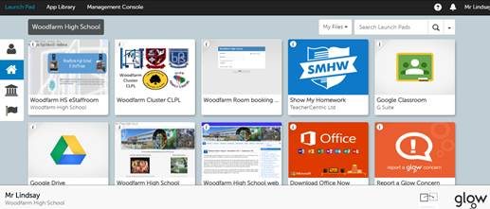

Pupil opens Download Office Now

Step 2: Installation screen
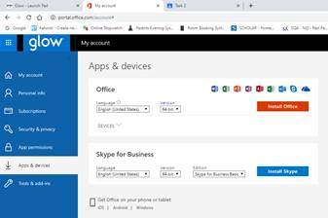

Pupils click Install Office. They will then install onto device for full suite of MS Office software.

Tip 3: Google G-Suite
When using mobile devices pupils need to log into Google products such as Google Classroom using their Glow credentials NOT their personal Google account.
How do they do this?
- Step 1: Example: gw08lastnamefirstname@er.glow.scot

- Step 2: They will then enter their Glow credentials on the Glow sign-in page

- Step 3: They now have access to Google products

