***Curriculum Rationale and Plan***

**Woodfarm High**



As a school community our vision, values and aims have been revisited to represent who we are at Woodfarm and what we want for our learners to define and shape our curriculum.

**This rationale sets out:**

* *our vision, values and aims*
* *the under-pinning principles of the curriculum*
* *an overview of how we deliver the curriculum*

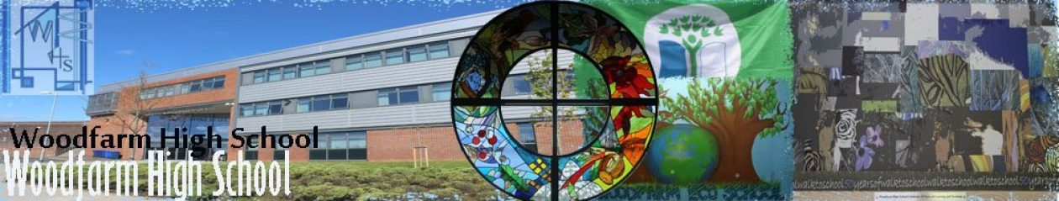

**The rationale for the curriculum is based on the school’s shared vision of preparing our young people for life.** **We aim to:**

* Deliver coherent experiences providing well planned, joined up learning within the four aspects of the curriculum.
* Plan a broad curriculum that develops skills for learning, life and work and develops the four capacities to ensure positive destinations for all our young people.
* Provide stimulating, challenging, relevant and enjoyable experiences and to take into account personalisation and choice.
* Deliver a flexible curriculum that provides a range of progression routes to meet the needs and interests of our young people.
* Provide a clear strategy for the development and assessment of literacy, numeracy and health and wellbeing to ensure progression and achievement.
* Produce a Learner Profile, which allows our young people to reflect upon their learning and skills progression and regularly captures their progress and achievements to support their future transitions.
* Ensure excellence and equity by establishing a culture of self-evaluation, improvement and collegiality.
* Allow pupils to contribute to the ethos and life of the school community by providing opportunities for personal achievement.

**Vision and Values**

* Our vision statement is Woodfarm:

The school that PREPARES you for life.

* Our core values are:

Partnerships, Respect, Equality, Participation, Ambition, Responsibility, Excellence and Skills

* All our young people, parents, staff and the wider community have a voice within the school.
* Our young people are encouraged to develop resilience, skills and knowledge to become lifelong learners and responsible citizens.
* Staff are committed to change which results in improvements for learners.

**Personal Support**

* A range of activities are planned to support our young people during transitions and to support choices.
* We plan a range of leadership and wider school opportunities and celebrate achievement.
* We are committed to planning a range of learning experiences to support and challenge all learners.
* We work closely with all stakeholders and partners to tackle barriers to learning.
* We are committed to supporting all learners’ social, mental and physical wellbeing.

**Curriculum Areas**

-Languages (English and Modern Languages) and Literacy

-Mathematics and Numeracy

-Social Subjects

-Sciences

-Creative

-Health and Well-being

-Religious and Moral Education

-Technologies

**Totality of the Curriculum**

* Our young people participate responsibly in decision making via the Woodfarm Parliament, and contribute as leaders across the school and the community.
* Our young people experience a range of achievements in the classroom and beyond and play an active part in putting the values of the school community into practice.
* Interdisciplinary learning provides opportunities to extend and deepen understanding.
* Experiences and Outcomes are planned in creative ways to encourage deep learning and to lead to subject specialisation.

**Principles**

• Challenge and enjoyment

• Breadth

• Progression

• Depth

• Personalisation and choice

• Coherence

• Relevance

See below

**Learning and Teaching**

* We work in partnership to provide engaging and active learning experiences in an inclusive and nurturing environment.
* Learning intentions are shared and success criteria are discussed and agreed to ensure excellence.
* Differentiation takes into account individual needs.
* Staff have high expectations of all learners.
* Collaborative approaches and CLPL opportunities are planned to identify and share effective practice.

**Assessment**

* Formative strategies are firmly embedded across learning at all levels, including self and peer assessment.
* Use of experiences and outcomes and benchmarks to develop assessment across the school.
* Robust moderation to ensure consistency of standards.
* Rigorous self-evaluation and improvement ensures that we improve attainment for all.
* Regular feedback is provided to learners and parents to share strengths and next steps.

**Entitlements**

Our young people have the opportunity to:

* Experience a broad education to reflect their stage and development.
* Develop skills for learning, life and work throughout the curriculum and wider school activities which are captured in profiles.
* Experience transitions that are well planned to ensure a coherent curriculum.
* Move into a positive and sustained destination.
* Receive support to achieve the highest possible levels of literacy, numeracy and cognitive skills.

-

**Learner**

**Responsible Citizen**

We are a Rights Respecting Level 2 school. Learners respect our school community.

**Confident Individual**

We support learners’ physical, emotional and mental wellbeing to develop self-awareness

and confidence.

**Effective Contributor**

Learners lead their learning.

**Successful Learner**

Learners are committed to achieving their potential and developing their skills.

**Curriculum Rationale**

**Broad General Education (S1-S3)**

All pupils have an entitlement to experience a Broad General Education. **Breadth** is achieved in S1 and S2 by designing learning activities based on all the Experiences and Outcomes across all curriculum areas. Learners have an entitlement to experience up to and including third level with the majority extending their learning into the fourth level by S3. As pupils progress through the broad general phase they will engage with a broadening range of experiences growing in confidence and competence in skills for learning, life and work in different contexts.

Our young people experience **progression**. We have a shared understanding of teaching methodologies and moderation activities to build on prior learning. All our young people experience a challenging gradient of learning and are tracked and monitored at all stages to ensure progression. Curriculum links are developed with the cluster primary schools through our Cluster Improvement Plan and our Transition Programme. This involves regular visits by P7 pupils to Woodfarm to participate in the Design Challenge with Technologies, Cluster Ceilidh and Sports Day with the PE department and the Onatti play with Modern Languages. The History department also organise a WW1 poetry competition to encourage creativity and develop literacy skills; the winning poem is inscribed on a wreath and presented at the Thornliebank War Memorial. S5/6 pupils visit the primaries as part of their Sports Coaching qualification; they plan and deliver activities to improve health and wellbeing. Targeted pupils also participate in the Skills Champions programme, the aim of which is to encourage our young people to connect with, enjoy and care for wild spaces. S1 and S2 pupils mentor P6 and P7 pupils to achieve their John Muir Award. Staff in a number of departments including English and Maths also visit the cluster primary schools to develop pupils’ numeracy and literacy skills and target learners to close the attainment gap.

Formative and summative assessment evidence is used to support teachers to make professional judgements about learners’ progress in the BGE and inform staff when learners are ready for the challenge of new and stimulating learning contexts. The P7, S1, S2 and S3 Skills Profile is designed to capture their skills development and achievements.

**Depth** in S1 to S3 is enhanced through interdisciplinary learning opportunities to connect learning across curricular areas; through planned activities and whole school opportunities. Our young people work at a pace to ensure a secure understanding and the ability to apply their learning in different contexts. Learners also have opportunities to discuss their learning, explain it to others and apply their knowledge and skills in a variety of contexts.

All stakeholders have high expectations of what learners can achieve. Activities are suitably **challenging**, engaging and motivating, encouraging high aspirations and ambitions for all pupils. As pupils progress through the Experiences and Outcomes they develop higher order thinking skills; including analysing, evaluating and creating. The design of our curriculum provides a number of **enjoyable** ways in which pupils can engage with the Experiences and Outcomes. Strategies such as active learning and the use of technology provide learners with stimulating lessons matched to their styles and abilities. Staff continue to embed digital technologies, for example, Show My Homework, Microsoft Teams**,** and Sway,to drive innovation and achievement.

Learning activities form a **coherent** experience with clear links between different aspects of learning. Staff from a variety of curriculum areas work closely together in order to ensure a coherent experience for learners within the curriculum area and across the experiences and outcomes. Partners are also involved in planning learning experiences to ensure a coherent curriculum. There is coherence and consistency in the development of literacy, numeracy, health and wellbeing, and skills for learning, life and work.

Learners have opportunities for **personalisation and choice** across many aspects of their learning throughout S1 to S3. The introduction of choice at the end of S2 within the broad general education phase ensures that there are appropriate progression routes at the end of S3 as pupils move into the senior phase. Learners have opportunities to choose from a variety of activities including homework projects to encourage learners to lead their own learning. There is also opportunities for choice during electives in English, PE, BIT and Technical. Learners are involved in the planning and assessment processes.

The broad general education is closely connected to the senior phase with the learning undertaken up until the end of S3 providing a strong foundation to extend learners knowledge and skills and to ensure a successful transition to National Qualifications at the appropriate level for each young person. The curriculum content is **relevant** and connects with the young person’s experience, learning and interests in and beyond the school environment. Learners know why, what and how their learning relates to everyday life in their family, local community and the world of work.



**S1 Curriculum Plan**

Learning will take place across all the Experiences and Outcomes in the eight curriculum areas.

* Learners develop their self-management skills and take responsibility for managing their own learning. They have opportunities to work collaboratively with others and learn to cope with challenging situations.
* Curricular areas work closely together to ensure a coherent experience for pupils. Themed days and IDL projects are a feature of the S1 curriculum including a Rapid Response event. Planned projects are also embedded in the curriculum, for example, in History and Modern Languages learners write a letter home from the trenches in French, in English and Art learners develop critical language skills on a gothic theme, also in Art learners explore artistic design in textiles to support cushion making in Home Economics.
* Learning for sustainability is embedded in learning and teaching. Learners develop their confidence and debating skills by exploring global issues to make connections with their own lives. For example, by developing and applying what has been taught in the PSHE curriculum via Drama and imaginatively role-playing how these issues affect their characters. Also to engage our young people in issues, BIT explore Brexit and support our young people to develop their views on the impact on business. The Music department use world music to explore diversity, and in Social Subjects and RME learners have the opportunities to consider their rights and address discrimination and prejudice. In Science learning for sustainability is embedded in the curriculum including waste reduction and recycling and tackling climate change. In Technologies staff support learners in the Adventure Group to design and create planters for their eco project. Learners also have an opportunity to complete a sketchbook project using recyclable materials; this involves sourcing sustainable materials and considering the impact of the materials. S1 learners have planned opportunities to participate in outdoor learning in English to develop their reflection skills and an orienteering event to connect our young people with the local community and environment.
* There are opportunities for personalisation and choice throughout the S1 curriculum. For example, in English S1 learners choose an elective to engage and challenge learners; they can focus on the media, Shakespeare or sports journalism. In Drama learners have a choice of stimulus and can develop their technical theatre skills by specialising in lighting, sound, props or costume. Young people also have the opportunity to study French and Spanish (6 week block) as well as taster sessions in Mandarin and Urdu.
* Planned activities enable our young people to have greater confidence and skills in leading their own learning and that of others, for example, by participating in the Readathon and the Carnegie Medal Awards in English. In Music they have the opportunity to practice graded pieces to lead their own gradient of learning and by organising the shoebox appeal in Social Subjects. Learners have the opportunity to participate in wider opportunities including the School Orchestra and Choir, Science club, Fairtrade, Amnesty International, Sport Council and Adventure Group to develop their skills and attributes.

**S1 Curriculum Plan**

* There is a wide range of extra-curricular activities in PE to improve health and wellbeing. PE are also identifying and supporting athletes who are talented to maximise their potential. In Drama learners’ mental wellbeing is improved by developing Living Life To The Full strategies, and learners’ social and emotional wellbeing is also explored in the friendship unit.
* Staff across the curriculum plan opportunities to improve literacy and numeracy. For example, the ExPLORE model and group discussion skills are embedded in subject areas to develop literacy skills. Numeracy skills are also developed including estimating and measuring in Science, reading engineering drawings and use of CAD/CAM in technical. Learners also read information and charts in all curriculum areas and learn to manage their finance in BIT and Maths.
* STEM opportunities are planned to stimulate and engage learners. For example, in Art learners have an opportunity to design a logo for a local business and participate in activities from Wreck This Journal to develop their creativity skills. In BIT learners work collaboratively to develop new products and approaches in the Enterprise unit. In PE there are opportunities also to use their creativity, problem solving and risk assessment skills. Maths provides regular opportunities to interpret and analyse data and information and in Science learners experiment and explore ideas. Also in Technologies, S1 learners participate in the Cookie Cutter Challenge to develop a new product and develop an idea.
* Peer learning improves the S1 experience, for example, S6 careers ambassadors support S1 pupils to develop their skills profile to ensure learners capture their achievements and skills across all of their learning experiences. S6 Performing Arts Ambassadors, Language Ambassadors, Literacy Ambassadors and Numeracy Partners also support pupils to develop their confidence and skills to raise attainment.
* Digital skills are integrated in the curriculum. In BIT learners create their Skills Profiles and capture their skills progression and achievements. They also have opportunities in BIT to develop their coding skills, use movie maker and web design software. All learners use Show My Homework for home learning tasks including developing their digital skills in Art and using 3D Made Easy in Technologies.

|  |  |  |  |  |  |  |  |
| --- | --- | --- | --- | --- | --- | --- | --- |
| **Language** | **Mathematics** | **Science** | **Social Studies** | **Technologies** | **Expressive Arts** | **Health & Wellbeing** | **Religious & Moral Education** |
| English (5 periods)  French (3) | Maths (4 periods) | Chemistry, Biology and Physics delivered as a common course (3) | Modern Studies, Geography and History delivered as a common course (3) | Computing (1)  Business Enterprise (1)  Administration (1)  Technical (1.5)  Home Economics (1.5)  *Delivered via rotations and electives* | Art & Design (1.5)  Music (1.5)  *Delivered via rotations*  Drama (1) | PE (3)  PHSE *Delivered via* Drama(1) | RME (1) |

**S2 Curriculum**

Learning will take place across all the Experiences and Outcomes in the eight curriculum areas.

* In S2 there is a focus on raising aspirations and ensuring learners have the knowledge to plan for choices and changes. They develop skills for personal planning and make informed choices and decisions about their future learning.
* IDL projects are planned to ensure learners apply their skills in a different context, and provide opportunities for extended activities to draw different strands of learning together. In RME and Science learners explore the ethics of DNA profiling, and in History and Science learners make links by investigating cholera. In BIT and Maths numeracy experiences and outcomes are planned and connections explored.
* Learners’ health and wellbeing is supported by delivering the PSHE curriculum via Drama in S2. Learners also complete a health and wellbeing journal in PE and Home Economics to review their targets and capture their achievements. Resilience and social relationships are promoted throughout the curriculum and during Endeavour week.
* A STEM project is delivered in S2. Approximately 15 pupils participate over one period each week. The project is repeated with 3 cohorts and provides targeted support. The programme involves four innovative STEM themes delivered by Science, Technologies, BIT and Mathematics. Themes include; Robotics and Creative Building, Product Design, App Design and Fuels of the Future.
* Staff ensure that digital technology is a central consideration in all areas of curriculum. Learners are engaged through digital approaches to learning including Inventor in Technologies, Microsoft Teams, Google Classrooms and Kahoot quizzes.
* There are opportunities for personalisation and choice throughout the S2 curriculum to respond to individual needs and support particular aptitudes and talents. For example, in English pupils choose a skill they have developed in PE and reflect on their progress. In Technologies learners choose from an elective to develop their skills and deepen their learning through a project based approach. For example, in Graphics they can choose Spin Wars and Digital Design, in Design and Manufacturing they can chose from a soundwaves project and a project to design and manufacture an LED desk light. Also in Woodwork there are opportunities to participate in a boom box and storage solution elective, learners can also choose from a global food challenge and the community café project in Hospitality. Further specialisation and choice is available in BIT; learners can choose the App Inventor elective which involves using software to design and develop an App. They can also select the Digital Business elective to develop their digital skills including web design or the Psychology elective.

**S2 Curriculum**

* Learners build their values, attitudes, knowledge, skills and confidence through learning for sustainability. For example, in Social Subjects they discuss controversial issues and tackle discrimination and prejudice in RME. Rights based learning is also embedded in our curriculum.
* Learners continue to build upon earlier knowledge and achievements, for example, in PE they continue with the Sports Education model to develop their problem solving and creativity. Opportunities are also planned to ensure progression when learners have rotated to Music, for example, in Art learners continue with sketch book drawings
* Staff provide learners with opportunities to lead their learning. For example, in Technologies and Art they have a choice of design based projects, in PE learners develop the skills required to work effectively with others, solve problems and develop their thinking creatively in order to move on successfully to the next stage of learning.
* The curriculum is planned to support learners to understand the relevance of their learning to their lives, for example, in Music they have an opportunity to explore music in the media. Industry visits are also a feature of the curriculum to ensure learners experience opportunities which raise their awareness of future choices and their own expectations. All learners’ career aspirations are recorded in a database to target learners for specific visit to develop the skills and attributes they require to achieve and sustain positive destinations beyond school.

|  |  |  |  |  |  |  |  |
| --- | --- | --- | --- | --- | --- | --- | --- |
| **Language** | **Mathematics** | **Science** | **Social Studies** | **Technologies** | **Expressive Arts** | **Health & Wellbeing** | **Religious & Moral Education** |
| English (4 periods)  French (3) | Maths (5 periods) | Chemistry, Biology and Physics delivered as a common course (3) | Modern Studies, Geography and History delivered as a common course (3) | Computing (1)  Business Enterprise (1)  Administration (1)  Technical (1.5)  Home Economics (1.5)  *Delivered via rotations and electives* | Art & Design (1.5)  Music (1.5)  *Delivered via rotations*  Drama (1) | PE (3)  PHSE *Delivered via* Drama(1) | RME (1) |

**S3 Curriculum**

* Beyond S2, learners have the opportunity to make choices within curricular areas. This provides the opportunity to explore subjects in depth and for the majority of learners to achieve fourth Level experiences and outcomes and to begin to prepare pupils for Senior Phase qualifications.
* All S3 learners develop their leadership skills and serve as role models to others. They contribute to the ethos of the school and have opportunities to be selected for Junior House Captain, Woodfarm TV and World of Work Ambassadors. Staff regularly seek the support of learners for their input into events such as the Curricular Choice Evening and Learning Festival to share their knowledge and understanding with parents/carers as well as young people.
* IDL opportunities are planned to revisit experiences and outcomes where it is felt this would be beneficial. Learners also participate in the Youth Philanthropy Initiative in English and RME and lead fundraising events to raise funds for their chosen charity. YPI engages learners to understand the needs of their community and develops teamwork, communication, research and presentation skills.
* Learners will be given the opportunity to choose two subjects from Art, Music and Drama, two subjects from Computing, Business, Technical and Home Economics and to choose three Sciences if appropriate.
* In Languages, pupils will be given the opportunity to specialise in French but also Spanish if they choose an additional language.
* Learners’ entitlement to personal support is met through a timetabled period of PSHE. The curriculum is planned to ensure progression in LLTF to develop resilience, support learners to understand the impact of risk-taking behaviour, acknowledge diversity and reflect on strengths and skills to help make informed choices.
* There are opportunities to learn about sustainability including a Scottish tourism topic in Modern Languages and the John Muir Award in Scottish Studies Also in Business Management sustainability is covered throughout the "Operations" unit, learners explore how businesses are impacted by changes to legislation regarding recycling. It also explores the ethics of employers and the strategies that they implement to minimise any harm to the environment. The aim is to equip learners with the knowledge and understanding, skills and attributes needed to work and live in a way that safeguards environmental and social and economic wellbeing.
* PE offer an elective as part of the options process to ensure choice. Learners can choose from Sports Coaching, Dance or Duke of Edinburgh.
* We are committed to supporting learners to make the right choices therefore a range of alternative pathways are offered for learners in S3 including Environmental Science, Languages for Life and Work, Scottish Studies, and Personal Development to provide an alternative curriculum. Whatever a learner’s ability and preferences, our curriculum is challenging and allows them to aspire to excellence.

**S3 Curriculum**

* Learners develop their skills for learning, life and work by participating in the Credit Union lessons to provide them with the skills and knowledge to manage their finances. Pupils also have an opportunity to develop employability skills in the English literacy unit which involves interviewing a range of professionals and discussing career pathways. Learners also lead and organise catering events in the school. There are further opportunities to develop employability skills including the Future Chef School and visits from the Armed Forces to promote healthy eating in Hospitality.
* All young people complete a Learner Profile. This supports learners to reflect upon their achievements across all curriculum areas, including literacy, numeracy and health and wellbeing. The profile also includes learning experiences out with the classroom in extra-curricular activities, as well as wider achievements outside of school. This helps develop learners’ understanding of their own skill development.

|  |  |  |  |  |  |  |  |  |
| --- | --- | --- | --- | --- | --- | --- | --- | --- |
| 1 (5 ) | 2 (4) | 3 | 4 (3) | 5 (3) | 6 (3) | 7 (3) | 8 (3) | 9 (3) |
| English | Maths | PE (3)  Sports Coaching, Dance or DOE Award (1) | French or Languages for Life and Work | Geography  History  Mod St.  RMPS  Scottish Studies | Biology  Chemistry  Physics  Enviro. Sci. | Administration & IT  Business  Computing  Practical Craft Skills  Design & Manufacture | Music  Drama  Art & Design  Hospitality  Graphic Com. | Business  Art & Design  Chemistry  Personal Development  Spanish |

**The Senior Phase**

By the end of the Broad General Education in S3 learners will have benefited from a wide range of learning and experiences. They will have progressed at different rates and the majority will have achieved Fourth Level. Other pupils will have covered a number of Second and Third level experiences and outcomes and will continue with alternative pathways.

During the Senior Phase **depth** of learning will continue to be provided through opportunities for pupils to engage with increasingly demanding concepts, develop progressively more complex cognitive abilities and build and learn new skills. This will be provided through working towards National Qualifications at the appropriate level for each individual pupil.

**Breadth** will be further enhanced as learners build on their qualifications over the three years.

We will continue to have the highest possible expectations of what our young people can achieve and provide **enjoyable** learning experiences. Through offering choices in personal development, leadership opportunities and extra-curricular activities our learners will continue to be **challenged** to develop as well rounded, responsible and confident young people.

As with the Broad General Education, learning activities in the Senior Phase combine to form a **coherent** experience with clear links between different aspects of learning.

**Personalisation and choice** will continue in the Senior Phase and will be further enhanced through continuing to work with the local authority to offer extended choices especially at Advanced Higher level and vocational courses.

**Relevance** will be enhanced in the Senior Phase through links with business partners, work experience opportunities, community involvement and further and higher education partners.

The main **progression** routes that will be available to learners will be based on their prior achievements and interests and can be viewed in our learner journeys.

**S4 Curriculum**

* Pupils will continue to study nine subjects to enable all pupils to undertake a range of national qualifications at the appropriate level to ensure a positive destination.
* English and Mathematics are compulsory.
* Learners’ entitlement to personal support will be met through a timetabled period of PSHE.
* Learners are targeted for one-to-one mentoring.
* Learners participate in a work placement to further develop their knowledge, skills for life, learning and work to support planning for their future lives, careers and lifelong learning.
* To encourage an active and healthy lifestyle, pupils will continue to receive 4 periods of PE.
* Learning and teaching will provide specialisation, depth and rigour.

|  |  |  |  |  |  |  |  |  |
| --- | --- | --- | --- | --- | --- | --- | --- | --- |
| 1 (5 ) | 2 (4) | 3 | 4 (3) | 5 (3) | 6 (3) | 7 (3) | 8 (3) | 9 (3) |
| English | Maths | PE (3)Sports Coaching, Dance or DOE Award (1) | French or Languages for Life and Work | Geography  History  Mod St.  RMPS  Scottish Studies | Biology  Chemistry  Physics  Enviro. Sci. | Administration & IT  Business  Computing  Practical Craft Skills  Design & Manufacture | Music  Drama  Art & Design  Hospitality  Graphic Com. | Business  Art & Design  Chemistry  Personal Development  Spanish |

**S5 Curriculum**

* Learners will continue to study five subjects or four subjects and a vocational course.
* Learners’ entitlement to personal support will continue to be met through a rotation of PSHE, RME and employability.
* Learners will continue to be targeted for one-to-one mentoring.
* There will be no compulsory subjects although English is encouraged.
* Learners’ entitlement to Physical Education will be met by timetabling 2 periods.
* Six periods will be allocated to each option.
* A range of alternative courses are available including Travel and Tourism, Laboratory Skills, Financial Maths, Sports Coaching, Refereeing and Dance.
* Learners can be selected to become a school prefect.

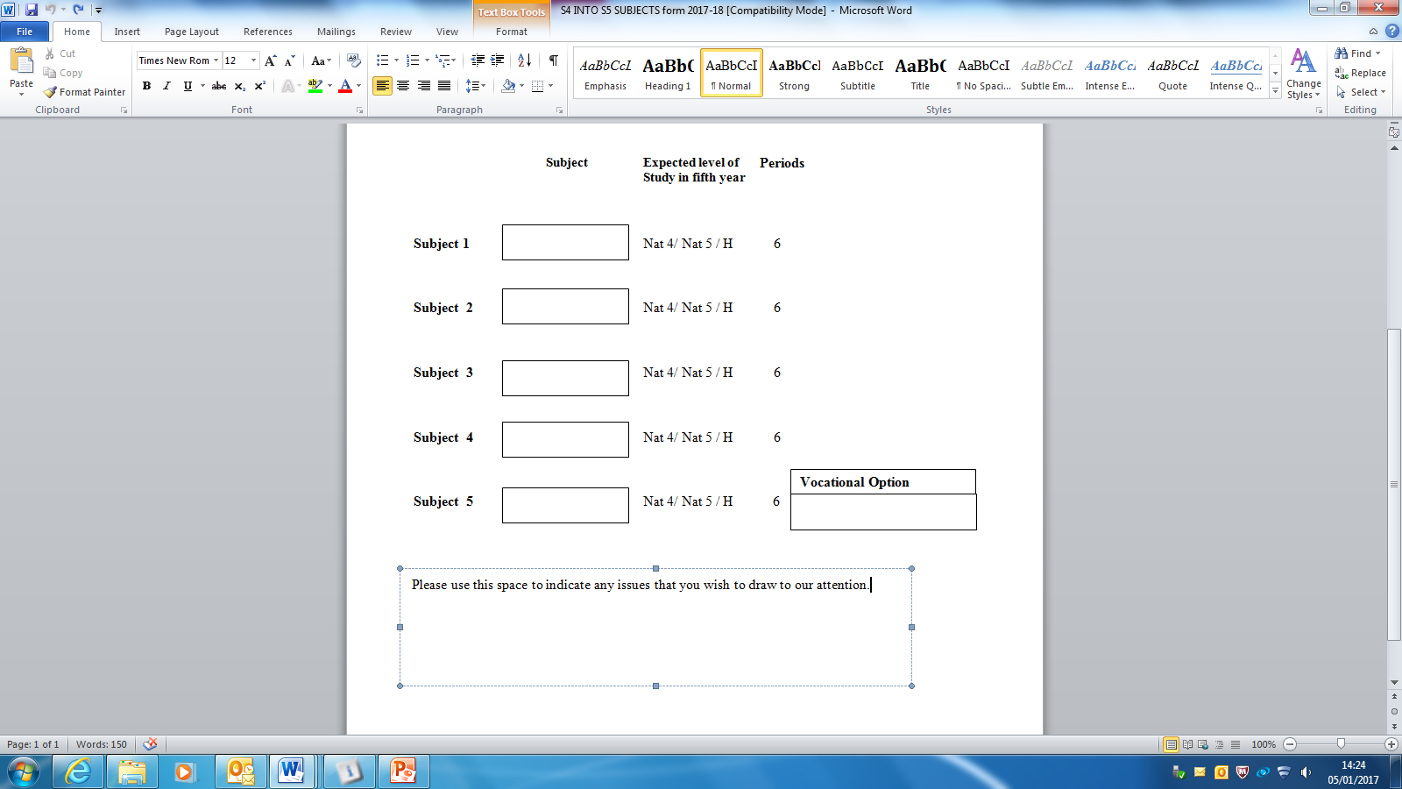

**S6 Curriculum**

* Pupils will continue to study four or five subjects.
* Opportunities will be provided for learners to participate in a range of leadership opportunities in school and the wider community by choosing from the S6 leadership options.
* Learners will act as mentors for S1-S3 pupils in targeted classes and take responsibility for leading committees including charities, whole school events, yearbook and award ceremonies.
* Learners’ entitlement to personal support will continue to be met through weekly PSHE.
* Learners’ entitlement to Physical Education will be met by timetabling 1 period.
* Learners also lead and manage a number of extra-curricular activities and lunch duty. They will become school prefects and can participate in the selection process to become a Senior Prefect, House Captain and/or Senior Ambassador.
* Learners will be offered a range of Advanced Higher courses as well as the option to study Higher Psychology.

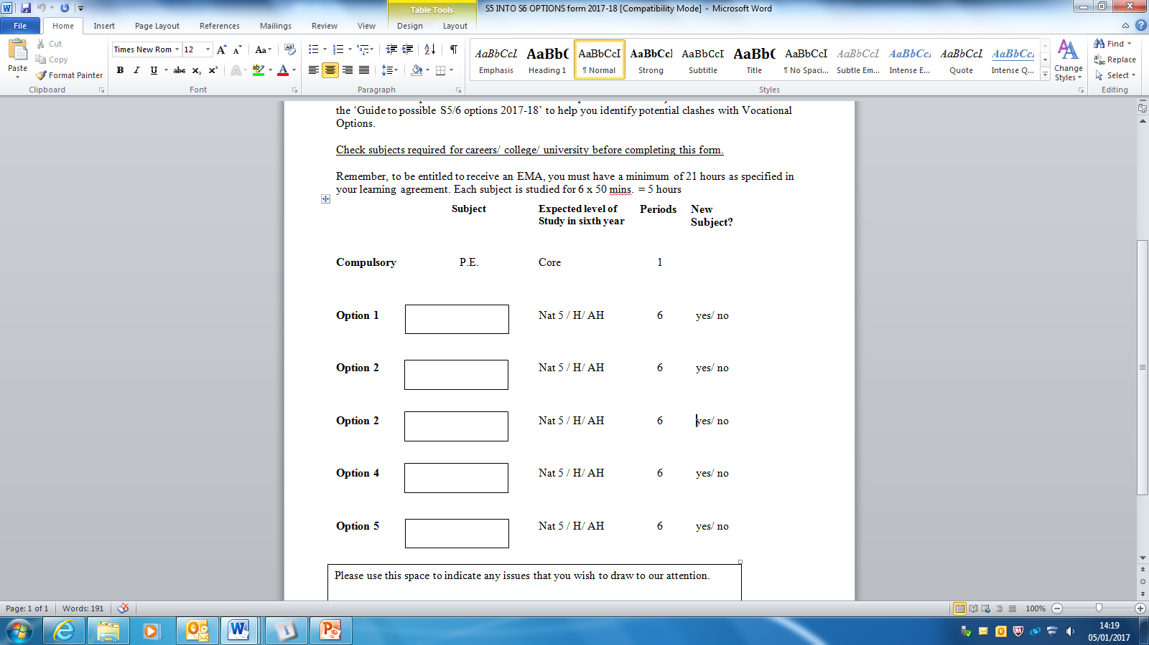

**Learner Journeys**

|  |  |  |  |
| --- | --- | --- | --- |
| Learner | A | B | C |
| S2 Outcomes | By the end of S2 has demonstrated achievement of 3rd level CfE Outcomes in all curricular areas | By the end of S2 has achieved most/some 3rd level CfE Outcomes across a range of curricular areas | By the end of S2 is working towards 3rd level CfE Outcomes across a range of curricular areas |
| S2 Curricular Pathway Choices | Embarking upon a range of subjects - leading to specialisation based around 4th level Outcomes providing more challenge depth and understanding- quickly moving to a full programme of National Qualifications (NQ) during S3 | Embarking upon a range of subjects giving specialisation in curricular areas where 3rd level CfE Outcomes have been achieved.  Moving to a range of National Qualifications across choices at some point during the S3/S4 experience. | Embarking upon a range of subjects across the 8 curricular areas - providing the opportunity to achieve 3rd level CfE outcmes, leading to a range of National Qualifications by the end of S4 |
| S3 Experience | Using level 4th level Experience and Outcomes to progress towards National Qualifications during S3, providing opportunities for study at greater depth and specialisation | A blended approach to learning with curricular areas delivered around CfE Outcomes together with NQ standards | An experience predominately based around 3rd level CfE Outcomes |
| S4 Outcomes | 9 National 5 Qualifications (A-C). Available Vocational Qualifications also an option | 8/9 National 4/5 Qualifications. Available Vocational Qualifications also an option | A number of subjects across a range of National and Vocational Qualification levels |
| Potential progression routes | Further specialisation in S5 leading to presentation for 5 Highers, potentially including vocational learning experiences | Further specialisation in S5 leading to presentation for 5 subjects at Higher/National 5, potentially including vocational learning experiences | Further study of literacy and numeracy plus additional subjects and vocational learning experiences |