Common Language and Methodology for Teaching Numeracy & Mathematics
3 - 18

Woodfarm Cluster

Contents

Introduction 1

Do You Know ? 2

Add and Subtract 3

Multiply and Divide
- Basic skills 8
- By 10, 100, 1000 (including decimals) 8
- By multiples of 10, 100, 1000 9
- Long Multiplication 9

Order of Operations (BODMAS) 10

Rounding 13

Percentages
- Non-Calculator 15
- Calculator 16

Algebra
- Introducing Algebra 19
- Number Machines 20
- Collecting Like Terms 21
- Expanding Brackets 22
- Solving Equations 23
- Solving Inequalities 25

Patterns & Sequences
- Special Sequences 27
- Linear Patterns 29

Information Handling
- Types of Data, Averages and Range 31
- Pictogram/Pictograph 32
- Bar Chart/Graph 33
- Line Graphs 33
- Frequency Diagrams 34
- Pie Charts 34
- Stem-and-Leaf Diagram 35
- Scattergraphs / Scatter Diagram 36

Fractions
- Converting Mixed Numbers to Improper Fractions 38
- Performing calculations to fractions (adding/subtracting/multiplying/dividing) 39

Workings and Units 42

AifL and Interactive Learning Strategies in Mathematics
- Using AifL Strategies 43
- Using Interactive Learning Strategies 47

Introduction

A Learning and Teaching Scotland Numeracy project was set up to “raise standards of educational attainment for all in schools, especially in the core skills of literacy and numeracy”. The project had three key areas of development:

- Expectation, continuity and progression in numeracy
- Numeracy for all
- Support for teachers of numeracy

Within East Renfrewshire the focus is on developing a common language and methodology for the teaching of numeracy. Within the Woodfarm cluster a working party was set up to carry this out.

Where possible the group has sought to make clear the correct use of language, and put in place a common use of language. Alongside that a common methodology has been designed for key elements of Numeracy and Mathematics in line with the Significant Aspects of Learning and Experiences and Outcomes of CfE. The aim is to ensure continuity and progression for pupils, which should then impact on attainment.

In planning learning, teaching and assessment using the experiences and outcomes, the use of the significant aspects of learning in numeracy and mathematics aims to help staff gather and organise a range of evidence of pupil progress in mathematics and numeracy in a holistic way.
The five significant aspects of learning in numeracy and mathematics are:
- Using knowledge and understanding of the number system, patterns and relationships
- Using knowledge and understanding of measurement and its application
- Using knowledge and understanding of shape and space
- Researching and evaluating data to assess risks and make informed choices
- Applying numeracy and mathematical skills

It is also expected that the work on Assessment is for Learning, interactive maths, problem solving and mental maths would be integral to the delivery of the common language and methodology.

Young people should be actively encouraged to develop and use their own strategies to solve a range of mathematical problems and calculations.

Do You Know. . .

- We use the word ‘calculation’ instead of ‘sums’ as sum refers to addition.

- We avoid the use of ‘and’ when adding i.e. we do not say ‘4 and 2 is 6’

- We say, ‘9 subtract 4’, we do not say ‘4 from 9’

- We say ‘3 multiplied by 2’, we do not say ‘3 times 2’

- We say ‘zero’ when referring to the number ‘0’, we do not say ‘nothing’, or use the letter ‘o’

- We say ‘one hundred’, we do not say ‘a hundred’

- We say ‘two point three six’ not ’two point thirty-six’ and ‘zero point five’, not ‘point five’.

- When writing decimals, including money we ensure the decimal point is placed at middle height

- When using Money we
  - Say e.g. 50 pence piece when referring to coins
  - Say ‘one pence’, we do not say 1p
  - Write £1.00 or £1 and say ‘one pound’, we do not say ‘a pound’
  - Write with only one sign i.e. £1.80 not £1.80p

- When using fractions we emphasise that e.g. ¼ is “one divided by four” or ‘1 divided into 4 equal parts’

- The difference between a decimal fraction (0.5) and a common fraction (½)

- We say negative four, we do not say minus 4. In temperature ‘minus 4’ is technically wrong even though it is widely used.

- When drawing Co-ordinate axis we write the numbers on the lines, we do not write the numbers in between the line

- We say ‘twenty degrees Celsius’, we do not say ‘twenty degrees centigrade’

- We say 3 squared centimetres, we do not say 3 centimetres squared

- We say 80 cubic centimetres, we do not say 80 centimetres cubed

- When we multiply or divide a decimal by multiples of 10 e.g. 20, 400 we move the digits to the left (multiplying) or the right (dividing), we do not move the decimal point

- When solving equations we ‘balance’ each side of the equation, we do not use the ‘change side, change sign’ or the ‘cover up’ methods

- Bar graphs have spaces in between the bars, whereas Histograms do not

- When working with distance (d), speed (s) and time (t) formula we use lower case letters

Common Methodology
for
Add and Subtract

Adding and Subtracting

- Use the word “calculation” instead of “sums” as sum refers to addition. Use “show your working” or “written calculation” rather than “write out the sum”.

- Words for addition and subtraction

Add: Plus, total, how many altogether, more than, find the sum of,
Subtract: Difference between, less than, take away moving towards subtract and minus

- Avoid the use of “and” when meaning addition e.g. “4 and 2 is 6”

- Say, “9 subtract 4” not, “4 from 9”.

- The number ‘0’
  - Say ‘zero’ when referring to the number ‘0’ e.g. zero, one, two . . . do not use ‘nothing’
  - Use nothing when carrying out a calculation

- Say one hundred not a hundred

- Distinguish between digits and numbers

- Addition is commutative i.e. you can swap numbers over and still get the same answer e.g. 3 + 5 = 5 + 3

- Initially set out addition and subtraction horizontally e.g. 5 + 4 = 9.
Then introduce pupils to this written out vertically.
Start addition and subtraction at the top and work downwards e.g.

5 6
+ 4 − 2

is “five add four.” is “six take away two”

Addition

- When one addition fact is known it is important to elicit the other three facts in terms of addition and subtraction. Concrete materials should be used to experiment and explore linked facts for as long as is necessary.

2 + 3 = 5
3 + 2 = 5
5 − 2 = 3
5 − 3 = 2

- The above facts are linked to 5. Children should be encouraged to investigate and explore other facts which “make” 5. e.g.

9 – 4 = 5
27 – 22 = 5

- Concrete materials should be used to experiment and explore linked facts to 20 for as long as is necessary and should only be removed when the pupil is confident to move on.

- Encourage pupils who are secure in their number bonds to look for patterns in the number bonds. e.g.
6
7
+4

Pupils could either do 6 add 7 add 4 (down) or 6 add 4 add 7 (patterns).

- Pupils need to set out addition and subtraction properly. The sign needs to be out-with the calculation. Don’t write:

2 3
+ 9

- When “carrying”, lay out the algorithm as follows:

5 6
+ 3 9
9 5
1

Steps for addition:
- Check the sign and ask, is it addition or subtraction?
- Start with the units column.
- Say “six add nine equals fifteen”. Staff may trace a shape for pupils, to focus them on the addition or subtraction sign.

5 6 Staff would trace from the six to the addition
+ 3 9 sign, and back to the nine.
1

- The “carry” digit always sits below the line.
- Add the tens column. Say, “five add three add one equals nine”.

If pupils find this process challenging staff should highlight the tens and units column.
When pupils have added the units they could place the fifteen to the side. Then break this down into 1 ten and 5 units for carrying purposes.
T U
5 6
+ 3 9

Subtraction
Same process as addition.
Say “three take away one equals two”. And “six take away two equals four”.
6 3
− 2 1

- Exchanging

T U
2
3 ¹1
Introduce exchanging with concrete materials.
− 1 2
1 9

- Say, “one take away two, we can’t do this”
- Exchange one ten for ten units.
- Then say, “eleven take away two equals nine”.
- Then for the tens say, “two take away one equals one”.

H T U
3
1
1
9
4 0 0
− 2 3 4
1 6 6

- Say “zero subtract four, we can’t do this”.
- We have no tens to exchange, so we have to exchange one hundred for ten tens. Then exchange one ten for ten units.
- Repeat as before.

Common Methodology
for
Multiply and Divide

Multiplying and Dividing

- Words for multiply and divide
Multiply: Multiplied by, product,
Divide: Divided by, quotient

- Table facts e.g. 2 × 5 = 10 should be stated as “two fives are ten”.

- For multiplication tables the table number comes first.
e.g. Two times table 2 × 0 = 0
2 × 1 = 2
2 × 2 = 4
2 × 3 = 6 and so on…

- When multiplying by one digit, lay out the algorithm as follows:
As with addition, the ‘carry’ digit sits below the line.
2 6
× 4
1 0 4
2

Steps:
- Say “four sixes are twenty four”.
- As for addition/subtraction the four goes in the units column and the two is carried below the line.
- Say “four twos are eight”.
- Add the two tens that were carried to give ten.
- Ensure that the one representing the hundreds is placed in the answer.

- 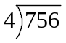 Say “this is 756 divided by 4”.
Start by saying “7 divided by 4”.
Support if necessary by saying “how many 4’s in 7?”

Avoid saying “4 goes into 7” or “4 into 7”

Multiplying and Dividing by 10, 100, 1000

When we multiple and divide a number by 10, 100, 100 the decimals point stays fixed and we:
- move the digits
  - to the left when multiplying (as the answer is bigger)
  - to the right when dividing (as the answer is smaller)
- move the digits
  - 1 place if multiplying or dividing by 10
  - 2 places if multiplying or dividing by 100
  - 3 places if multiplying or dividing by 1000
- put in zero(s) to keep place value when appropriate

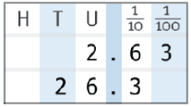

Example 1: 2.63 x 1000
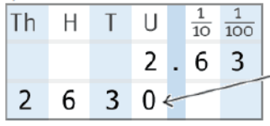
The numbers have moved so far to the left that you need to put a zero to fill the gap

Example 2: 2.63 x 10 = 26.

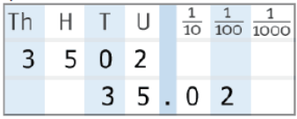
Example 3: 3502 ÷100 = 35.02

Multiplying and Dividing by multiples of 10, 100, 1000

 | 2 | . | 6 | 3
 | x |  | 1 | 0
2 | 6 | . | 3
 | x |  | 2
5 | 2 | . | 6
Example 1: 2.63 x 20 = 52.6

We do this in 2 steps
Step 1: x 10
Step 2: x 2

Example 2: 642.6 ÷ 600 = 1.071
642.6 ÷ 100 = 6.426
 | 1 | . | 0 | 7 | 1
6 | 6 | . | 4 | 2 | 6

We do this in 2 steps
Step 1: ÷ 100
Step 2: ÷ 6

Long Multiplication i.e. multiplying by two digits

Lay out the algorithm as follows:

4 7
× 5 6
2 8 2
4
+ 2 3 5 0
3
2 6 3 2

It is important to emphasise the difference between the carrying digits so that when pupils are adding they only include the relevant digits. If pupils start adding the wrong digits they should be encouraged to cross them out after they have used them. In the example above, pupils could cross out the 3 after calculating “five times four equals twenty plus three is twenty three”.

Common Methodology for
the Order of Operations (BODMAS)

Overview

BODMAS is an acronym used to assist in the order of operations of calculations in Mathematics. The acronym is as follows:

Brackets
Order
Division
Multiplication
Addition
Subtraction

From an early stage young people should be encouraged to know BODMAS and understand the terminology. Most of the terms are self explanatory with the exception of order, which is another work for index. These are both ways of describing the ‘power’ of a number e.g. for 5² we could say 5 to the power 2 or the order of 5 is 2.

Example 1 - Evaluate: 3 + 5 x 2

Pupil records: 3 + 5 x 2
Multiplication comes before addition, therefore our first calculation is 5 x 2, not 3 + 5.

= 3 + 10
= 13

Example 2 - Evaluate: (2 + 3) x 5
Pupil records: (2 + 3) x 5
Work out the brackets first.

= 5 x 5
= 25

Example 3 – Evaluate: 25 - 18 ÷ 2
Pupil records: 25 - 18 ÷ 2
Division before subtraction
= 25 - 9
= 16

Example 4 – Evaluate: (4 + 3) x 2²
Evaluate what is in the brackets first
Next evaluate orders or powers i.e. 2² = 4
Then multiply

Pupil records: (4 + 3) x 2²
= 7 x 2²
. = 7 x 4
= 28

It is important to emphasise the need for BODMAS and working through calculations in the correct order. This may be emphasised through investigation of different examples such 3 + 4 x 5. More often than not a class will come up with two answers to a question like this; 35 and 23. Using BODMAS the correct will be 23 and 35 can only be obtained through the introduction of brackets (3 + 4) x 5.

After learning the acronym BODMAS and the order in which operations are calculated, it is important to emphasise the importance of each operation in relation to others.

Rule 1: Addition and Subtraction have EQUAL importance

However we should ALWAYS calculate the addition and/or subtraction in the order that they appear from left to right.

Example 5 – Evaluate: 10 + 4 - 8
Pupil records 10 + 4 – 8
= 14 – 8
= 6

Example 6 – Evaluate: 5 – 6 + 3
Pupil records = -1 + 3
= 2

Rule 2: Multiplication and Division have EQUAL importance

However we should ALWAYS calculate the multiplication and/or division in the order that they appear from left to right.

Example 6 – Evaluate: 5 x 6 ÷ 3
Pupil records = 30 ÷ 3
= 10

Example 7 – Evaluate: 18 ÷ 9 x 7
Note the importance of working from LEFT to RIGHT here.
Pupil records = 2 x 7
= 14

Further examples can be found here: https://www.youtube.com/watch?v=dAgfnK528RA

Common Methodology
for
Rounding

Rounding to nearest 10, 100, 1000

- Underline appropriate column
- Look at the number on the right
  - if it is a 1, 2, 3, 4 – the underlined number does not change
  - if it is a 5, 6, 7, 8, 9 – the underlined number increases by 1
- Put in zero(s) as to keep place value

Number to the right is an 8 so we increase the underlined number by 1
Example 1: Round 3658 to nearest ten

Pupils Records: 3658 3660

Number to the right is a 2 so we leave the underlined number unchanged
Example 2: Round 9422 to nearest hundred

Pupils Records: 9422 9400

Number to the right is a 5 so we increase the underlined number by 1. However as it is a 9 we need to carry it over into the thousand column
Example 3: Round 6953 to nearest hundred

Pupils Records: 6953 7000

Rounding to given number of decimal places

- Underline appropriate column
- Look at the number on the right
  - if it is a 1, 2, 3, 4 – the underlined number does not change
  - if it is a 5, 6, 7, 8, 9 – the underlined number increases by 1
- Never write numbers beyond underlined number

Number to the right is a 3 so we leave the underlined number unchanged
Example 1: Round 4.536 to 1 decimal place

Pupils Records: 4.536 4.5

Number to the right is a 7 so we increase the underlined number by 1
Example 2: Round 3.2687 to 3 decimal places

Pupils Records: 3.2687 3.269

Further examples can be found here: https://www.youtube.com/watch?v=fd-E18EqSVk

Common Methodology
for
Calculating Percentages

Common Methodology for
Calculating Percentages

Percentages

Percent means out of one hundred

Non-Calculator Percentages

- Common Percentages as Fractions

Pupils should know common percentages and their equivalent fractions.

Firstly pupils become confident in using the four basic common percentages as fractions

1% = 10% = 25% = 50% =

Progressing to other common percentages as fractions

20% = 75% =

then

33 % = 66 % = 12 % =

- Lay out of calculations involving common percentages

e.g. Calculate 25% of £28

Pupils Workings: 25 % of £28

= x 28

= £7 (as 28 ÷ 4 = 7)

- Other Percentages

Pupils should calculate simple percentages, such as 10%, 5% and 1% and use combinations or multiples of these to calculate the correct percentage.

Examples

- Calculate 30% of 60 (method uses the fact that 30 % = 10% x 3)
Pupil records: 10% = of 60
= 6
30% = 6 x 3
= 18

- Calculate 4% of £800 (method uses the fact that 4% = 1% x 4)
Pupils records: 1% = 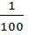of £800
= £8
4 % = £8 x 4
= £32

- Calculate 5% of £40 (method uses the fact that 5 % = 10% ÷ 2)
Pupils records: 10 % = of £40
= £4
5 % = £4 ÷ 2
= £2

- Calculate 15% of 60 (method uses the fact that 15% = 10% + 5%)
Pupils records: 10 % of 60 = 6
=> 5 % = 3
=> 15 % = 9

Calculator Percentages - layout

Example: Calculate 23% of £978

Pupils Workings: 23 % of £978

= x 978 (pupils enter 23 ÷ 100 × 978 into calculator)

= £224.94

Common Methodology for
Algebra

Overview

Algebra is a way of thinking, i.e. a method of seeing and expressing relationships, and generalising patterns - it involves active exploration and conjecture. Algebraic thinking is not the formal manipulation of symbols.

Algebra is not simply a topic that pupils cover in secondary school. From primary one, staff are involved in helping pupils lay the foundations for algebra. This includes:
- Writing equations e.g. 16 add 8 equals?
- Solving equations e.g. 2  = 7
- Finding equivalent forms e.g.
- 24 = 20 + 4 = 30 – 6
- 24 = 6 x 4 = 3 x 2 x 2 x 2
- Using inverses or reversing e.g.
4 + 7 = 11 → 11 – 7 = 4
- Identifying number patterns
- Expressing relationships
- Factorising numbers and expressions
- Understanding the commutative, associative and distributive laws

Commutative, Associative and Distributive laws
(Note: pupils do not need to know names of laws, just where and how to use them)

Commutative: you can swap numbers over and still get the same answer
e.g. 3 + 5 = 5 + 3 or 3 x 5 = 5 x 3

Associative: it doesn't matter how you group the numbers i.e. which you calculate first
e.g (3 + 5) + 2 = 3 + (5 + 2) or (3 x 5) x 2 = 3 x (5 x 2)

Distributive: says you get the same answer when you: multiply a number by a group of
numbers added together, or do each multiply separately then add them
e.g. 3 x (5 + 2) = 3 x 5 + 3 x 2

Introducing Algebra

Pupils will be introduced to the idea of finding a missing value
e.g.
2 + 3 = Ask, “Two add three equals what?”

6 − 4 = “Six take away four equals what?”

Pupils will start to look at finding the operator along with more complicated versions of finding the missing value.

Pupils should be encouraged to think of these in a variety of ways, so that they are adopting a strategy to solve the equation.
e.g.
2 + = 6 Ask, “Two plus what makes six?”
“What add two makes six?”
“Six take away two gives what?”

2 6 = 8 Ask, “Two add what makes seven?”
“What sign makes sense here/completes the equation?”

Pupils should be introduced to a variety of layouts e.g. 6 = 3 

Number Machines

Pupils should use the following terminology: input, output, reverse, do the opposite, work backwards, inverse, undo etc.

Pupils should be introduced to single function machines and then double function machines.

Pupils should find the ‘?’. ‘✓’ indicates the information given.

✓

✓
?
✓

?
✓
?

✓
✓
✓

?
✓

✓
?
?

✓
✓

✓
?
?

✓
?

✓
✓

COLLECTING LIKE TERMS

It is possible to tidy up expressions by collecting all the like terms.

Note:
- This is an algebraic expression not an algebraic equation as there is no = sign.
- Therefore a value for x cannot be found.

Example 1: Simplify 8x + 3x – 5x

Pupil records: 8x + 3x – 5x
= 6x

Notes:
- This cannot be simplified to one term as they are not all like terms.
- The sign in front is kept with the term.
- Letters should come before numbers.

Example 2: Simplify 4p + 7 – 3p – 2

Pupil records: 4p + 7 – 3p – 2
= 4p – 3p + 7 – 2
= p + 5

Example 3: Simplify 3a – b + a
Notes:
- Again this cannot be simplified to one term as they are not all like terms.
- The sign in front is kept with the term.
- Letters should be in alphabetical order

Pupil records: 3a – b + a
= 3a + a – b
= 4a – b

EXPANDING BRACKETS

Pupils should be familiar with the terminology: multiplying out, expand, remove, rewrite without brackets

Multiply all the terms inside the brackets by the number or letter directly in front.

Example 1: Expand the brackets 3(x + 1) Pupil records: 3(x + 1)

= 3x + 3

Example 2: Expand the brackets 3(1 - x) Pupil records: 3(1 - x)

= 3 - 3x

Example 3: Expand the brackets 2(2 + 5x) Pupil records: 2(2 + 5x)

= 4 + 10x

Example 4: Expand the brackets x(4x + 1) Pupil records: x(4x + 1)

= 4x² + x

Example 5: Expand the brackets 2a(a + 3b) Pupil records: 2a(a + 3b)

= 2a² + 6ab

Example 6: Expand the brackets 3 + 5(2x + 7) Pupil records: 3 + 5(2x + 7)

Expand brackets first = 3 + 10x + 35

Collect like terms = 10x + 38

SOLVING EQUATIONS

Method

Pupils should be taught the concept that an equation is a balance.

We will not use:
- the “change side change sign” method
- the “cover up” method (may be mentioned when solving easier examples)

General Points

When solving equations pupils should:

- write x as opposed to x

- be aware that x stands for the number we do not know

- underline their answer

- write the equals signs directly below each other

- show working

- make sure x is always on the LHS

- collect the ‘x’s first before the numbers

- rewrite the equation so that largest number of ‘x’s are always on the LHS

- eliminate any fraction first by multiplying all the terms on both sides by a number which eliminates all the denominators (lowest common multiple, lcm, is preferable)

- be aware that they can write their answer in fraction form

- be familiar with the terminology: multiplying out, expand, remove, rewrite without brackets, find the solution, collect like terms, solve etc.

Examples to follow are:

- Example 1 Unknown is on one side

- Example 2 Unknown is one two sides

- Example 3 Answer is not an integer

- Example 4 Equation includes a bracket

- Example 5 Equation with fractions

Always:
- Write equals signs directly below each other
- Write working directly below the number
- Make sure x is on the LHS

Example 1 UNKNOWN IS ON ONE SIDE

x | – | 4 | = | 7
 |  | +4 |  | +4 |  |  |  | (add 4 to both sides)
x |  |  | = | 11

Example 2 UNKNOWN IS ON TWO SIDES

5x | + | 7 | = | 3x | + | 11
-3x |  |  |  | -3x |  |  |  | (take away 3x from both sides)
2x | + | 7 | = |  |  | 11
 |  | -7 |  |  |  | -7 |  | (take away 7 from both sides)
2x |  |  | = |  |  | 4
÷2 |  |  |  |  |  | ÷2 |  | (divide both sides by 2)
x |  |  | = |  |  | 2

Note:
- Always collect the ‘x’s first.

- If asked to solve 3x + 11 = 5x + 7
This should be rewritten so that largest number of ‘x’s are always on the LHS
i.e. 5x + 7 = 3x + 11, and solved as above

Example 3 ANSWER IS NOT AN INTEGER

2x | = | 5
÷2 |  | ÷2 |  |  |  |  |  | (divide both sides by 2)
x | = |  | or 2.5

Example 4 EQUATION INCLUDES A BRACKET

If there are brackets in the equation pupils should expand the brackets first.

6 | + | 2(x + 2) |  | = | 12
6 | + | 2x + 4 |  | = | 12 |  |  | (expand bracket)
10 | + | 2x |  | = | 12 |  |  | (collect like terms)
-10 |  |  |  |  | -10 |  |  | (take away 10 from both sides)
 |  | 2x |  | = | 2
 |  | ÷2 |  |  | ÷2 |  |  | (divide both sides by 2)
 |  | x |  | = | 1

Example 5 EQUATION WITH FRACTIONS

x  a) | + | 3 | = | 7
x | + | 6 | = | 14 |  |  |  | (multiply both sides by 2)
x |  |  | = | 8
b)
x | + |  | = | 2
9x | + | 8 | = | 24 |  |  |  | (multiply both sides by 12  i.e the lcm of the numerators)
9x |  |  | = | 16
x |  |  | = | 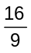

Always eliminate the fraction first by multiplying all the terms on both sides by a number which eliminates all denominators (lcm of all the fractional denominators is preferable).

Note: Pupils should know that 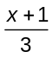 + 4 = 6 is the same as ( x + 1) + 4 = 6

SOLVING INEQUATIONS / INEQUALITIES

Use the words “inequality” and “inequation” interchangeably

Pupils should be aware of the symbols.

Symbol | Meaning
< | is less than, so 2 < 5 is a true statement
> | is more than, so 6 > 4 is a true statement
 | is less than or equal to, so 2 5 is true, and so is 2 2
 | is more than or equal to, so 6 4 is true, and so is 6 6

Solving equalities is almost identical to solving equations.

Pupils should be aware that an expression such as
3x - 7 < 8 is similar to the equation 3x - 7 = 8
Unlike 3x - 7 = 8, which has just one answer (x = 5), there are lots of numbers for which this is true (in fact an infinite number of answers). So our answer is not a number, but a range of numbers.
When solving some inequalities solutions have to be chosen from a list of numbers - see example 1.

Example 1 (UNKNOWN IS ON ONE SIDE)

Solve 3x – 7 < 8, choosing solutions only from (-1, 0, 1, 2, 3, 4, 5, 6)

3x | – | 7 | < | 8
 |  | +7 |  | +7 |  |  |  | (add 7 to both sides)
3x |  |  | < | 15
÷3 |  |  |  | ÷3 |  |  |  | (divide both sides by 3)
x |  |  | < | 5
x |  |  | = | -1, 0, 1, 2, 3, 4, |  |  |  | (from list)

So the inequality in 3x – 7 < 8 is satisfied when x is less than 5 and a member of the set (-1, 0, 1, 2, 3, 4, 5, 6) i.e. x =

Example 2 UNKNOWN IS ON TWO SIDES

5x | + | 7 | > | 3x | + | 11
-3x |  |  |  | -3x |  |  |  | (take away 3x from both sides)
2x | + | 7 | > |  |  | 11
 |  | -7 |  |  |  | -7 |  | (take away 7 from both sides)
2x |  |  | > |  |  | 4
÷2 |  |  |  |  |  | ÷2 |  | (divide both sides by 2)
x |  |  | > |  |  | 2

So the inequality in 5x + 7 > 3x + 11 is satisfied when x greater than 2.
e.g. x = 3, 4, 5, 6,… Note this does not include 2 itself

Example 3 MULTIPLYING OR DIVIDING BY A NEGATIVE NUMBER

Generally we treat inequations like equations except when we have to multiply or divide both sides by a negative number.

If we divide both sides by a negative number we need to reverse the inequality sign.

-4x | < | 8
÷(-4) |  | ÷(-4) |  |  |  |  |  | (divide both sides by negative 4)
x | > | 2 |  |  |  |  |  | (reverse the sign)

The example below illustrates the reason for reversing the inequality.

4 > 2 is a true statement.
Multiplying both sides by a  positive number e.g. 2 | multiplying both sides by a negative number e.g. -2 | multiplying both sides by a negative number e.g. -2 and reversing the sign
8 > 4 | -8 > -4 | -8 < -4
still true | no longer true | is now true

.
.

Common Methodology for
Patterns & Sequences

Special Sequences

Prime Numbers

A prime number is a number that:
- Has exactly 2 factors

- The factors are one and itself

Note: the number one is not a prime number as it is only divisible by 1
i.e. it does not have 2 factors

The sequence of Prime Numbers up to 20 is: 2, 3, 5, 7, 11, 13, 17, 19

Square Numbers

1² | 2² | 3² | 4² | 5² | 6²
= 1 x 1 | = 2 x 2 | = 3 x 3 | = 4 x 4 | = 5 x 5 | = 6 x 6
= 1 | = 4 | = 9 | = 16 | = 25 | = 36

The sequence of Square numbers is: 1, 4, 9, 16, 25, 36, . . .

Triangular Numbers
 |  | 1 |  | 3 |  |  | 6 |  |  |  | 10 |  |  |  |  | 15
The sequence of Triangular numbers is: 1, 3, 6, 10, 15 . . .
Do you see the pattern? The difference between consecutive numbers is 2, 3, 4, 5 . . .

Fibonacci Sequence

The first two Fibonacci numbers are 0 and 1, and each subsequent number is the sum of the previous two

The sequence of Fibonacci numbers is: 0, 1, 1, 2, 3, 5, 8, 13, 21, . . .

Interesting facts about Fibonacci numbers
- The numbers exist in Nature – get your pupils to count the arrangement of leaves on a stem, branching in trees, the arrangement of a pine cone.
- If you divide a Fibonacci number by the preceding number as you work your way up the sequence the answers seem to be settling down about 1.618. This is called the GOLDEN NUMBER.

Linear Patterns

Pupils need to be able to find the pattern given a sequence and then describe it by giving a rule.

They need to be able to work with sequences written vertically (as below) or given horizontally.

Example: Find a rule for this sequence

Term | Sequence
1 | 3  +3  +3
2 | 6
3 | 9
4 | 12
n | 3n
Method:
- Pupils should identify the steps in the sequence. Here it is 3, which indicates the three times table.

- Check by multiplying the terms by 3 that it gives the sequence.

- For the nth term the rule is n × 3 which is rewritten 3n

The sequences get more difficult and may involve 2 steps.

Example: Find a formula for the nth term of the sequence

Term | Sequence
1 | 5  +4  +4
2 | 9
3 | 13
4 | 17
n | 4n + 1
Method:
- The steps in the sequence are 4, which suggests the rule will be based on the four times table.

- Pupils need to check if that works eg 4 × 1 = 4 but the first number in the sequence is 5. This indicates that the rule requires additional steps.

- Ask, “What do we now need to do to get 5?” Add 1. This suggests the rule is multiply by 4 and then add 1.

- Check ‘ multiply by 4 then add 1’ works for the other terms in the sequence.

- The rule can then be generalised to n × 4 + 1 which can be rewritten 4n + 1.

In both examples outputs were larger than the input, so the options were addition or multiplication. Similarly if the outputs are smaller it implies subtraction or division.

Common Methodology for
Information Handling

INFORMATION HANDLING

Discrete Data

Discrete data can only have a finite or limited number of possible values.
Shoe sizes are an example of discrete data because sizes 39 and 40 mean something, but size 39.2, for example, does not.

Continuous Data

Continuous data can have an infinite number of possible values within a selected range. e.g. temperature, height, length.

Non-Numerical Data (Nominal Data)

Data which is non-numerical. e.g. favourite TV programme, favourite flavour of crisps.

Tally Chart/Table

A tally chart is used to collect and organise data prior to representing it in a graph.

Averages

Pupils should be aware of the different types of average, but that often “average” is used to indicate the mean.

- Mean: add up all the values and divide by the number of values.

- Mode: is the value that occurs most often.

- Median: is the middle value or the mean of the middle pair of an ordered set of values.

Range

The difference between the highest and lowest value.

Pictogram/pictograph

A Pictogram is a way of displaying discrete or non-numerical data.

A pictogram/pictograph needs:
- a title
- appropriate x and y-axis labels
- if each picture represents a value of more than one, then a key should be used.
The weight each pupil managed to lift
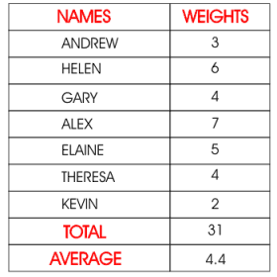
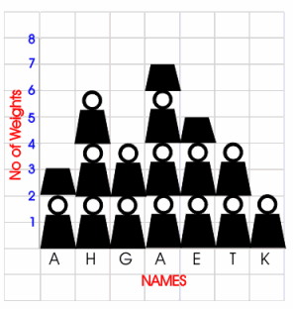

represents
two units

Bar Chart/Graph – do not confuse with a Histogram

A Bar Chart is a way of displaying discrete or non-numerical data.

A Bar Chart needs:
- a title

- appropriate x and y-axis labels.

- an even space should be between each bar and each bar should be of an equal width.

- a space between the y-axis and the first bar.

- When using a graduated axis, the intervals must be evenly spaced.
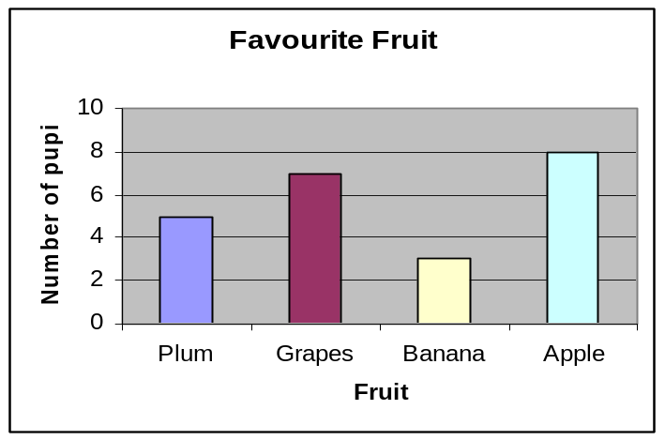

Line Graphs

Line graphs can be used to compare two quantities (or variables).

Each variable is plotted along an axis. A line graph has a vertical and horizontal axis. So, for example, if you wanted to graph the height of a ball after you have thrown it, you could put time along the horizontal, or x-axis, and height along the vertical, or y-axis.

A line graph needs
- a title
- appropriate x and y-axis labels.
- if there is more than one line graph on the same axes, the graph needs a key.

Frequency diagrams

1. Histogram - is a way of displaying grouped data.

A histogram needs
- A title
- Appropriate x and y-axis labels
- No space between each bar.
- Each bar should be of an equal width.
- When using a graduated axis, the intervals must be evenly spaced.
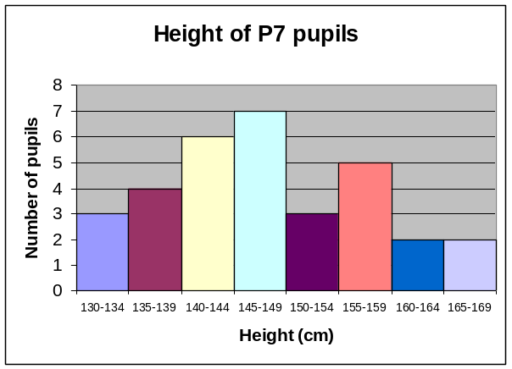

2. Frequency Polygon

To draw a frequency polygon,

draw a histogram

then join the midpoints of the top of each bar.

It is then optional, whether or not you remove the bars.

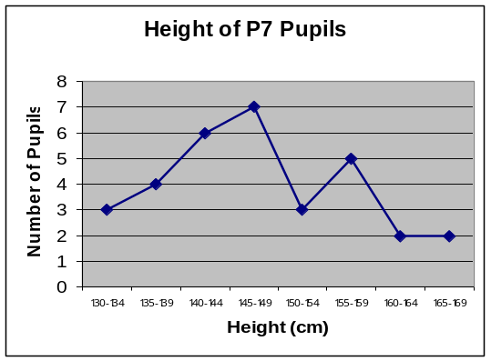
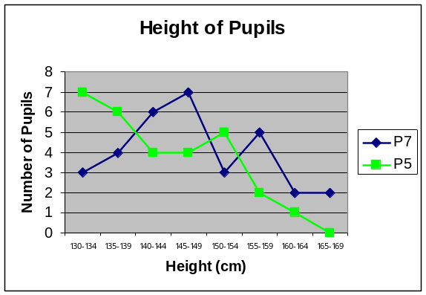
Frequency polygons are useful when comparing two sets of data.

Pie Charts

A pie chart is a way of displaying discrete or non-numerical data.
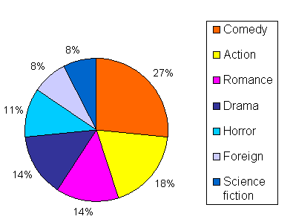
It uses percentages or fractions to compare the data
Favourite type of Movies

The whole circle (100% or one whole) is then split up into sections representing those percentages or fractions.

A pie chart needs
- a title
- a key.

Reading Pie Charts:

- If Percentages given
E.g. in above pie chart if 300 people were surveyed the number who preferred Comedy would by 27% of 300 (see Percentages chapter)
Hair Colour

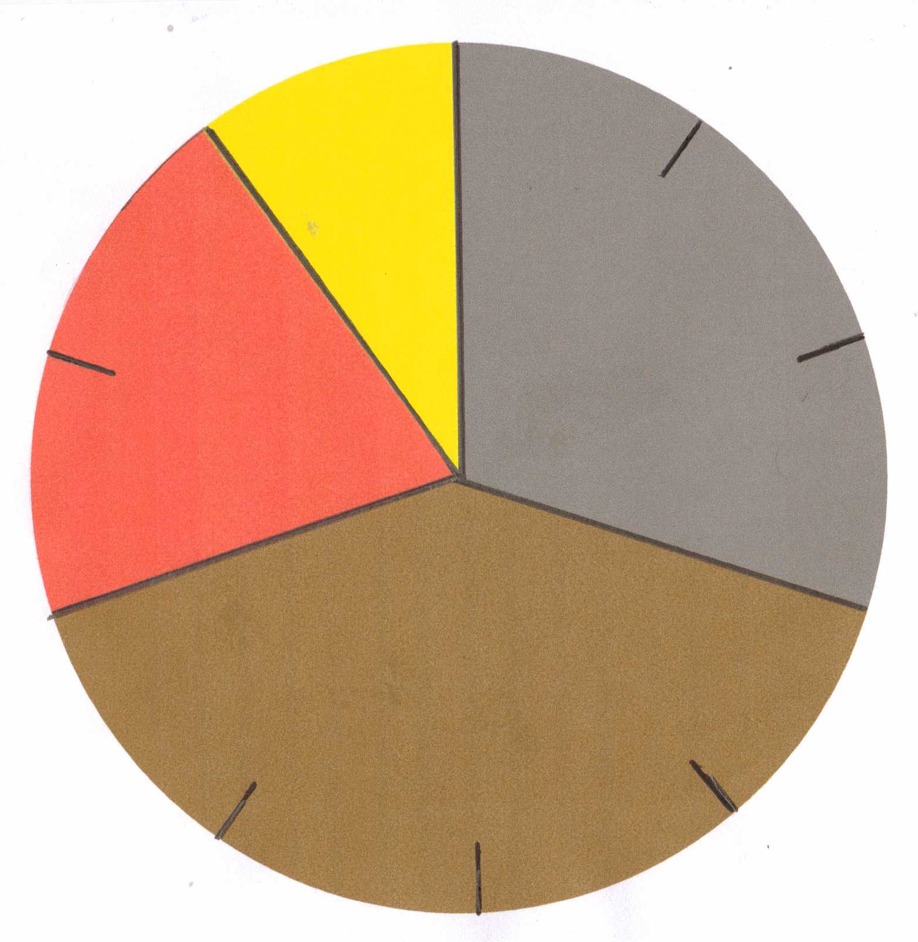
- Where no percentages given

B Black

Brown

Red

Blonde

If the whole pie chart represents 200 people

There are 10 sections
- Each section = 200 ÷ 10 = 20 people

Black hair = 3 sections
- Black hair = 3 x 20 = 60 people

Stem-and-leaf diagram

A stem-and-leaf diagram is another way of displaying discrete or continuous data.

A stem-and-leaf diagram:
- needs a title
- needs a key
- should be ordered.

It is useful for finding the median and mode.

Example
The following marks were obtained in a test marked out of 50. Draw a stem and leaf diagram to represent the data.

3, 23, 44, 41, 39, 29, 11, 18, 28, 48.

Split the data into a stem and a leaf.
- Here the tens part of the test mark is the stem.
- The units part of the test mark is called the leaf.

Unordered stem-and-leaf diagram Ordered stem-and-leaf diagram

Test marks out of 50 Test marks out of 50
0 | 3 | the diagram can be ordered  to produce an  ordered stem and leaf diagram | 0 | 3
1 | 1 8 |  | 1 | 1 8
2 | 3 9 8 |  | 2 | 3 8 9
3 | 9 |  | 3 | 9
4 | 4 1 8 |  | 4 | 1 4 8

Key: 1 | 3 means 13 out of 50 Key: 1 | 3 means 13 out of 50

If we have two sets of data to compare we can draw a back-to-back stem-and-leaf diagram e.g. in a recent Maths test out of 50:

Boys scores: 13, 32, 34, 41, 38, 26, 12, 28, 28, 48
Girls scores: 42, 12, 26, 39, 38, 27, 18, 32, 39,

Maths test results
Girls |  | Boys
8 2 | 1 | 2 3
6 7 | 2 | 6 8 8
9 9 8 2 | 3 | 2 4 8
2 | 4 | 1 8

Key: 1 l 2 means 12 out of 50

Scattergraphs (Scatter diagrams)

A scattergraph allows you to compare two quantities (or variables).

Each variable is plotted along an axis. A scattergraph has a vertical and horizontal axis.

A scattergraph:
- needs a title
- needs appropriate x and y-axis labels.
- for each piece of data a point is plotted on the diagram.
- the points are not joined up.

A scattergraph allows you to see if there is a connection (correlation) between the two quantities.

There may be a positive correlation when the two quantities increase together e.g. sale of umbrellas and rainfall.

There may be a negative correlation were as one quantity increases the other decreases e.g. price of a car and the age of the car.

There may be no correlation e.g. distance pupils travel to school and pupils’ heights.

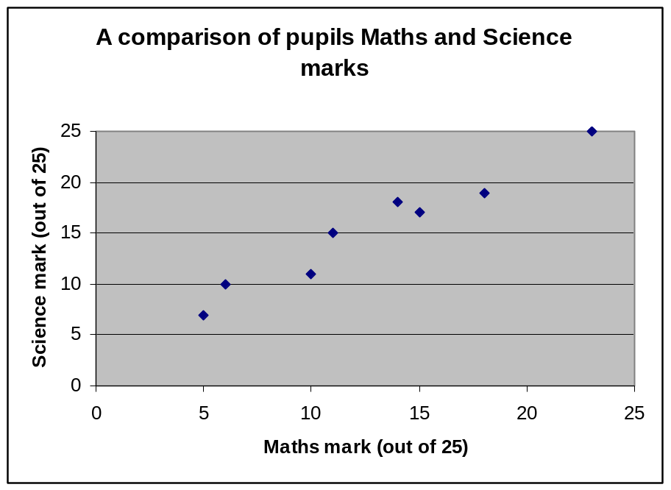

Common Methodology for
Fractions

FRACTIONS

Converting Improper Fractions to Mixed Numbers

Example 1 Covert the following improper (top heavy) fractions to mixed numbers:

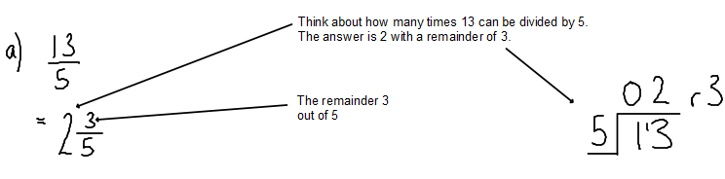

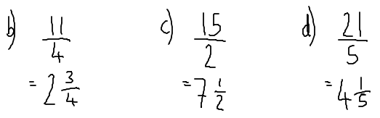

Example 2 Covert the following mixed numbers to improper fractions:

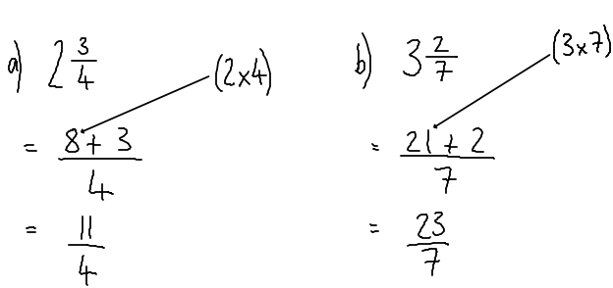
*Note this process is the reverse of what we did in the previous example*

Further examples can be found here: https://www.youtube.com/watch?v=-55KA6kaXFY

FRACTIONS

Adding – Subtracting - Multiplying – Dividing

Example 1 – Adding basic fractions

When adding or subtracting fractions, if the denominators are not of the same it is important to manipulate the fractions so the denominators become equal.

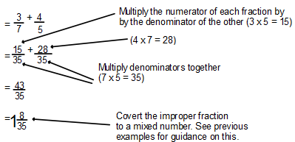

Example 2 – Adding mixed numbers

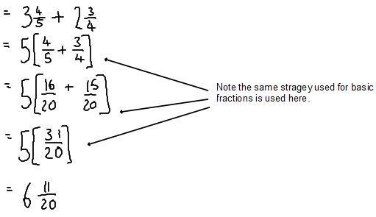

Example 3 – Subtracting

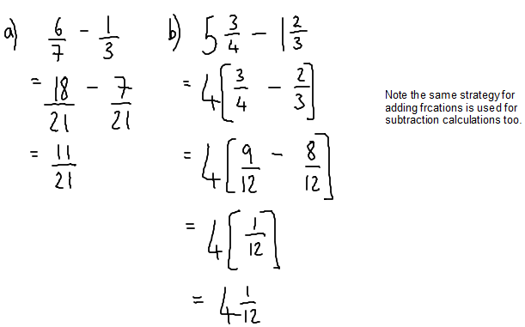

Example 4 – Multiplying

When multiplying fractions you multiply the denominators together, and multiply the numerators together.

If multiplying mixed numbers together you must convert to improper fractions before beginning the multiplication.

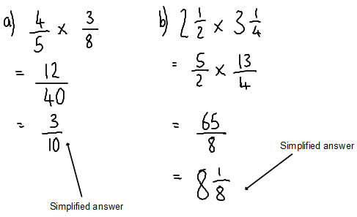

Example 5 – Dividing

Dividing fractions involves ‘flipping’ the fraction you are dividing
by, and then using the same strategy used for multiplying fractions.

Again, if dividing mixed numbers, you must convert to an improper fraction(s).

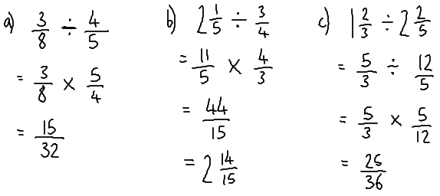

A recommended online video with further detail and examples on all of the above can be found here:

https://www.youtube.com/watch?v=5juto2ze8Lg (Adding & subtracting)

https://www.youtube.com/watch?v=qmfXyR7Z6Lk (Multiplying)

https://www.youtube.com/watch?v=4lkq3DgvmJo (Dividing)

Workings & Units

As full marks are no longer awarded for correct answers with no workings (or units) in SQA exams, showing workings is a part of Maths and Numeracy which should always be encouraged.

Please see the examples below as a guide to required workings in 2 basic questions.
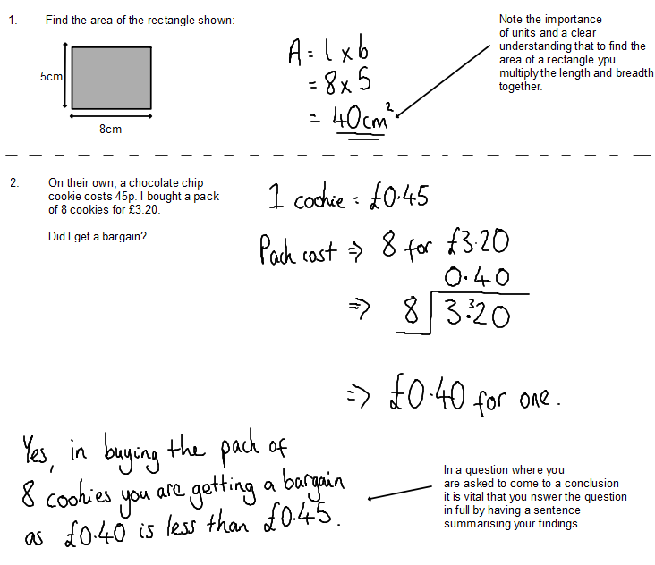

Using AifL Strategies

and

Interactive Learning Strategies

in Mathematics

This section summarises the various Assessment is for Learning (AifL) strategies and provides guidance on how best to use them within a mathematical context. Teachers should exercise their professional judgement as to which strategies are appropriate for their pupils and the content of the lesson they are teaching, and use accordingly.

Using Assessment is for Learning Strategies

The following section provides details on using a number of AifL strategies and how they can be used at the different stages of a mathematics lesson. The strategies include:

Learning Intentions and Success Criteria
- Wait Time
- No Hands Up Rule
- Traffic Lights
- Thumbs Up
- Think, Pair, Share
- Share an Answer with the Group/Class
- Two Stars and a Wish

Learning Intentions and Success Criteria

Teachers must share the learning intentions with the children and young people. The learning intentions can be shared orally, displayed on the classroom wall, interactive whiteboard or written in pupils’ jotters.

Teachers need to separate the task instructions clearly from the learning intention and success criteria. Children/young people need to know clearly what you want them to do and what you want them to learn.

For many lessons where children will be asked to do some independent or group work, rather than engage in discussion, it is more effective to begin with the activity instructions, rather than the learning intention.

Children/young people often need to be captured at the start of the lesson, by the context and the introduction and stimulus. Then the learning intention becomes the last piece of the jigsaw for the children/young people to be able to focus appropriately on the task they have been asked to do.

Clearly, there will be some situations where it makes more sense to start with the learning intention, because that helps make sense of the activity instructions. In many cases, however, the learning intention makes no sense if given too early, before the children/young people have heard the activity context – especially if it is a new area of learning.

The learning intention should be stated in ‘child-speak’ if the children/young people would not understand it in its original form. It is more effective if it is then followed by an invitation to create the success criteria.

After the learning intention has been shared with the children/young people, they can invariably suggest how the teacher – and they themselves – will know that this has been learnt or carried out. They now know the activity and the learning intention, so the success criteria are heavily contextualised.

The purpose of the success criteria is to make children absolutely sure about what is in the teacher’s mind as the criteria for judging their work.

However the importance of inviting children/young people to create the success criteria in this way is that in involves them still further in their own learning. They are being asked, effectively, to link the learning intention with the task instructions. They then have to decide how the two are synthesised to create success criteria – a much more challenging learning experience than simply being given the information. Children/young people have even more of a stake in the learning process if they have been involved in the creation of success criteria and are more likely to be able to be self-evaluative as they are working and questioning the task as it evolves.

Strategies:
- separate the task instructions from the learning intention and success criteria
- state the learning intention, in ‘child-speak’ if necessary
- invite children/young people to create the success criteria
- tell the children/young people why they are learning this – the ‘big picture’
- display the learning intention and success criteria
- read aloud the learning intention and success criteria.

Unlocking Formative Assessment, Shirley Clarke, 2001

East Renfrewshire 3-15 Writing Programme

Example
The learning intention is to plot coordinates on a grid or diagram.
The success criteria are:
- understand the difference between the x-axis and y-axis
- plot the first number horizontally and the second number vertically

Wait Time

The teacher should allow pupils at least five seconds thinking time after asking a question. This allows pupils to think carefully before answering and results in a greater number of pupils offering a more considered response. Wait time can be extended according to the level of difficulty of the question and to meet the pupils’ needs.

No Hands Up Rule

The teacher can use this strategy in conjunction with “Wait Time” to facilitate discussion and encourage listening and participation by more pupils. A set time may be given with “no hands up” to encourage the pupils to think before rushing to respond, thereafter the teacher could ask for a whole class response or select an individual pupil. Use of this strategy avoids the same pupils’ dominating the lesson.

Traffic Lights

Traffic lights are used in a variety of ways:
- to rate existing knowledge
- to show understanding
- to indicate responses to questions
- to ask a question
- to seek clarification
- to raise a point
- to rate achievement
- to create a formative dialogue.

Traffic lights allow learners to respond without calling out. In response situations all children/young people show the card or label their work in the way that most accurately reflects their response.

Red – did not understand and found this difficult.
Amber – understood some of it but still not confident.
Green – understood this and am confident.

Using traffic lights is more challenging and participatory than the conventional hands up approach and provides a diagnostic tool for the adult. Best practice would be for cards to be left flat on the desk so that the child is more confident about displaying their progress to the teacher. This encourages learners to express difficulties while the lesson is in progress. Learners could be asked to:
- focus on one of the success criteria.
- point to the colour which best represents their achievement or feeling about how they are doing at that moment or their understanding of the learning intention / success criteria.

This discrete method of self-assessment indicates where support is needed. Teachers can work with ‘reds’. ‘Greens’ can be paired with ‘ambers’ to provide peer support. ‘Greens’ can be given extension work where appropriate.

Pupils could use this as part of the process of self-evaluating their own learning.

When handing in work for marking pupils could use traffic lighted marking trays as part of self-assessment.

Thumbs Up

The teacher asks the pupils to show their level of understanding by holding their thumbs up (secure), thumbs down (requiring assistance), thumbs horizontal (unsure). This is a simple way of assessing progress. This strategy can also be used to group pupils appropriately.

Think, Pair, Share

Using assessment evidence gathered using “Traffic Lights” or “Thumbs Up”, the teacher can pair or group pupils accordingly, facilitating peer support. This can encourage shy/unconfident pupils to share their views in a less intimidating setting. Allowing time for discussion promotes an active way for children to consolidate the learning for themselves.

Share an Answer with the Group/Class

The purpose of this strategy is to promote group/class discussion. A pupil’s incorrect or correct response can be used by the teacher to facilitate an open discussion with the whole group or class. This strategy works effectively with interactive mental mathematics and the discussion part of problem solving. Written responses could be displayed and explained by the pupil on the board for discussion with the class.

Two Stars and a Wish

The teacher can make two favourable comments (two stars) about the pupil’s work and identify the most important thing they think could be improved (a wish). Equally the pupil’s could be asked to do this themselves (self-assessment) or for each other (peer assessment). This could be used in a variety of ways including classwork, homework and summative assessment.

Assessment is for Learning Strategies in the Mathematics Lesson

The table below indicates the most appropriate AifL strategies to be employed at the different stages of a mathematics lesson:

Lesson Stages: | Assessment is for Learning Strategies:
Interactive Mental Mathematics/  Lesson Starter | Wait Time; No Hands Up; Traffic Lights;  Thumbs Up
Introduction | Share Learning Intentions and Success Criteria; Think, Pair Share
Direct Interactive Teaching and Follow Up | Wait Time; No Hands Up; Traffic Lights;  Think, Pair Share; Thumbs Up; Take a Break; Walk About, Talk About
Plenary | Traffic Lights; Two Stars and a Wish; Thumbs Up;

Using Interactive Learning Strategies

‘To learn something well, it helps to hear it, see it, ask questions about it, and discuss it with others. Above all, students need to ‘do it’ – figure things out by themselves, come up with examples, try out skills, and do assignments that depend on knowledge they already have or must acquire.

When learning is active, students do most of the work. They use their brains…studying ideas, solving problems and applying what they learn.’
Active Learning, Mel Silberman, 1996

This section gives practical strategies for interactive mental maths, problem solving and direct interactive teaching. The activities are designed to encourage active learning with a focus on a range of learning styles and include:

- Battleships  - Beat the Teacher  - Before and After Chart  - Bingo  - Brain Breaks  - Broken Pieces  - Conversion  - Countdown  - Fizz Buzz  - Going for Goal  - Guess What?  - Hide and Seek  - Hot Seating  - Loop Cards  - Memory Board | - Multi-Sensory Memories  - Odd Man Out  - Order Order  - Pass the Buck  - Question/Answer  - Quick Draw  - Quick Fire  - Recap Exercise  - Taboo  - Text Highlighting  - The Directions Game  - The Construction Game  - Verbal Tennis  - Walk about Talk About  - Who wants to be a Millionaire?


Battleships

Children play the battleship game using a coordinate grid and ships. Children play in pairs and guess co-ordinates. This can be extended to involve negative coordinates.

Beat the Teacher

Teacher explains going to complete a calculation or process e.g. solve an equation, and is likely to make some mistakes. The children’s job, working individually, is to spot and make a note of the mistakes. The children pair up, compare results and come up with a joint list. The teacher asks each pair to offer a mistake. To conclude, the teacher’s corrections are written on the board.

Before and After Chart

Children record their prior knowledge about a topic in the ‘before’ web. They complete the ‘after’ web, when the topic is finished. This could be done individually first in jotters, and then as a whole class and displayed on the wall.
Shapes with 4 sides
Square
Rectangle
Rhombus
Parallelogram
Trapezium
Quadrilaterals
Shapes with 4 sides
What I knew before:
Square
Rectangle
Diamond
Kite
What I know now:

Bingo

Play bingo with children choosing eight numbers from 1 to 20 and the teacher (or a pupil) asking appropriate questions. The first pupil to have all eight numbers wins.

For tables bingo, the children choose eight numbers from the multiplication tables and then the teacher (or a pupil) asks questions.

With coordinate bingo, the children mark five coordinates and the teacher (or pupil) calls out coordinates. The first pupil to have all five coordinates wins. This can include negative coordinates and all four quadrants.

Brain Breaks

Brain breaks help children to concentrate and pay attention.

They can:
- either be totally different from classroom learning or linked to it
- involve movement, be fun, linked to social learning or to the enhancement of self-esteem
- last for as long as sixty seconds or as long as five minutes.
- be used to energise the class or to calm it down
- be routine brain breaks or surprise ones.

You can have a brain break menu and the children/young people choose from the selection.

Broken Pieces

Broken pieces is a technique designed to develop problem-solving skills through co-operation governed by a clearly defined set of rules. It is best done in circles but can work with conventional seating arrangements.

Each child/young person is given a piece of information or a responsibility that is essential to complete a group task.

The rules to be followed are:

- do not show or give your information to anyone else
- do not take anyone else’s information
- exchange your contributions by word of mouth only
- only one person in each group is allowed to write anything down
- do not move or leave your seat, except for one person who may be asked to writes notes on a board or flipchart
- from time to time the adult will let you know how long you have left and will remind you of the rules if they are being broken
- apart from this the children/young people organise themselves.

While the groups try to put the pieces together, the adult sits back, watches and probably discovers quite a lot about how the pupils learn to solve the problem they have been set.

Conversion

Ask pupils to take material that is presented in one format and convert it into a different format. For example, turn text into a mind map, flowchart, ranked bullet points and vice versa. Turn a process or convention (solving equations) into a written description.

This technique ensures deep learning takes place and provides children with a core independent learning and revision skill.

Countdown

Like the TV programme, children use numbers to make a chosen total.
http://www.mathsnet.net/puzzles/countdown/countdown.swf

Fizz Buzz

All pupils start off standing up, and take it in turns to say a number in sequence. If the number is a multiple of three, pupils say “fizz” instead of the number. If it is a multiple of seven they say, “buzz”. If pupils hesitate, or make a mistake in the sequence they sit down.

The same idea can be used with other multiples or set of numbers e.g. prime numbers. It could be made easier by only using one set of multiples.

Going for Goal

Divide the class into two teams, with each team appointing a captain. Decide which team will go first. Ask a question, anyone on that team can answer it. If they answer it within five seconds, they retain possession and pass the ball. If the team puts together a string of three passes they score a goal. Once a player has answered a question they cannot answer again until everyone on the team has had a go. The captain and the team monitor who hasn’t taken part. If the question is answered incorrectly it’s a tackle and the possession switches to the other team. If the team is unable to answer the question within five seconds then it is a loose ball. If the opposition can answer within a further five seconds, they take possession. The winning team is the one with the most goals at the end of the session.

The game could be used with revision at the end of a topic, for introducing a topic to see what is already known or to keep skills fresh. One team could ask the questions to the other team. A foul can be introduced for answering when ineligible, for shouting out or arguing with the referee!

Guess What?

This game is perfect for consolidation and revision e.g. shapes. Children/young people work in groups of four, sitting so that group members can easily see and hear each other. Each group has a pack of cards depicting items that should have been learned.

The pack is shuffled and placed face down in the middle of the table. To decide who goes next, group members either take turns or allocate numbers and then use a die. The player whose turn it is picks up the top card and looks at it, taking care not to let anyone else see. The rest of the group ask questions, e.g. about the shape’s properties. The player holding the card can answer only yes or no. If preferred, the number of questions, or the time can be limited. Once the group has successfully identified the item, the turn passes to the next player.

Hide and Seek

This is a basic memory technique, the foundation of many variations. Supply each child with a pack of cards. On one side of the cards the children write the items to be learned, one per card, and on the reverse their meanings or definitions e.g. shapes, averages.

Children lay their cards out on the desk face up. The meanings/definitions are face down. The procedure is: look at the card, give its meaning or definition in their head, and then turn it over to see if correct. If correct the card can be turned over. If wrong the card is left face down.

Hot Seating

Using the strategies above, the teacher identifies a pupil or pupils who indicate secure progress. This pupil or pupils can be invited to sit on the hot seat(s) to answer questions from the remaining pupils. i.e. Children generate questions for the person on the hot seat related to a particular skill. The children asking the question might correct the answer individually or as a group. It may be more appropriate for the teacher to sit on the hot seat.

Loop Cards

The teacher gives out a card to each pupil, on each card is an answer and a follow-up question. One pupil has the start card, they read out the question and the pupil with the answer on their card responds with the answer and the follow-up question. The process continues until every child has read out their answer and question. One pupil has the end card. This can be done against the clock.

For blank loop cards see:
http://www.erc.schools/learnteach/Mathematics/Resources/BlankLoopCards.doc

Memory Board

Write a number of technical terms or specialised vocabulary on the board. Give the children a minute to remember the list. The children have to write out not the terms but the definitions, remembering as many as they can, again in a specified length of time.

The teacher goes over the terms and discusses the different ways in which children have defined them.

Variations include:
- working in pairs rather than on their own
- working in groups and organise their strategy in advance for the successful collaborative completion of the task.
- providing 3 separate one-minute viewings of the terms before the children are allowed to write the definitions, therefore relating the need for revision.

Multi-Sensory Memories

The idea is to bring information or a process alive by using colours, patterns, sound and movement e.g. “live” algebra. Pupils come to the front holding large colourful cards with numbers, operators and letters on. The class has to solve the equation, by using the balancing method, following the same approach as they would with paper and pencil. However, they have to direct the pupils at the front of the class to move in and out of the equation. It is a large, live, collaborative version of the method already shown to them.

The teacher can prompt, assess and alter the difficulty of the challenge set.

Odd Man Out

Give pupils a set of cards and ask them to identify the number or word which does not share the same characteristics as the others and explain their choice. Possible replacements should then be discussed and be written on their sheet. Discussion between pupils during this exercise is very important as there may be more than one answer.

Order Order

In pairs give pupils a copy of a problem e.g. solving an equation, and ask them to read through the attached sheet of labels. The labels are steps which when placed in the correct order will lead to a full solution. The pupils cut out the labels and sort them into the correct order. Appropriate red herring labels can be added to promote discussion. Errors that arise from these can be used in the de-brief session to enable fuller understanding.

Pass the Buck

Pupils work in pairs and have five minutes to begin an answer to a difficult question or problem solving activity. The pupils work on large sheets of paper with felt pens. After the five minutes is up they pass the answer to the pair behind and receive an answer from another pair. Each group now reviews and extends the answer so far. They are encouraged to add to it, cross out bits and improve the answer they have. This continues until the pairs have had time to complete the question or problem. Papers are returned to the original authors who use the contributions to produce a finished version.

The time for drafting answers can be varied, along with the questions that each pair starts with. Alternatively the time can be set so that the first pair complete an answer and the second pair mark it to agreed exam criteria.

Question/Answer

Children/young people supply an answer and the next one thinks up a question for which it could be the answer.

“The answer is four”, children then come up with questions relating to addition, subtraction, multiplication and division.

“The answer is four, what equation is this the answer for? (x + 2 = 6)”

For blank question and answer grids:
http://www.erc.schools/learnteach/Mathematics/L&TMethodology/Appendix%202/appendix2.htm

Quick Draw

The teacher prepares sets of, say, ten questions about a topic, enough for each group in the class. The class is divided into groups of three. Each group is allowed to use resources to help solve the problems. At the word “go” one person from each group runs up and gets the first question from the teacher, and returns to their group. With the help of the resources the group solve the question and write down the answer on a separate bit of paper. The second person in the group takes the answer to the teacher who checks it. If it is correct they then try the second question, if the answer is incorrect or not complete they return to the group to try again. This continues until all the questions are completed, and one group wins.

The ten questions could be steps in a series that leads to the completion of a more difficult problem. This could be done as a race against the clock rather than against the other groups. The questions could be differentiated depending on the groups within the class.

Quick Fire

Oral quick fire questions and answers e.g. table facts, prime numbers, ... etc.

Recap Exercise

Provide each child with 3 post-its. All write down 3 things known about the topic e.g. properties of shapes, remembered facts from the last lesson etc. Use a new post-it and pupil writes a question indicating they require help.
Create post-it displays for existing knowledge, areas for development.

Taboo

The class/group should be divided into two teams, team 1 and team 2. One player from team 1 tries to describe the word on the “taboo” card, without using any of the “taboo” words listed underneath it. A player from team 2 stands alongside them to ensure that they don’t use the “taboo” words. A set time is given for each card, at the end of the time if the team has not guessed the other team is given the opportunity to guess. Points can be allocated by how quickly the team guesses the word.

It is an effective way to assess whether pupils understand terminology or information associated with a topic.

Text Highlighting

This strategy can be used as the first step to problem solving, which is read, think and discuss The aim of this step is for the pupils to read the problem carefully, highlight any areas of uncertainty, seek clarification through discussion, establish the facts and ascertain what it is they have to find out. Pupils should be supplied with a highlighter pen to indicate any vocabulary or phrases they do not understand.
Pupils should be asking themselves:
- What is the problem?
- Do I understand everything?
- What do I know?
- What do I need to find out?

The Directions Game

Get a child to describe as precisely as possible how to move from one point in the classroom to several others to either carry out certain activities or pick up certain objects. The description is written on a piece of card, which is then used by another child to try to follow the same actions exactly. Any points where the directions are inaccurate or ambiguous can be discussed and the written directions altered.

If the directions are written precisely enough it should be possible for a blindfold child to follow them as they are read aloud. Children can try this and discuss the kind of precision they need to include when giving directions.

The Construction Game

Two sets of materials are needed e.g. lego or shapes. One child arranges the set of materials in a certain way. Without the other seeing, a child has to write a description of the arrangement. The materials are then hidden from view.

The description is given to the other child who has to try to arrange the second set of materials into exactly the pattern described. When the second child is satisfied the description has been followed, the first set of materials is uncovered, and both sets compared. If there are any discrepancies, both children rewrite the description to make it more accurate.

This activity can be used to develop children’s positional language and the idea of patterns. It could be extended to include ideas on symmetry.

Verbal Tennis

Children sit facing each other in pairs. The teacher decides the rule e.g. count up in sixes. The server begins with a number, the partner immediately gives the second number, the server gives a third and so on backwards and forward in rapid succession.

The scoring follows the rules of tennis. If a child hesitates, or gets stuck or gives an inaccurate contribution, their partner gains a point.

The activity is ideal for revision and makes a perfect lesson starter to tune into the learning.

It could also be done as a whole class or team activity.

Walk about Talk about

The class is divided into groups of three/four. Each group has a coloured marker and a large sheet of paper with a heading or topic marked on the top of the paper. Each group has a different topic. Each group has three minutes to discuss the topic heading and add as many statements to their sheet of paper as they can agree on. When the time is up, they move round to the next sheet of paper taking their marker with them. They then review what the last group(s) have written, adding a tick to statements they agree with and a cross to those they don’t. Pupils then add new statements to the list. They continue to move round all the topics. At the end of the session, pupils can discuss some of the statements and explain why they agreed/disagreed.

This is an effective strategy for introducing/summarising/revising a topic and provides pupils with a strategy they can use in their own study. It could be used with longer exam questions with the pupils writing “model” answers.

Who wants to be a Millionaire?

Who wants to be a Millionaire? lends itself to any area of the curriculum. Merit points can replace cash prizes. One child/young person participates but the others listen closely in case there is a need to phone a friend.

This strategy should help pupils reasoning and evaluation skills, promote discussion and encourage full and clear working.

