Physical Education – BGE Tracking and assessment framework

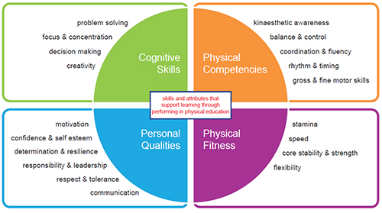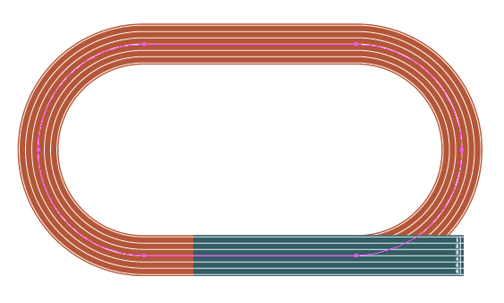Name: Class: Teacher:

4A

4W

4M

3A

2M

2W

2A

3M

3W

4A

4W

4M

3A

2W

2A

3M

3W

4W

4M

3A

2M

2W

2A

3M

3W

3A

2W

2A

3M

4A

4W

4M

3W

2M

4A

2M

Social & Emotional

Physical Fitness

Physical Skills

Mental & Physical Tactics

Fitness Test Results

Cooper Test - Record of Results

|  |  |  |  |  |  |
| --- | --- | --- | --- | --- | --- |
| S1 | | S2 | | S3 | |
| August | April | August | April | August | April |
|  |  |  |  |  |  |

National Averages **Boys**  **Girls**

|  |  |  |  |  |  |  |  |
| --- | --- | --- | --- | --- | --- | --- | --- |
| Year | Above Average | Average | Below Average | Year | Above Average | Average | Below Average |
| **S1** | <2300m | 2100- 2299m | >2100m | **S1** | <1800m | 1500-1799m | >1500m |
| **S2** | <2400m | 2200-2399m | >2200m | **S2** | <1900m | 1600- 1899m | >1600m |
| **S3** | <2500m | 2300-2499m | >2300m | **S3** | <2000m | 1700- 1999m | >1700m |

Co-ordination Test

|  |  |  |  |  |  |
| --- | --- | --- | --- | --- | --- |
| S1 | | S2 | | S3 | |
| August | April | August | April | August | April |
|  |  |  |  |  |  |