 ***Woodfarm High School***

***PE Department***

***Broad General Education***

***Health and Wellbeing Evidence***.

***Pupil Name……………………………………………..***

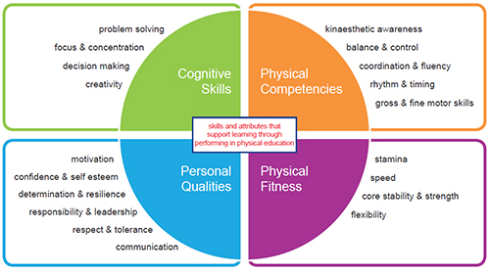

In DANCE you will:

* Learn how to put together simple motifs (dance parts) to make a whole dance sequence.
* Learn how to observe a partner and compare their performance to criteria needed for that dance sequence to be successful.
* Compare your observed performance to a ‘model performance’ of that sequence to identify parts of the sequence which can be improved.
* Work with a partner to develop an 8 count sequence to be added to the group dance.

Describe your sequence: _________________________

Dance sequence checklist (Peer Assessment)

(SAoL – Communication, creativity and rhythm and timing)

|  |  |  |
| --- | --- | --- |
| Criteria | Yes | No |
| My partner observed that I link the movements smoothly |  |  |
| My partner observed that I move in time to the music. |  |  |
| My partner observed that I remember the whole sequence. |  |  |

My strengths in this sequence are _______________

I know I need to work on __________

In BADMINTON you will:

Develop the skills to enable you to play a game against other members of the class.

(SAoL – gross and fine motor skills, coordination and fluency and balance and control)

Complete a checklist to show the skills you are making progress with (new to you) making good progress with (needing some more practice in, but making fewer mistakes with) or can achieve (having most success with).

|  |  |  |  |
| --- | --- | --- | --- |
|  | Achieved | Progressing well | Making progress |
| Always | Sometimes | Rarely |
| I can move around the court keeping my balance |  |  |  |
| I can return to base position after hitting each shot |  |  |  |
| I can serve consistently |  |  |  |
| I can play an overhead clear to the back of my opponent’s court while playing a game |  |  |  |
| I can get the shuttle before it hits the floor. |  |  |  |

Badminton checklist (Self-assessment)

Look at your results and answer the following questions.

My strengths in badminton are, I can __________________________________________________________

______________________________________________________________________________________

______________________________________________________________________________________

The areas I need to work on in badminton are:

______________________________________________________________________________________

______________________________________________________________________________________

In TEAM GAMES (Football, Volleyball, Basketball, Netball & Hockey) you will:

* Develop the skills that will allow you to participate effectively in team games Develop communication and interpersonal skills that will allow you to contribute in team discussions
* Learn how to officiate a game where you will keep the score and help the game to be played fairly.
* (SAoL – responsibility and leadership, respect and tolerance)

During your PE lessons you will have many opportunities to OFFICIATE (take control of) certain activities. You might need to:

* 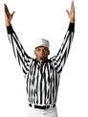Blow the whistle when the ball goes out of play
* Keep the score
* Blow the whistle when someone fouls
* Blow the whistle when someone foot-faults
* Record scores

Officiating Checklist (TEAM GAMES)

I can: *Understand the rules and apply them while participating or officiating*

Please complete the officiating checklist by identifying the roles you carried out and the responsibilities (duties) that you had to perform

|  |  |  |  |
| --- | --- | --- | --- |
| Activity | Role – umpire, referee, timekeeper | Date | Responsibilities - |
| *Example:*  *Basketball* | *Timekeeper* | *25/12/16* | *Keep track of the time during a game. Blow whistle when 3 mins has passed* |
|  |  |  |  |
|  |  |  |  |