Maths
Information
for
Parents
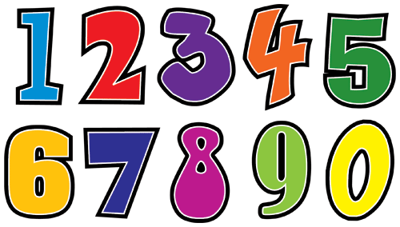



Uplawmoor Primary School
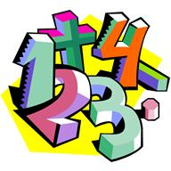
Mental Maths

There are three main aspects of mental maths:

- Quick recall of facts – recognising numerals, remembering facts such as the names of common shapes and recognising different coins.

- Mental calculations – developing efficient techniques to make mental calculations such as adding on 1 to a range of numbers, using calculation skills to work out where numbers go on a number line. This also includes doubling small numbers and knowing answers to simple addition and subtractions calculations.

- Mental problem solving – this includes word problems and problems where the operation is not immediately obvious.

Maths lessons are preceded by daily mental maths sessions. Mental maths sessions provide opportunities for pupils to articulate their mathematical thinking, practise skills, discuss alternative mental methods and be shown how to use a range of approaches.

Mental maths sessions are fun and interactive using various activities, lively questioning and illustrations.

You can help your child develop essential mental maths skills by introducing a few simple activities at home, as you walk to school or as you travel in the car. The activities mentioned here relate closely to mental calculations and problem solving.
Primary 1 Number Skills

Sequence of numbers

- Counting forwards and back beyond 20
- Counting on from one number to another
- Counting back from one number to another
- Counting on and back in 1’s and 2’s to at least 10
- Counting in 10’s to 100

Counting items

- Quickly recognise small quantities without counting
- Counting real objects
- Counting pictures
- Counting things they cannot touch
- Counting sounds (claps etc)
- Counting physical actions and movements

Numerals

- Writing numbers to at least 10
- Ordering numbers to 20
- Matching quantity and numerals
- Recognising some number words

Calculations

- Counting on within 10
- Counting back within 10
- Knowing doubles to 10
- Knowing one more than and one less than to and beyond 20
Activities

Here is a list of some of the activities that you can do at home with your child to help practise mental maths skills.

- Singing number songs and rhymes





- Ordering numbers written on cards

- Matching numerals to number names

- Ask your child to close his / her eyes and count your claps

- Counting forward and back from 0 – 5, 0 – 10, 0 – 20.

- Ask “What is the number after 7, before 3…….? and so on

- Counting on and back within 20 starting with a number greater than 0

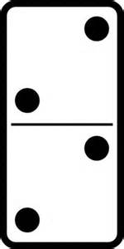
- Number doubles using dominoes or dice. What is double 3? Double 2? etc

- Choose a number between 1 – 10 and ask your child t say something about that number e.g. “Tell me about 6.” It is one more than 5, six is 7 take away 1 etc

- Add mentally by putting the big number in your head and the small number in your hand, and count on

- Tell me two numbers that add to make 4, 5, 6 etc

- The answer is 10. What is the question? Use numbers 0 - 20

