East Renfrewshire: Primary Music Programme
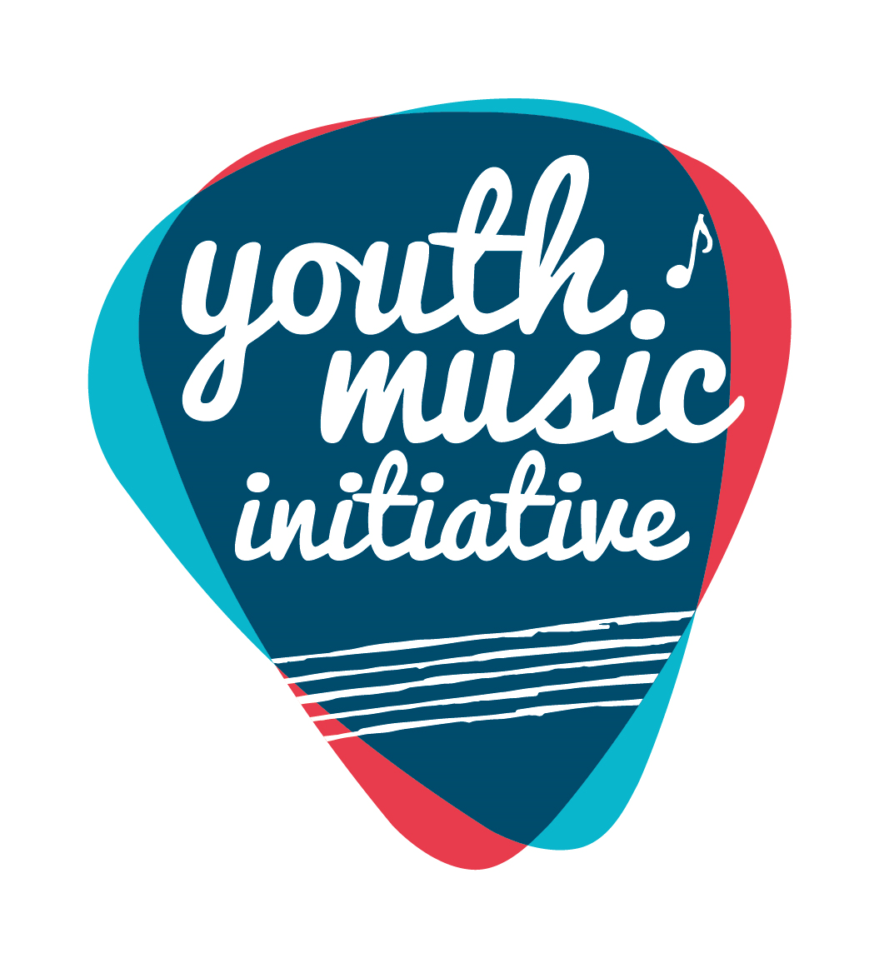
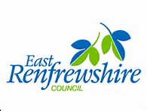

The Primary Music Programme has been running in East Renfrewshire for the past 11 years and is funded by Creative Scotland’s ‘Youth Music Initiative’. The Primary Music team have written courses for each stage of the primary school and are currently working closely with P4, P5 and P6 classes. Each of the 23 primary schools in East Renfrewshire is visited by primary music specialists. This includes Isobel Mair school, where we aim to support the teaching and learning of music for pupils with additional support needs. East Renfrewshire’s Primary Music team were involved in the Youth Music evaluation in 2015 and the case study report can be found at www.creativescotland.com

The courses are mostly musicianship based with lots of singing and playing songs and games. Classes work on various aspects of music such as rhythm, pitch and reading notes from the stave. Our courses use the Kodaly singing names and hand signs (do re mi fa so la ti do’) and the rhythm names (ta, tete, tiri tiri etc). We also link closely with NYCoS and all schools have the song books ‘Singing Games and Rhymes for Early/Middle Years’.
Another area of the courses is ‘listening’ where classes will listen to music such as ‘Peter and the Wolf’, ‘Carnival of the Animals’ ‘Tam O’ Shanter’ etc. This enables classes to focus their listening on instruments of the orchestra and learn musical concepts.
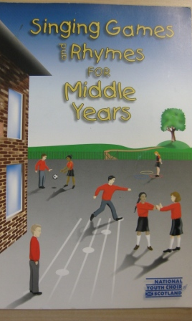
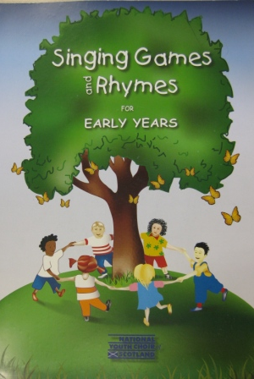
Classes also work on ‘inventing/composing’ music where they make up rhythms and melodies and are able to perform these on classroom percussion instruments.
Zoltán Kodály (1882 –1967) was a Hungarian composer and music educator who is best remembered internationally for his development of the Kodály method of teaching music.
“Very simply, the Kodály Concept could be summed up as the practice and belief in musicianship development through singing. Kodály educators believe that the learning process should start as early as possible through the learning and singing of unaccompanied songs and good art material. Music is for everyone is a fundamental belief …”

For more information on our Primary Music Programme, please contact Donald Finlayson on 0141 577 3835.

