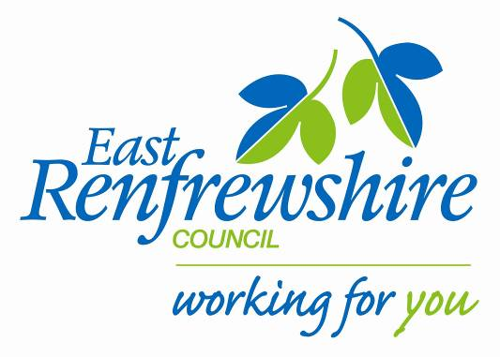
Education

Director: Mhairi Shaw, DCE
Council Headquarters,
211 Main Street,
Barrhead,
East Renfrewshire G78 1SY

Marie Baxter
Active School Coordinator (Woodfarm Cluster)
C/o Thornliebank Primary, Main Street
Thornliebank, East Renfrewshire, G46 7RW
Mob: 07800 629 690
E-mail: baxterm1@ea.e-renfrew.sch.uk

Dear Parent/Guardian,

Your child has the opportunity to attend a NEW P4 Tennis Club at Giffnock Tennis Club, 4 Percy Drive, G46. The details of the club are as follows:

Activity: P4 Tennis Club
Venue: Giffnock Tennis Club, 4 Percy Drive, G46
Day: Thursday
Dates: 7th, 14th, 21st, 28th May.
Time: 3.30 – 4.30pm
Cost: £4 per block

This is not a school provision and parents will have sole responsibility for dropping off and collecting their children from each session. Children must bring a filled water bottle and wear appropriate clothing (tracksuit bottoms, jumper, gym shoes and a waterproof jacket).

Places are limited. In the event of the club being oversubscribed, names will be drawn at random and children will be notified if they have a place. Please do not include any money until you have received notification of a place.

If your child is interested in attending, please complete and return the form below to the school office by Friday 24th April 2015. The forms will then be drawn and the relevant children will receive a consent form to complete.

Yours Sincerely,

Marie Baxter

Marie Baxter
Active School Coordinator
Woodfarm Cluster
-------------------------------------------------------------------
P4 Tennis: Giffnock Tennis Club

My child is interested in attending the Tennis club @ Giffnock Tennis Club.

Name……………………………………………Class…………………………………………………………………….

