**Going Bananas for Fair Trade**

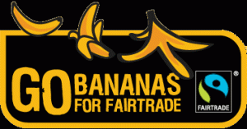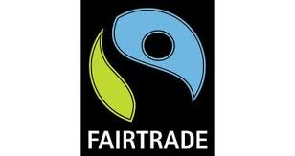

At Thornliebank we believe learning about Fair Trade is an ideal opportunity for children to find out about the world they live in. Through Fair Trade events the pupils can contribute to making the world a fairer place and be part of something that’s happening all over the country and around the world. Throughout the year the Fairtrade Committee works hard to raise awareness of Fair Trade by organising various events and activities. They meet several times throughout each term to monitor progress, share their ideas and make future plans.

Annually, the children participate in Fairtrade Fortnight where they are taught about the importance of Fair Trade and how it can help farmers who are struggling across the world. During this time the children organise a Fair Trade stall, attend Fair Trade assemblies and take part in Fair Trade themed lessons and activities.

This Fairtrade Fortnight we’re going bananas! Although one in three bananas sold in British shops is Fairtrade, there’s still a long way to go. During this Fairtrade Fortnight (24 February – 9March 2014) we’re hoping to celebrate bananas and focus on other changes that are needed so that millions of banana growers can get a fairer deal for their hard work. We are hoping to set up a banana stall at school to explain why taking action to make bananas fair is so important. Our aim is to get as many staff and parents as possible to sign a petition that the Fairtrade Foundation is organising.

On Wednesday 26th February we are also organising another Fairtrade stall selling pocket money toys, stationary and chocolate. Your child will be given the opportunity to come to the stall during the school day with their teacher. The products range from 50p - £2. We will stay open till 3.30 and would be delighted if you could come along with your child to browse and sign our banana petition.

It doesn’t stop there! On Thursday 28th February the Fairtrade Committee are organising a ‘Fairtrade Fruit Day’. We are encouraging everyone to bring in a piece of Fairtrade fruit to eat as a snack during playtime. The Fairtrade Committee will complete a survey of Fairtrade fruit and at the end of the day the class that has brought in the most Fairtrade fruit will receive stickers and a certificate. Please help your child to support the work of the Fairtrade Committee by giving them some Fairtrade fruit to bring in. Examples of Fairtrade fruit are: bananas, raisins, mangos, oranges and apples.

**Finally** on Friday 7th March the Fairtrade Committee will be leading an assembly about Fairtrade. To celebrate the end of what we hope will be a very informative and enjoyable fortnight we ask all pupils to dress in Fairtrade colours; blue, green or black.

Many thanks in advance for your support.

The Fairtrade Committee