**Dyslexia Scotland 01786 446650**

[**www.dyslexiascotland.org.uk**](mailto:helpline@dyslexiascotland.org.uk)

**Helpline phone number: 0844 800 84 84**

**helpline@dyslexiascotland.org.uk**

Dyslexia Scotland is a company registered by guarantee. Registered in Scotland No 153321 Charity No SCO 00951

**‘A GUIDE TO STUDY’**

**By Emma Gordon from Barrhead High School**

**Tuesday 4th February 2014,**

**7.15pm-8.15pm**

**Mearns Castle High School, Newton Mearns G77 5GU**

[**http://www.dyslexiascotland.org.uk/your-branch/glasgow-east-ren**](http://www.dyslexiascotland.org.uk/your-branch/glasgow-east-ren)

**Parents and Pupils**

**Are welcome to our**

**OPEN MEETING**

**Our New Email Address is dyslexiascotland.er@gmail.com**

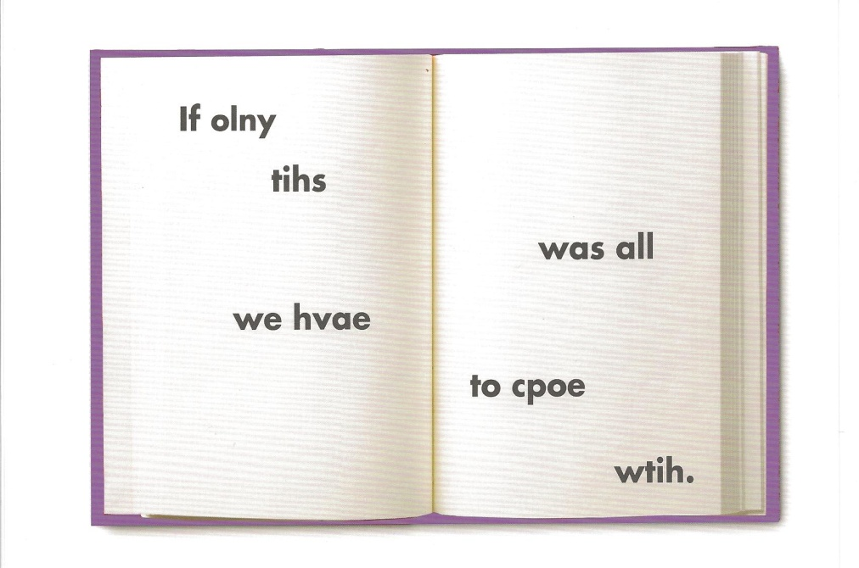

**Dyslexia Scotland Glasgow East Ren**

