

In this guide you will find information you can share with your child and a variety of activities you may or may not know already.

Together with weekly teaching tasks these ideas can be used to try and break up any rainy days or times you may be stuck inside.

Community Family Activity Guide

2020

Dear Parent/Carer,

As we find ourselves in ever changing times, this document has been created to help families in supporting ideas and activities for periods of time spent at home.

The information and ideas are suggestions, some you may already be familiar with, or new, our hope is that this document, together with online learning tasks and regular updates, will help support routines and activities at home. Every child has their own glow log in and passwords, they have access to a variety of online accounts. Daily tasks are set for children on google classrooms.

The website has a home learning page ‘Remote Learning’ for the school and family centre with a range of resources and activities for you to pick and choose from as part of sustaining your child’s learning journey.

In this guide you will also see suggestions on how to support discussions on the current situation surrounding the Corona Virus, we have included various ideas around this including a simple story example which you may wish to use.

You can continue to contact the school via email at:

[schoolmail@st-thomas.e-renfrew.sch.uk](mailto:schoolmail@st-thomas.e-renfrew.sch.uk)

We along with our teams will endeavor to continue to provide support and care, underpinned by our school community values as best we can during this time.

May we take this opportunity to thank you for your understanding and support and hope that you and your families stay safe and well during this time.

Kind regards,

Ian Gillies

Head Teacher

**Helping children and young people manage in unsettling times**

The Coronavirus outbreak has led to a high degree of worry, uncertainty and concern. The spread of the disease and its implications for everyday life has been very present in the news, and in daily conversation. Some young people may already have had their lives disrupted.

During these times both children and adults can potentially feel anxious and unsure about their safety. School staff and parents/carers can help provide opportunities where feelings can be discussed within a safe context, at the same time as maintaining a sense of normality, routine and calm. Supporting children will enable them to process and manage their feelings and help build resilience.

You may find the following suggestions helpful (some of these are adapted from advice shared by the Chinese International School in Hong Kong):

* **Reassure children and young people that they are safe:** Children benefit from regular reassurance that they are safe, and being reminded that adults will do what they can to keep them safe.
* **Let children know that it is alright to be upset**: Reassure children all feelings are OK.
* **Maintain a normal routine**: In school, this is more straightforward. **If** advice changes about school closures, or if children need to be at home because of self-isolation, try to set up a work/leisure/exercise routine there. Many parents will be maintaining their own work from home, so the abundance of useful activities being shared on social media might offer support. Lots of these resources are being shared freely and widely by groups of parents who already home educate. They can be found by doing an internet search too. Some of the materials are split into school stage categories, and there will be opportunities for independent learning, depending on the age and stage of your child.
* **Emphasise their resilience and strengths**: Focus on the strengths of our children and young people, in terms of their daily life. Help them to see and acknowledge that they have many strengths to help them cope if they are feeling anxious or upset. As above, communication can be used as a key strength by us all just now.
* **Look for opportunities to help others:** Acts of kindness, charity and humanity help to restore positivity about the world. We all know this phrase by now:



**Helping children and young people manage in unsettling times**

* **Provide opportunities for children to be honest about their feelings**: Sharing worries or feelings of upset with teachers or family members can help to reduce a sense of vulnerability and isolation, and it can raise optimism and self-esteem. Checking in with children and young people to see if they have any worries can help them start these conversations. Take cues from the child – invite them to share what they have heard and how they feel. The crucial thing is, if you can, make extra time to listen to what children need to tell you.
* **Try to help children and young people separate fact from fiction:** The information being shared about coronavirus is plentiful, and changes rapidly, and, as adults, it can be hard to know what is evidence-based, and what is speculation. Children and young people are naturally curious and even more so if they are worried. It is the adults’ job, as far as possible, to separate fact from fiction. Try to answer their questions rather than volunteering too much information as this might be a little overwhelming.  It is of course okay to let children know if you’re unsure of the answer; even though we don’t know the answers to everything now, let them know that you will keep them informed. Consider limiting news and social media exposure.

Being available is what matters most.  Attached is a social story (copyright permission granted) which might be useful for helping to explain some of the current changes.

* **Provide opportunities for physical exercise:** Exercise can be a valuable way of developing natural chemicals in the brain to help us cope with difficult emotions like shock and anxiety.
* **Continue to keep in contact with family and friends:** Let children know it is still okay and important to have fun and to plan nice things to do together taking account of any restrictions in place. Use technology as a way of keeping in touch.
* **Communicate any concerns with school:** If parents/carers have any concerns about their child coping with the current situation, please do let the school know.
* **It is important to look after yourself too**: A time of stress can mean less energy and more potential for illness for you, as well as others. If you’re feeling anxious or worried, it probably isn’t the right time to answer your child’s concerns. So please take care of yourself.

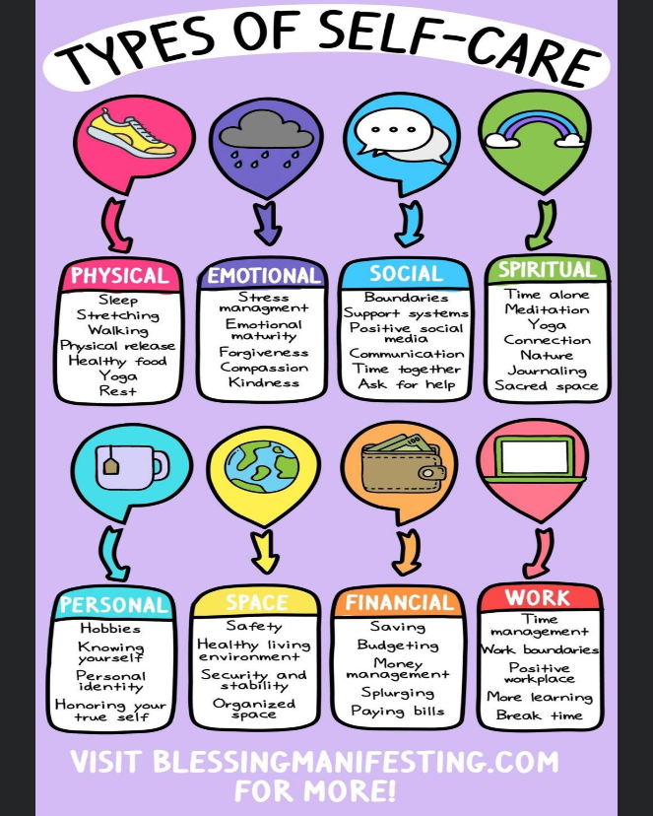

**Guidance for parents and carers in the event of school closure due to Coronavirus**

Your child will be learning from your response to the current situation. Seeing you staying calm and resilient will be crucial to helping them cope with the circumstances.

It is very important to maintain structure and routine for your child whilst schools are closed. The following 10 tips may help you to maintain your child’s health and well-being.

1. Set times for getting up and going to bed for your child.
2. Have regular times for meals.
3. Build in time for fresh air and exercise as far as this is possible.
4. Structure your child’s day so that they have a variety of activities and break times.
5. Create a menu of activities that your child can do during the day.
6. Make a daily plan of activities and share these with your child the night before so that you and your child know what is happening the next day.
7. Review the day’s activities and talk about what they have done. A sense of accomplishment is important for children and young people.
8. Make Monday to Friday different from the weekend by structuring the activities along the same timings as a normal school day.
9. Decide when and for how long your child will have access to electronic devices and for what purpose.
10. Maintain contact with friends and family through technology.

**Remember that your child will be learning from your response to handling this situation. Seeing you staying calm and resilient will be crucial to helping them cope with the circumstances.**

**A sample story for children**

|  |  |  |
| --- | --- | --- |
|  |  |  |
|  |  |  |
|  |  |  |

Suggestions and ideas for families

1. Balancing Beam –co ordination

**What You Will Need**

* Coloured tape
* Flat floor space to play

**How to Play**

* Stick different coloured tapes tape on the floor
* Each coloured tape can have a different rule to walk on. For example, you can ask your child to walk on one leg on the red coloured tape
* The child has to walk only on the tape. If he falls off the tape, he’ll be out of the game.
* The child that walks the entire length of the tape without falling off the tape wins the game

**Suggestion**

Make the game interesting by changing the rules

2. Pitching Pennies - This game will help in building your child’s hand-eye coordination.

**What You Will Need**

* Pennies or currency coins
* Large sized paper or plastic drinking cups

**How to Play**

* Place the cup on a chair on the table in front of the family
* Give each child 5 coins each
* You can ask the child to take a few steps away from the cup in accordance with his age
* Explain to your child that he has to toss the coins, one at a time, into the cup
* The person with the most coins in the cup wins

**Suggestion**

You can use marbles or ping pong balls in place of pennies to play this game.

3. Indoor Bowling

Create a simple bowling alley in your house and have fun. This game is also ideal for hand-eye coordination in children.

**What You Will Need**

* Flat floor space to play
* Ten empty bottles or plastic bottles or light things that knock over but not break easily!
* Plastic ball or a tennis ball
* Tape
* Marker

**How to Play**

* Using the tape, create a bowling lane
* Peel off the wrappers of the cans and the bottles – you could even decorate for fun.
* Arrange the bottles at the end of the lane. You may arrange it like bowling pins or stack them on top of each other to form a pyramid
* Ask the child to strike this arrangement using the ball

4. In and Out Hangman

This game can be engaging for young children and may even be a fun way to learn.

**What You Will Need**

* White or blackboard
* Marker or chalk
* Set of questions and answers or words and hints

**How to Play**

Ask your child a question and on the board draw tiny blanks to correlate with the number of letters in the answer. Allow enough space between two words to make it easier for the child to guess the answer

* Instruct your child to guess one letter in the answer and one letter that isn’t in it alternatively.
* Your child is allowed seven wrong guesses, which is the number of steps it takes to complete a hangman figure

**Suggestion**

You can make the game exciting for your child by asking about his favourite toys, movies, etc.

5. Pictionary

Pictionary is a fun game that requires one player to draw an image indicating the word, where the other player has to guess it correctly.

**What You Will Need**

Paper or board

Pencil or marker

**How to Play**

* Write down different words on pieces of paper and drop them in the bowl
* Ask your child to pick up the pieces and draw it on the board without telling you what it is. Alternately, you can draw, and he can guess

**Suggestion**

You can make this game more fun by having groups and competing against each other.

6. Sock Toss

Using some folded up socks and a bucket, you can enjoy a game of mini basketball right at home.

**What You Will Need**

Space to play

* Socks
* Bucket

**How to Play**

* Roll up the socks into little balls and tie them
* Place the bucket in one place and ask your child to move a few steps away from it
* You can then take turns to throw the sock balls into the bucket. Move further away from the bucket after each turn

**Suggestion** It can be made challenging for older children by using buckets with a narrower opening.

7. Indoor Obstacle Course

You can build an obstacle course around child-proofed areas; this is a fun option for children of various ages.

**Suggestions**

* Chairs
* Blankets
* Exercise ball
* Hula hoops
* Anything else that may be useful

**How to Play**

* Set up the course as space permits and as you would like it and make the rules
* Each obstacle may require a different way to cross through it. For example, ask your child to pass from under a chair or pass through the blanket tunnel twice before he could move on to the next obstacle.
* He will be given a point only after successfully completing each obstacle

**Suggestion**

Child-proof the area before setting up an obstacle course to avoid any injuries.

8. Follow the leader

If you have several children at home, this activity can be great fun and is one of the easiest ways to get the children to follow what you are doing.

**What You Will Need**

* A list of simple activities
* Space to play

**How to Play**

* Select different themes for the game. It could be physical activity, gestures, or expressions
* You can be the leader or give each child a chance to be the leader
* All the players will have to mimic what the leader does, jumping, dancing, laughing, etc

**Suggestion**

This game can be the perfect excuse to squeeze in some exercise when children are bound inside the house.

9. Puzzles

Give your child access to various puzzles that can be both engaging and educational.

**What You Will Need**

Different kinds of a picture or word puzzles

**How to Play**

Explain to your child that he needs to set the pieces of the puzzle together to form a picture in case of a picture puzzle

If you have younger children, you can try some 3D puzzles toys

Words puzzles are excellent for older children in order to improve their vocabulary

**Suggestion**

Keep some puzzle books handy at home that can be given to your child when you cannot get out.

10. Card games

Simple [card games](https://parenting.firstcry.com/articles/10-fun-and-easy-card-games-for-kids/?ref=interlink) are great for children in order to mould their logical reasoning and colour and number identification.

**What You Will Need**

* A deck of cards or two

**How to Play**

* You can play simple children card games like spoons, trash, cards, memory card (needs two decks), crazy eights (where you need to get rid of all your cards), etc.
* Go fish is a simple card game that is ideal for pre-schoolers.

**Suggestion**

You can always opt for Uno, which can be a fun alternative.

11. Building a Fort

Although not necessarily a game, it can keep your child engaged and occupied.

**What You Will Need**

* Pillows
* Chairs
* Cardboard boxes
* Blankets
* Anything else in the house that can be used

**How to Play**

* To make a cardboard fort, you can simply stack up a few cardboard boxes together and stick them with tape
* Stack up pillows on two sides with a gap between them and throw a blanket over for a simple pillow fort
* A few sticks and a blanket can help you build a tepee tent
* Simply cover a table or a couple of chairs with a blanket, and you’ll have a small fort. You could also fold up the blanket on one side and call it an entrance

**Suggestion**

You can build a fort with pillows, cardboard boxes, and blankets with your children.

Try reading with a torch inside your den!

12. Dominoes

Stacking dominoes and watching them fall in quick succession can be enjoyable for people across ages. It can also give your child something to do for an entire day.

**What You Will Need**

* Dominoes game set

**How to Play**

* Stack the dominoes in the pattern and arrangement that your child prefers. You can help your child with this.
* Once all the pieces are set, you can ask your child to flip the first piece and watch as the rest follow suit.

**Suggestion**

Try different patterns and capture the entire thing on video for a memory that will last.

13. Read

Getting your child into the habit of [reading](https://parenting.firstcry.com/articles/15-interesting-reading-games-and-activities-for-children/?ref=interlink) is a great way to keep him occupied on most days.

**What You Will Need**

* Books

**How to Play**

* Pick up a book with pictures and read with your child

**Suggestion**

Get your child a new book each time to captivate his attention.

Try funny new titles

Put on character voices

Make up different endings

Record you both reading your story to share with a relative

Make characters from the story using paper then stick on spoons to make your own puppet show

Watch our Giffnock Story Time recordings online by staff

Try ERC 24 hour library all parents can log on at <https://www.ercultureandleisure.org/ebooks>

14. Musical statues



**What You Will Need**

* Music
* Space to play

**How to Play**

* Play the music and dance till the music stops and

ask everyone to freeze in the position they were in.

**Suggestion**

You can even ask the children to pose in specific postures to make the game challenging.

Research famous statues and landmarks, where would you like visit?

15. Paper Bag Skits

This creative game is ideal for imaginative story telling with your child on their own or with family

**What You Will Need**

* Paper bags filled with small props like spoons, jewellery, ball, sock, etc.

**How to Play**

* Make a bag filled with different props
* Tell them to create a small skit using the props they have received
* After 15 minutes, allow each family member enough time to showcase what they have planned

**Suggestion**

This game can be made more creative with elaborate props.

16. Hide and seek

With some space inside the house, you can play this for hours.

**What You Will Need**

* Space to play inside the house

**How to Play**

* Ask one child to close his eyes and count till 20 until the rest of them hide in different places
* Once the seeker is done with counting, he will have to go to find others
* The first person to be caught has to count the next time when the others hide again

**Suggestion**

You can take the game up a notch by playing it in the dark. Ensure to child-proof the house before doing so.

17. Treasure Hunt

With a simple yet fun treasure hunt game, you can give your child the chance to learn and utilise his cognition.

**What You Will Need**

* Hints and clues at each hidden location
* Coins or treats

**How to Play**

* Hide treats or coins in various places like under the bed or in cereal boxes along with clues to the next location, creating a trail
* Give your child a hint to where the first clue is and let him find the rest on his own

**Suggestion**

**Make up clues as rhymes together… “You’ll find me hidden in where you make the tea, I’m beside the tins and coffee” etc**

18. Hot Potato

This indoor game is ideal for a family group.

**What You Will Need**

* A potato or a ball

**How to Play**

* Make them sit in a circle and pass the potato to each other
* Play music
* Stop the music, and the person with the potato is out. The last one to remain wins

**Suggestion**

You can play this game with any prop like a ball or a toy.

19. The Listening Game

This game can engage your child’s senses and help him improve his [listening skills](https://parenting.firstcry.com/articles/listening-activities-games-and-exercises-for-kids/?ref=interlink).

**What You Will Need**

* Several objects like toys, combs, salt shakers, spoon, etc.

**How to Play**

* Place the objects before the child and let him observe
* Now have your child close his eyes
* One by one, use individual objects to create a sound and have your child guess what object it was

20. Simon Says

Simon says is a classic game that can be enjoyed by all the members of the family.

**What You Will Need**

* Space to play

**How to Play**

* Instruct your children that they are to do what you say only if you start the command with the phrase ‘Simon says…’
* If you say anything without saying the phrase, they aren’t supposed to do it. If they do, they will be out of the game.
* The last person to follow all the commands accurately wins and gets to become the next Simon.

**Suggestion**

Make the game more challenging by tricking the children by saying instructions quickly or in silly voices!

21. Touch and Feel Box

This entertaining game can be a good learning experience and teach the children to identify the object by touch alone.

**What You Will Need**

* Shoe box
* Different objects

**How to Play**

* Cut out a hole in the shoe box big enough for the child to fit his hand inside.
* Place different items in the box and ask your child to identify them by touch alone.

**Suggestion**

Make the game fun by adding objects of varying textures.

22. Playdough

Give your child some [playdough](https://parenting.firstcry.com/articles/10-creative-clay-craft-ideas-for-kids/?ref=interlink), and you can see his creativity unfold.

Or try the website below – we dare you not to laugh

<https://www.youtube.com/watch?v=i-IfzeG1aC4>

<https://www.youtube.com/watch?v=1JaF0mjG4e8>

**What You Will Need**

* Playdough

**How to Play**

* Set your child at a table or in his room with play dough and ask him to create anything that he likes

**Suggestion**

You can also give him names of specific objects and ask him to mould them to improve his cognitive skills.

23. Cooking

If your child shows interest in the kitchen, this can be the perfect game for him/her.

**What You Will Need**

* Simple utensils or a cooking set

**How to Play**

* Give your children access to a few utensils, and you can watch as their imaginary cooking skills unfold
* You can also place orders for them to prepare
* Support your child in planning and preparing lunches or evening meals for the family (lots of counting, weighing , pouring and measuring etc

24. Family Photo Game

This game can improve your child’s [memory](https://parenting.firstcry.com/articles/15-amazing-memory-games-for-kids/?ref=interlink).

**What You Will Need**

* 10 or more family photos

**How to Play**

* Arrange the photos in front of your child
* Call out the name of the family member and your child should be able to identify them in the photo and point them out
* You can also name the location and with for your child to point out

**Suggestion**

You can play this game with pictures of other places and objects as well.

25. Child Yoga

Yoga is a great activity to enhance flexibility in your children.

**What You Will Need**

* Flashcards with pictures of the postures
* Yoga mat or a carpet

**How to Play**

* Teach your child simple yoga poses and encourage him to do it when you name it
* You can use flashcards with the names and pictures of the postures to help your child remember

**Suggestion**

Make the activity more engaging by teaching your children animal poses and playing songs during the activity.

Some websites you could try

<https://www.youtube.com/watch?v=YKmRB2Z3g2s>

For older children try <https://www.youtube.com/watch?v=Td6zFtZPkJ4>

26. Balloon Ball

This game also improves a child’s hand-eye coordination.

**What You Will Need**

* Balloons

**How to Play**

* Blow up some balloons and play throw and catch with your child.
* You can also challenge your child to gently tap the balloon against the ground to keep it in the air.

**Suggestion**

This game can be challenging with more than one balloon of different colours.

27. Home Band

Create a musical instrument with simple things from around the house and encourage your child to play.

**What You Will Need**

* Buckets
* Shakers made of a plastic bottle with beans or coins
* Any other utensil or container that can be used

**How to Play**

* Provide your child with these objects and allow him to get creative.
* You can even sing along for a better experience.

**Suggestion**

Keep adding objects to the mix to encourage his creativity further.

28. A Dance Party

[Dance](https://parenting.firstcry.com/articles/top-10-dance-games-for-kids/?ref=interlink) party can be a fun way to spend your time indoors.

**What You Will Need**

Music and space to dance

**How to Play**

* Play your child’s favourite music and dance freely, or copy choreographed dance moves.

**Suggestion**

You can even choreograph your own routine to make it exciting.

Are there old fashioned dances that you can learn together? Who could you phone in your family to find out more from? What would be your favourite and why? What happy memories does anyone in your family have of dancing? Was it at a family event?

Have a look online try the Twist to the Loco motion!

Adults might know some of these! <https://www.insider.com/most-popular-dance-the-year-you-were-born-2019-4#1975-the-time-warp-14>

Children could try <https://www.dancing4beginners.com/jive/>

29. Magic Show

Simple, easy-to-do magic tricks can leave your little one in awe.

**What You Will Need**

* A cup and a coin or clip

**How to Play**

* Place the clip under the cup and slowly, without your child noticing it, drop it on the edge of the table
* Lift the cup to reveal nothing. Your child will be amazed that there is nothing under the cup

**Suggestion**

If you are creative, you can try more magic tricks to awe your child.

Research famous magicians, what do you think? What stories of their lives did you find out about?

<https://www.youtube.com/watch?v=ktupjfdgF5U>

30. Land, Sea, Air

This make-believe game can be the best for a fun time at home.

**What You Will Need**

* Space to play marked by various things

**How to Play**

* Divide your house into two parts, namely land and sea.
* When you call land, your child needs to jump on the land, and when you call sea, he has to jump on the floor that you decide. If you call air, he’ll need to jump as high as possible.

**Suggestion**

This game can be paired with a good amount of exercise along with fun.



31. Musical Chairs

This is a game for whole family or a group of children.

**What You Will Need**

* Music
* Chairs

**How to Play**

* Place chairs (1 less than the total number of players) in a circle
* Play music and ask the players to dance around the chairs
* When the music stops, they will need to sit on the closest chair. The person without a chair is out of the game. This chair and[music game](https://parenting.firstcry.com/articles/15-interactive-music-games-for-kids/?ref=interlink) is very much fun.

**Suggestion**

You can ask the players to run around the chair to make it more challenging.

32. Guess the Person

This is a pure guessing game and can be played by the whole family.

**What You Will Need**

A piece of paper to write the names on

**How to Play**

Your children will write a name of a family member, friend or teacher on the paper and keep it with him

You will need to guess the right name of the person

**Suggestion**

This game can be more interesting by giving clues about the person.

33. Dig out old family board games

Charity shops often have these for very affordable prices for example

**Snakes and Ladder**

Snakes and ladder is a classic family game that can be enjoyed by everyone.

**What You Will Need**

The snake and ladder board game with dice and coins

**How to Play**

Each person gets to roll the dice and move as many spaces as the number on the dice

If you reach a ladder, you climb up, and if you fall on the mouth of a snake, you will need to drop down to the tail

**Suggestion**

Play this game with three or four players for the best time.

34. Sorting Colours

This game is ideal for toddlers and younger children, and it aids in cognitive development.

**What You Will Need**

* Bowls
* Marbles or small items of different colours

How to Play

Mix up items of all the colours together.

Now ask your toddler to sort items of the same colour and put them each in a different bowl.

**Suggestion**

If you are using marbles ensure to supervise your child to avoid any choking hazard.

Make up colour charts of your own in the house, how many different shades of a colour can you find in your house? How many greens? Blues etc. Where did you find them?

Make up exciting names for your colours? Design your own colour chart like you would find in B&Q.

Take your colour charts outside – what colours and shades can you find in the garden? In the local area? What animals and plants have similar shades on your charts?



**35. Drawing challenge**

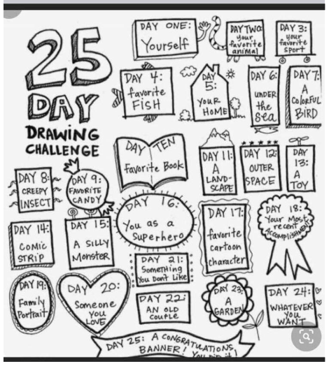

36 Non screen activities

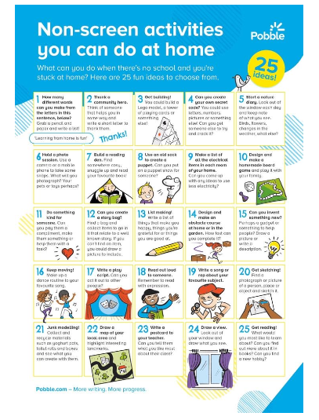

37 Home do able activities

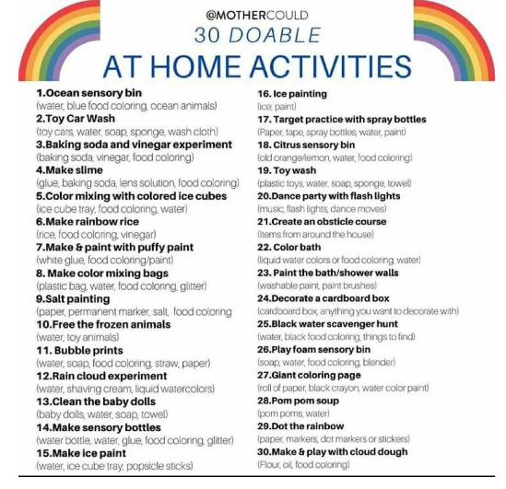

38 Lego ideas

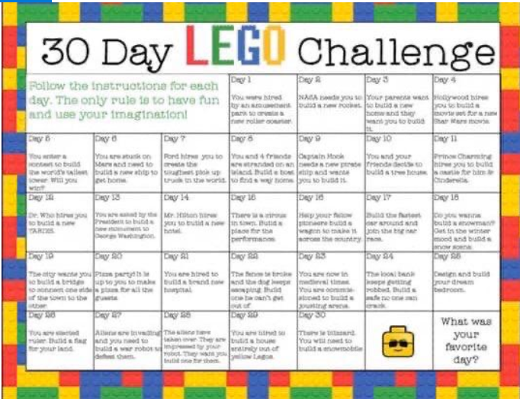

39. Learning around the house ideas

Being stuck inside can be boring however there are lots of ways to use what you have around you to learn from. Try some of these…

Arrange the heaviest items in the kitchen according to weight using the scales eg tins pasta potatoes vegetables, estimate then weigh – were you correct?

Volume – what items hold liquid in your house? Can you find the volume written on them? order what items hold the most to the least?

Were you surprised? Did all the largest or the biggest items weigh or hold the most? Or did their shape trick you into thinking they were bigger or heavier than they were?

Time – sort the hours of your day into a picture chart, write in what times things happen in the house, TV programmes, having lunch, how long it took you to tidy your room.

Measuring tapes – can you design a floor plan of an area of your house? What is the length and breadth of a room? Can you figure out the area?

Signs of spring – take photos and see what you can find is changing in the garden? Are there any shoots and leaves? What might they grow into? Have you planted anything?

*We hope you find these suggestions helpful and enjoy spending some time together trying these out at home.*

*Let us know how you get on we look forward to seeing your creations and stories! Share them @St_Thomas_ERC*