Learning Journal Ideas
While you are learning from home, can you keep a learning journal of different types of activities that you have completed?
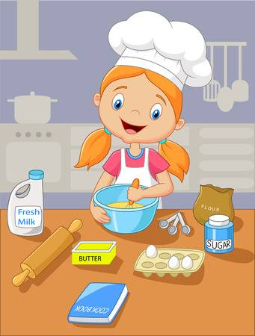
For example:
Write about any recipes you have made and the method you used. Have you learned to cook or bake something new?

You might have learned a new skill such as coding
or how to use the washing machine or the
dishwasher… Tell us about it!

Have you learned a new language, developed your artistic skills, read a fantastic book or learned the rules of a sport? Be as creative as you like when writing or drawing pictures in your learning journal! We can’t wait to read about everything you have learned when you come back to school!

