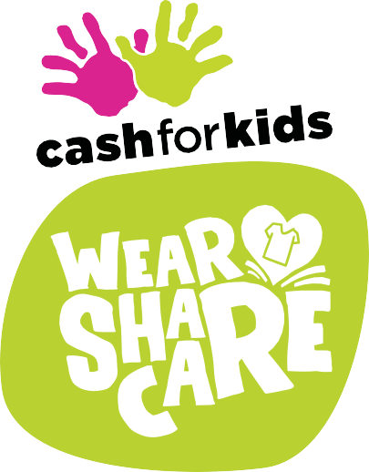

Dear Parent/Carer,
This March we will be taking part in the Wear, Share, Care campaign with Cash for Kids.

We would love for all our pupils and their families to join us in recycling old clothes to help raise money for local disadvantaged children.

Please bag up any unwanted items of clothing (see list below) and bring them to the school janitor’s office by 2.30pm on Friday 18th March.

This is a fantastic opportunity to teach our children the importance of recycling while raising funds that will benefit our local community.

It’s also a great excuse to have a clear out ahead of Spring!

The more we recycle, the more money we raise to help local children and we’d be incredibly grateful for your support.

The attached booklet outlines how this initiative will raise funds to make a difference to the lives of Young People.

WE CAN ACCEPT
- Wearable clothing • Paired shoes • Handbags • Belts
WE CAN’T ACCEPT
- Company branded workwear • Uniforms with logos (including school uniforms)
- Wet or soiled clothes • Curtains • Towels • Duvets or duvet covers
- Pillows or pillowcases • Blankets • Tablecloths • Linens • Cushions
- Carpets • Suitcases • Books • Bric-a-brac • Clothes hangers • Electricals

Bauer Media's Cash for Kids registered charity 1122062 (England, Wales & NI), SC041421 (East Scotland) and SC003334 (West Scotland)

