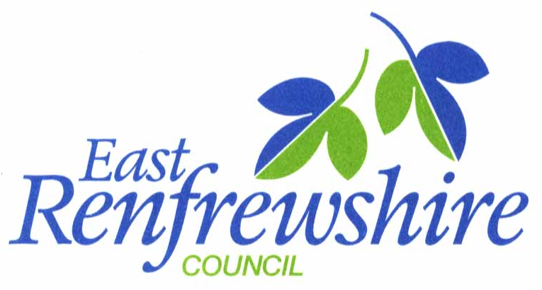
Ref: JAD
Your Ref:
Telephone: 0141 577 2000
Fax: 0141 577 2037
Email: SchoolMail@st-ninians.e-renfrew.sch.uk
Head Teacher: John A Docherty, BSc BA (Hons)
Date: 1st November 2020

Dear Parent/Carer,

I would like to take the opportunity to thank you again for your continued support during this challenging time. I have been very impressed with the way in which our young people have responded to our rigorous health and safety measures. The Scottish Government has published updated guidance, on reducing the risk of virus transmission in schools in level 3 and I wanted to remind you of the robust control measures that we have in place. Currently, there is no evidence of transmission of the virus within the school itself.

Face coverings and hand hygiene
Following the introduction of wearing face coverings in school, the majority of pupils have responded very well. All pupils and staff should continue to wear a face covering as they enter the school building, at every class changeover, when walking through corridors and during social times. From Monday 2nd November, additional measures will be required where all staff and pupils should wear a face covering during lessons in the senior phase (S4 to S6). Pupils in S1 to S3 can remove their mask in class, as can their teachers. Face coverings should be worn by parents and other visitors to the school site, even if not entering the building.
Good hand hygiene remains vitally important, and we ask that all pupils and staff continue to use the hand sanitiser at the four main entrances to the school as they arrive and leave the building. Hand sanitiser is available to pupils in every class/learning area.

Social distancing
Staff will endeavour to maintain a 2-metre distance from other colleagues and pupils. Pupils are strongly encouraged to remain in their year group bubbles at social times. We ask that pupils continue to observe social distancing as far as possible and to avoid large groups congregating together at social times.
Outside of school, we would ask that children please adhere to the government’s guidance for young people and their social contacts. Pupils should not be meeting outside in a group of more than six people. Indoor gatherings are currently not permitted. We appreciate your support in this very important manner.

Ventilation
We have maximised the ventilation of the school building with fresh air and have allowed for a constant change in airflow, by fitting magnetic locks to all corridor and stairwell doors. (The doors will automatically close in the event of a fire/ smoke detection). We have advised staff to keep windows in classrooms and learning areas open to allow for fresh air ventilation and to assist with minimising the risk of virus infection. This will be dependent on prevailing weather conditions as we move to the winter season. There is a need to maintain indoor temperatures for reasons including user comfort, health and wellbeing, and learning and teaching. We do not anticipate classrooms being cold and staff have been advised to monitor the temperature in their teaching areas. When teaching areas are not in use, we will monitor the heating and open windows accordingly to maximise ventilation. We take great pride in the high standard of our uniform and during the winter months, pupils should wear a grey v-neck jumper or cardigan with their blazer for added warmth if required.

In the event that a positive case arises
We remind and ask that all parents, pupils and staff continue to be vigilant in monitoring for COVID-19 symptoms and act fast in following the guidance on NHS Inform and Test and Protect..
If your child were to test positive, you should alert the school immediately by phoning the school office or by email to school mail (SchoolMail@st-ninians.e-renfrew.sch.uk) if out of school hours or at the weekend.

Please put in the ‘Subject’ line of the email: Positive COVID case
We ask that you provide the following details and a member of staff will contact you as soon as possible:

- The name and contact details of the positive individual
- The details of when the symptoms developed and when the test was undertaken
- Information on when the pupil was last in the school.

This information will be treated in the strictest of confidence. A prompt response will allow the Track and Protect Team to quickly identify the individuals who are close contacts of the confirmed positive case. These are individuals who will have been in close contact with the confirmed case in the 48 hours prior to the onset of symptoms.

Contacting Parents/Carers
Please be assured that at no point will the identity of the confirmed individual be disclosed. This is confidential health information and cannot be shared.
Our school will first alert parents/ carers of the children in the year group of the confirmed individual, by email, to inform them that Track and Trace is being carried out. There is not a requirement to contact the whole school as pupils are required to remain in their year group at all times when in school and therefore minimise any contact with other students out with their year group. (Please see previous information regarding year group zones that we ask all pupils to adhere to).
You will receive an additional letter if your child is identified as a close contact of the positive case and your child will be required to self- isolate for 14 days. We will also send a text message in conjunction with sending the letter to alert parents to check their email inbox. Please check all your inbox folders regularly. If you do not receive a further letter from Public Health then your son or daughter can continue to go to school as normal.

Self-isolation/Online work
We fully understand that the need to self-isolate can cause disruption to a pupil’s learning. Our aim is to ensure that pupils can access high quality online learning for every subject. It is essential that during the period of self-isolation those pupils, who are well, continue to keep up with their studies through the online platforms (Microsoft Teams and Google Classrooms). By accessing the online platforms, pupils will find:
- Online resources - including notes, PowerPoints, problems, homework and timelines.
- Teachers will post work including instructions regarding classwork and homework. This will not be directed at individual pupils to preserve anonymity.
- There will be the opportunity for pupils to communicate with their teacher through these platforms and submit work.
We ask that parents actively encourage their son or daughter to fully engage in their learning and to contact us if work is missing via school mail. SchoolMail@st-ninians.e-renfrew.sch.uk.
Class teachers are guiding pupils through online platforms to ensure they are familiar with the procedures they should follow to access resources, complete work and submit classwork/homework. Further details for subject specific online work can be found in the distance learning booklet, available here:
https://blogs.glowscotland.org.uk/er/StNinians/distance-learning/

Frequently Asked Questions for schools are available at;
https://www.nhsggc.org.uk/your-health/health-issues/covid-19-coronavirus/for-patients-the-public/schools-info/faqs/#

Yours sincerely

J. Docherty
Head Teacher

