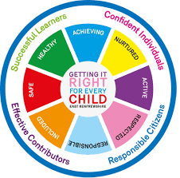
St Ninian’s High School
PSHE Newsletter
Week Beginning 9th March 2020

Focus:

Daily Prayers

- S1 Choices Evening, Thursday 5th March

- Don’t Just Learn, Overlearn : Pomodoro Technique

- Lent: Holy Mass each day 8.25am
- Life Afternoon Tea, Saturday 21st March, 1pm

- Time for Treats and Talk

HWB Mental Strength
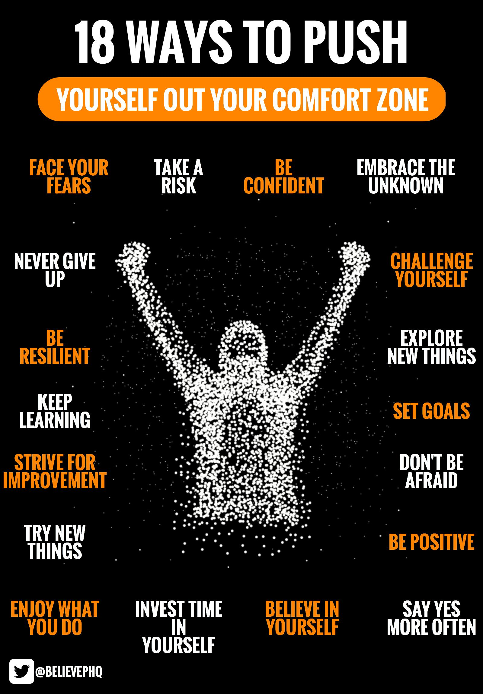

S1
The following classes will have visits by the careers adviser on the following days and periods:

- Wednesday the 11th March Period 4 1a6,1a7 and 1a8 and 1a11

- Friday the 13th March Period 3 1a4 and 1a5

- Wednesday the 18st March Period 4 1a9 and 1a10

Outcome of School Charities Vote – Please cover with all classes

Planning for Choices

PSHE Evaluation – QR Code is at the end of the slides for each year

Complete Inspiring Purpose booklet

S2
Online Etiquette

Outcome of School Charities Vote – Please cover with all classes

Mental Health Awareness

PSHE Evaluation - QR Code is at the end of the slides for each year

Human Rights

Prejudice and Discrimination
S3
Is medicine for me taster event Tuesday 19th May – Please cover the flyer with pupils and collate names of pupils who are interested. Places are limited and names will be picked by a ballot

Parents Nigh information for pupils – Please cover with class

Work on PSHE booklet in preparation for S3 parents evening

Mental Health and Wellbeing Award – Understanding Mental Health Issues
- Lesson
- Marking Scheme

Social media use & internet safety

PSHE Evaluation - QR Code is at the end of the slides for each year

Transferable Skills

MY WoW Ambassadors information regarding next meeting

Safer Internet Day

S4
Knife Violence & Gang Culture‐ Knife City (Clickview)

Outcome of School Charities Vote – Please cover with all classes

PSHE Evaluation - QR Code is at the end of the slides for each year

Self-Harm - On Edge

Online Etiquette
S5
Please pass names of pupils who are interested in a career in Teaching to Mr Marshall

Click view - Drug Education for Teens – (Pastoral Staff to choose video topic to be shown to class)

Positive Mental Attitudes - Stigma

Outcome of School Charities Vote – Please cover with all classes

PSHE Evaluation - QR Code is at the end of the slides for each year

Headstart STEM Opportunity – New round of applications are now open:
- To apply, click here
- https://www.etrust.org.uk/inspire-courses (year 11/S4*)
- https://www.etrust.org.uk/headstart-courses (year 12/S5)
- https://www.etrust.org.uk/headstart-bursaries (applicable to both Headstart & Inspire)

Ensure that PSHE booklets are up to date including:

- Full report reflection for S5
- Career education standards
- Wellbeing web
- SHANARRI task

Oxford Opportunity – please promote to pupils

Sutton Trust Summer school – please cover with pupils

S6
Drivers Early Intervention Talk from Fire Brigade:
6a1, 6a5, 6a6, 6a7, 6a9 and 6a10 Please register classes and take them to the lecture theatre for talk

Outcome of School Charities Vote – Please cover with all classes

PSHE Evaluation - QR Code is at the end of the slides for each year

Diploma completion – Pupils should go on to the school website and search for “S6 DIPLOAM 2020”. They should then click the link this takes them to and use their Glow login details to access the Microsoft forms document. When this opens pupils will then copy and paste each relevant section of their diploma into the appropriate box.

Diploma Completion for S6 pupils – See the below instructions

- Pupils go on to “Pupil Shared Area”
- Click on “PSHE”
- Pupils go on to “Diploma 2020”
- Pupils click on their own respective Alpha
- Click on the “S6 Diploma” and immediately save in their own folder using their name.
- Pupils are to complete each section of the Diploma by writing in to the text box at the bottom of each section. There should only 160 characters including full stops etc. Do not hit the return key as the software will not recognise it.
- This will be a working document and pupils should save their work as they go
- It is important that when pupils are writing information in to the text box that they do not hit the return key as this will not work with the software when transferring on to the Diploma

Link to examples of previous diplomas

Link to Lesson for “Responsible Citizen”
Link to Lesson for “Confident Individual”
Link to Lesson for “Successful Learner”
T. Low

