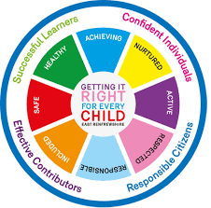
St Ninian’s High School
PSHE Newsletter
Week Beginning 13 February 2020

Focus:

Daily Prayers

- 5 steps to wellbeing video – Please show all classes

- Arnold Clark Vacancies for 16yo and above – Please promote

- HGIOURS – Please cover with all classes. If pupils are interested in contributing they should give their names to the teacher associated with each area - Pupils should contact the lead teacher of the theme they are interested in and the first meeting will take place during lunchtime on Monday 17th February in Tech Room 1 at 1.30pm.

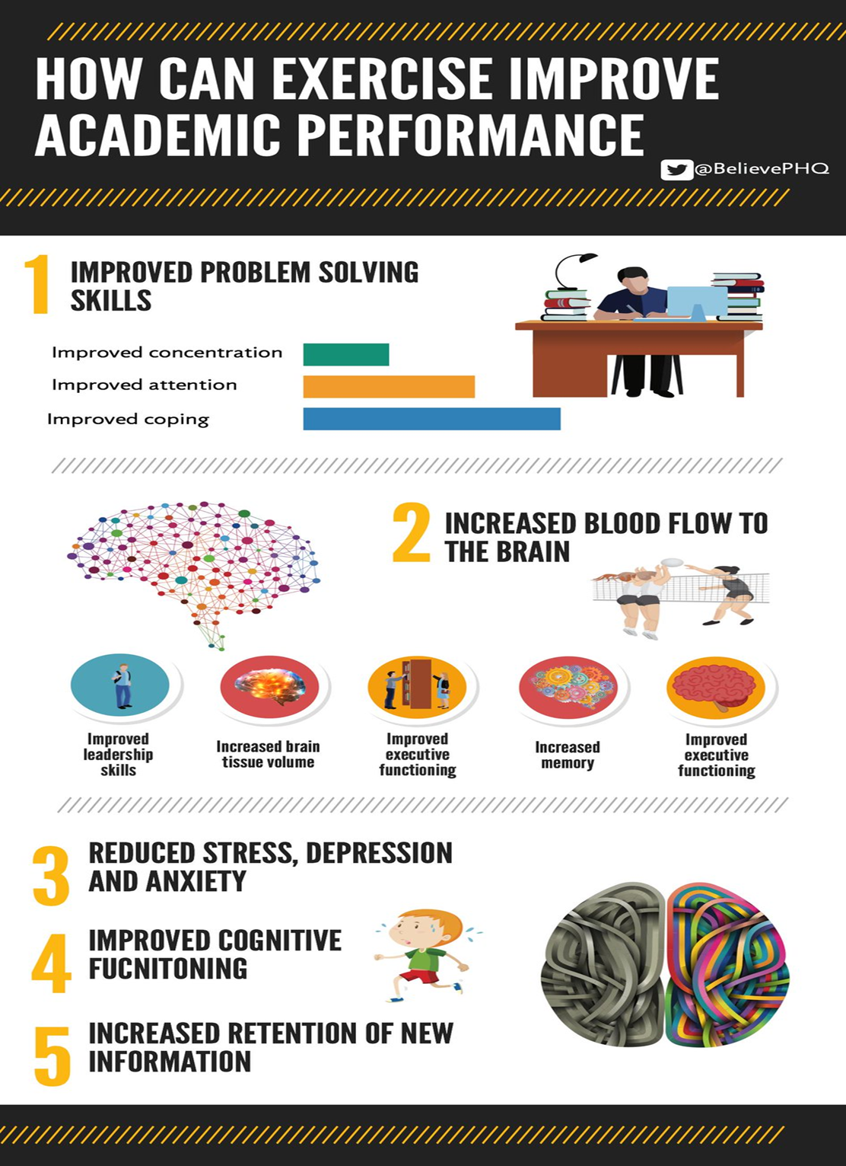
HWB Mental Strength

S1

Safer Internet Day

Inspiring Purpose Lesson 3

Inspiring Purpose Lesson 2

Inspiring Purpose Lesson 1 – Please collect booklets from Pastoral Base

Peer Awards

S2

Safer Internet Day

Prejudice and Discrimination

Peer Awards

S2 Tracking – please complete with your class

Mindfulness & Breathing Space

Factors Affecting Food Choice

S3

Safer Internet Day

Transferable Skills

Young Carers

Mental Health and Wellbeing Award – Understanding Mental Health Issues
- Lesson
- Marking Scheme

S4

Self-Harm - On Edge

Online Etiquette

Options process:
- S5 Options for pupils

Social Media

S5
Headstart STEM Opportunity – New round of applications are now open:
- To apply, click here
- https://www.etrust.org.uk/inspire-courses (year 11/S4*)
- https://www.etrust.org.uk/headstart-courses (year 12/S5)
- https://www.etrust.org.uk/headstart-bursaries (applicable to both Headstart & Inspire)

Anti-Smoking – Clickview – Smoking Our deadliest Habit – Click on link and use glow details to log in

Ensure that PSHE booklets are up to date including:

- Full report reflection for S5
- Career education standards
- Wellbeing web
- SHANARRI task

Oxford Opportunity – please promote to pupils

Arnold Clark Vacancies for 16yo and above – Please promote

Sutton Trust Summer school – please cover with pupils

Complete pages 70 and 71 of PSHE booklet in relation to options.

Study Skills
- Preparing for Exams
- Study Plan

EMA – Education Maintenance Allowance

S6

Digital Engagement Survey – Please ask pupils to complete using their phones

Burns Ceilidh Evening – Thursday 30th January 7pm £3 per ticket – Please promote to all pupils

Diploma Completion for S6 pupils – See the below instructions

- Pupils go on to “Pupil Shared Area”
- Click on “PSHE”
- Pupils go on to “Diploma 2020”
- Pupils click on their own respective Alpha
- Click on the “S6 Diploma” and immediately save in their own folder using their name.
- Pupils are to complete each section of the Diploma by writing in to the text box at the bottom of each section. There should only 160 characters including full stops etc. Do not hit the return key as the software will not recognise it.
- This will be a working document and pupils should save their work as they go
- It is important that when pupils are writing information in to the text box that they do not hit the return key as this will not work with the software when transferring on to the Diploma

Link to examples of previous diplomas

Link to Lesson for “Responsible Citizen”
Link to Lesson for “Confident Individual”
Link to Lesson for “Successful Learner”

T. Low

