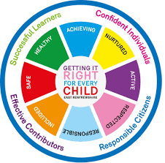
St Ninian’s High School
PSHE Newsletter
Week Beginning 03 February 2020

Focus:

Daily Prayers

- 5 steps to wellbeing video – Please show all classes

- Mental Health Time to talk day – 6th February – All staff and pupils are welcome to R.E. Room 1 for Tea, biscuits and juice at both break and lunch time. This is an opportunity for staff and pupils to chat and socialise over FREE refreshments. The S6 HWB Group will be organising this event. Please feel free to come along and show your support

- Arnold Clark Vacancies for 16yo and above – Please promote

- School Library Survey – Please ask pupils to use the link and complete the survey

- For All S5 Pupils - The Catholic Leadership Course for S5 Pupils continues on dates below. Pupils not already involved are more than welcome.

- Catholic Leadership Meeting with Fr Patten, 3.30pm on Monday 3 February 2020.

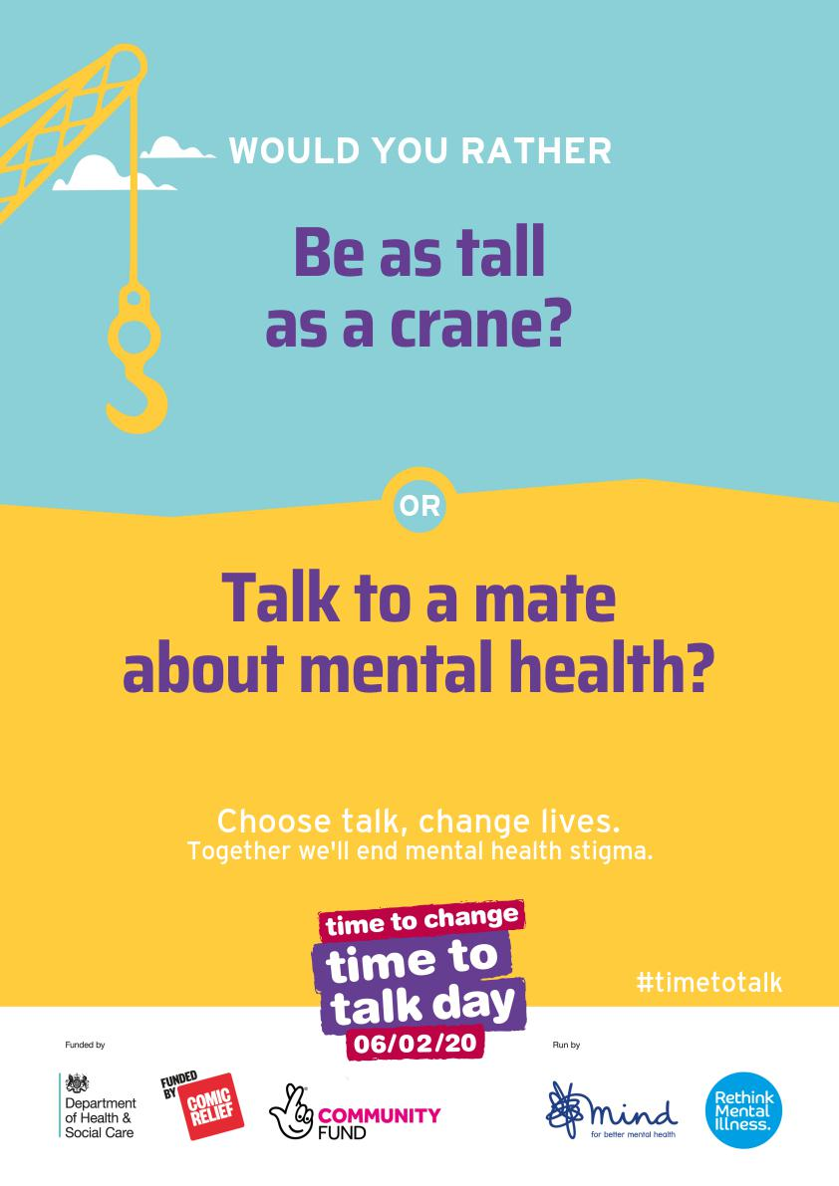

S1
Creatvie Industries Survey from Art – Pleaes ask pupils to complete

Safer Internet Day

Inspiring Purpose Lesson 3

Inspiring Purpose Lesson 2

Inspiring Purpose Lesson 1 – Please collect booklets from Pastoral Base

Peer Awards

S2
Creatvie Industries Survey from Art – Pleaes ask pupils to complete

Safer Internet Day

Prejudice and Discrimination

Peer Awards

S2 Tracking – please complete with your class

Mindfulness & Breathing Space

Factors Affecting Food Choice

S3
Creatvie Industries Survey from Art – Pleaes ask pupils to complete

Safer Internet Day

Transferable Skills

Young Carers

Mental Health and Wellbeing Award – Understanding Mental Health Issues
- Lessson
- Marking Scheme

S4
Creatvie Industries Survey from Art – Pleaes ask pupils to complete

Online Etiquette

Options process:
- S5 Options for pupils

Social Media

S5
Headstart STEM Opportunity – New round of applications are now open:
- To apply, click here
- https://www.etrust.org.uk/inspire-courses (year 11/S4*)
- https://www.etrust.org.uk/headstart-courses (year 12/S5)
- https://www.etrust.org.uk/headstart-bursaries (applicable to both Headstart & Inspire)

Anti-Smoking – Clickview – Smoking Our deadliest Habit – Click on link and use glow details to log in

Ensure that PSHE booklets are up to date including:

- Full report reflection for S5
- Career education standards
- Wellbeing web
- SHANARRI task

Oxford Opportunity – please promote to pupils

Arnold Clark Vacancies for 16yo and above – Please promote

Sutton Trust Summer school – please cover with pupils

Complete pages 70 and 71 of PSHE booklet in relation to options.

Study Skills
- Preparing for Exams
- Study Plan

EMA – Education Maintenance Allowance

S6

Digital Engagement Survey – Please ask pupils to complete using their phones

Burns Ceilidh Evening – Thursday 30th January 7pm £3 per ticket – Please promote to all pupils

Diploma Completion for S6 pupils – See the below instructions

- Pupils go on to “Pupil Shared Area”
- Click on “PSHE”
- Pupils go on to “Diploma 2020”
- Pupils click on their own respective Alpha
- Click on the “S6 Diploma” and immediately save in their own folder using their name.
- Pupils are to complete each section of the Diploma by writing in to the text box at the bottom of each section. There should only 160 characters including full stops etc. Do not hit the return key as the software will not recognise it.
- This will be a working document and pupils should save their work as they go
- It is important that when pupils are writing information in to the text box that they do not hit the return key as this will not work with the software when transferring on to the Diploma

Link to examples of previous diplomas

Link to Lesson for “Responsible Citizen”
Link to Lesson for “Confident Individual”
Link to Lesson for “Successful Learner”

T. Low

