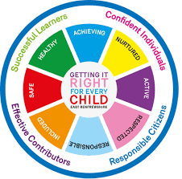
St Ninian’s High School
PSHE Newsletter
Week Beginning 27th January 2020

Focus:

Daily Prayers

- 5 steps to wellbeing video – Please show all classes

- Rainbows Group – Please cover with S1 to S3 pupils

- International Holocaust Remembrance Day, 27th January

- Arnold Clark Vacancies for 16yo and above – Please promote

- For All S5 Pupils - The Catholic Leadership Course for S5 Pupils continues on dates below. Pupils not already involved are more than welcome.

- Tuesday 28th January 2020 - 3.45pm - RE2 ‘The role of faith in undertaking a leadership role in society’ - Prof. Stephen McKinney

- Tuesday 25th February 2020 - 3.45pm - RE2 ‘How do you develop faith leadership in others?’ – Dr. Leonard Franchi

HWB Mental Strength

January challenge:

Whether it’s running 5k, or walking to school a new way, a morning swim or taking your bike out for a spin - join the thousands of people around the UK kick-starting their 2020 in the most positive way.

Start the year off by setting yourself a fitness challenge every day in January:

- Walk a mile a day

- Jog a mile a day

- Take part in our couch to 5k club run by Miss Miller

- Try a new sport or activity at one of our extra-curricular clubs

- Walk to and from school

These are just some of the things you could to help improve your fitness and mental wellbeing in January.

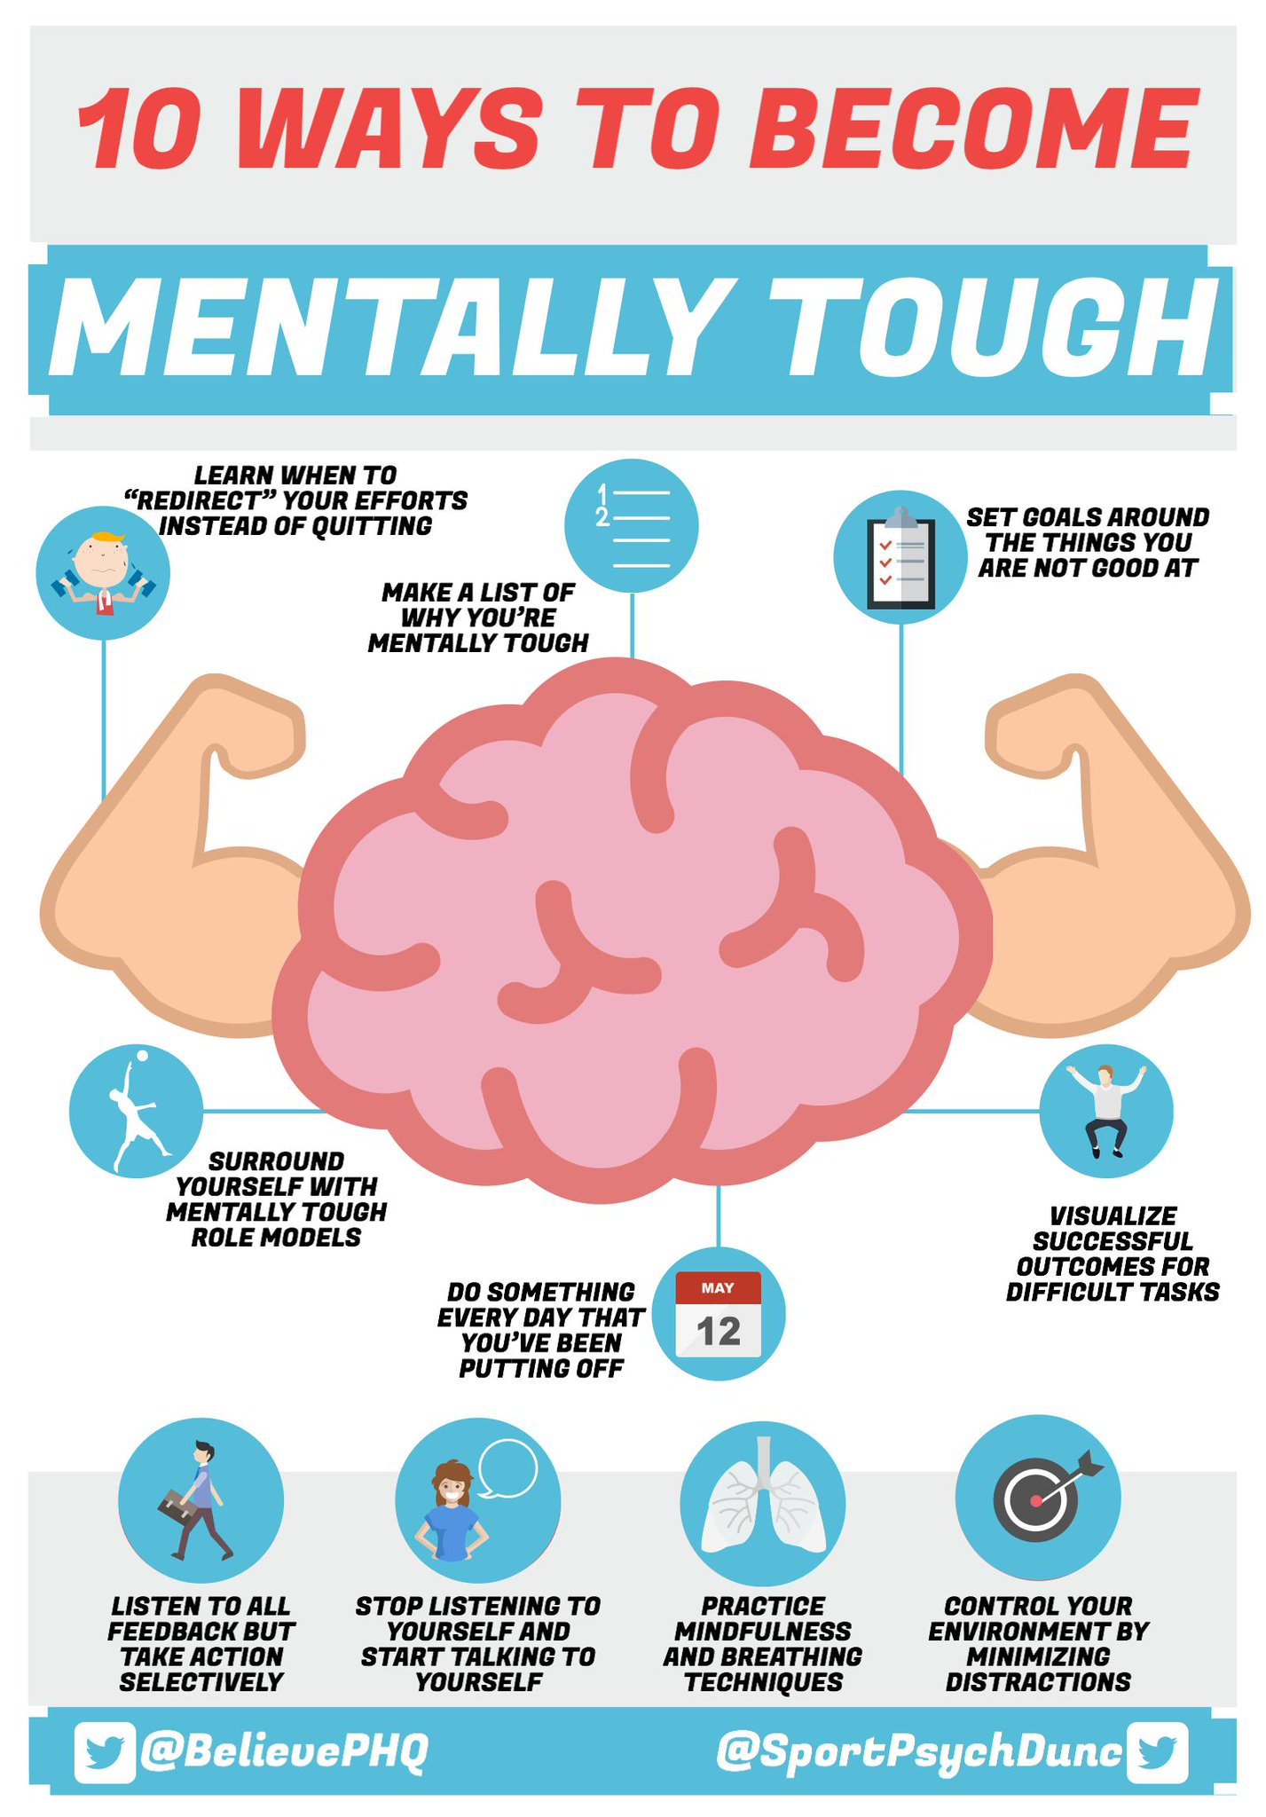

S1

Digital Engagement Survey – Please ask pupils to complete using their phones

Burns Ceilidh Evening – Thursday 30th January 7pm £3 per ticket – Please promote to all pupils

Inspiring Purpose Lesson 2

Inspiring Purpose Lesson 1 – Please collect booklets from Pastoral Base

Peer Awards

S2

Digital Engagement Survey – Please ask pupils to complete using their phones

Burns Ceilidh Evening – Thursday 30th January 7pm £3 per ticket – Please promote to all pupils

Peer Awards

S2 Tracking – please complete with your class

Mindfulness & Breathing Space

Factors Affecting Food Choice

S3

Digital Engagement Survey – Please ask pupils to complete using their phones

STUC Talks
Monday 27th January 1.50pm to 2.40pm – Classes 3a9 and 3a10
Please register pupils and take them to the lecture theatre. The speaker will also need to be collected from the school office

Burns Ceilidh Evening – Thursday 30th January 7pm £3 per ticket – Please promote to all pupils

Young Carers

Mental Health and Wellbeing Award – Understanding Mental Health Issues
- Lessson
- Marking Scheme

S4

Digital Engagement Survey – Please ask pupils to complete using their phones

Options process:
- S5 Options for pupils

Social Media

Burns Ceilidh Evening – Thursday 30th January 7pm £3 per ticket – Please promote to all pupils

Arnold Clark Vacancies for 16yo and above – Please promote

S5

Digital Engagement Survey – Please ask pupils to complete using their phones

Ensure that PSHE booklets are up to date including:

- Full report reflection for S5
- Career education standards
- Wellbeing web
- SHANARRI task

Burns Ceilidh Evening – Thursday 30th January 7pm £3 per ticket – Please promote to all pupils

Oxford Opportunity – please promote to pupils

Arnold Clark Vacancies for 16yo and above – Please promote

Sutton Trust Summer school – please cover with pupils

Complete pages 70 and 71 of PSHE booklet in relation to options.

Study Skills
- Preparing for Exams
- Study Plan

EMA – Education Maintenance Allowance

S6

Digital Engagement Survey – Please ask pupils to complete using their phones

Burns Ceilidh Evening – Thursday 30th January 7pm £3 per ticket – Please promote to all pupils

Diploma Completion for S6 pupils – See the below instructions

- Pupils go on to “Pupil Shared Area”
- Click on “PSHE”
- Pupils go on to “Diploma 2020”
- Pupils click on their own respective Alpha
- Click on the “S6 Diploma” and immediately save in their own folder using their name.
- Pupils are to complete each section of the Diploma by writing in to the text box at the bottom of each section. There should only 160 characters including full stops etc. Do not hit the return key as the software will not recognise it.
- This will be a working document and pupils should save their work as they go
- It is important that when pupils are writing information in to the text box that they do not hit the return key as this will not work with the software when transferring on to the Diploma

Link to examples of previous diplomas

Link to Lesson for “Responsible Citizen”
Link to Lesson for “Confident Individual”
Link to Lesson for “Successful Learner”

T. Low

