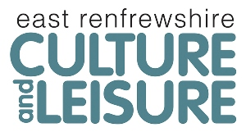
Our Ref: Swimming Development Free Lessons
Contact: Karen Baxter
Tel:
Email:
Date: 27/03/19

Dear Parent / Carer,

Swimming Development Programme: Free Taster Swimming Lessons

East Renfrewshire Culture and Leisure Swimming Development are looking for children aged 4 to 12 years to come along to FREE Lessons again.

Our existing swimming teachers are upskilling to a higher level of swimming qualification run by the National Governing Body Scottish Swimming.

If you are interested in bringing your children along to our free taster swimming lessons at Barrhead Foundry, being taught by our probationary teachers, then please see dates and times below.

Saturdays 22, 29 February and 14 March.
Sundays 9, 23 February, 01 and 15 March

Times as follows:-

Saturdays-11.30am-12.00pm, 12.00pm-12.30pm, 12.30pm-1.00pm and 1.00pm-1.30pm.
Sundays-12.30pm-1.00pm and 1.00pm-1.30pm 1.30pm-2pm and 2.00pm-2.30pm

Please choose which time slots you would like, (you can attend more than one session)

You can contact us at Neilston on 0141 577 4811 - opening hours (9am-12.30pm & 3.30pm-8pm) or Barrhead on 0141 580 1174 or pop into the centre and put their name down on the list.

Yours Sincerely,
Karen Baxter

