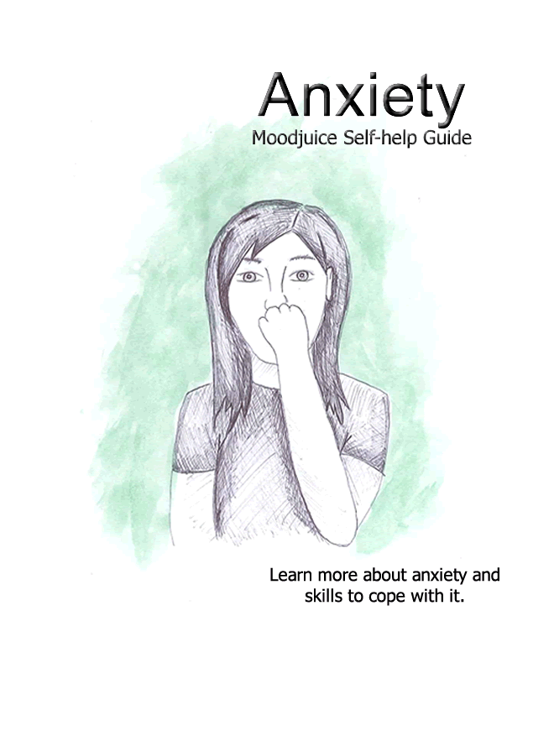
Self Help for Anxiety
- Do you find that you spend large periods of the day worrying?
- Do you often feel nervous, apprehensive or on edge?
- Do you feel that things are getting on top of you?
- Do you find it hard to relax and 'switch off'?
- Do you often experience unpleasant physical sensations such as 'butterflies' in your stomach, muscular tension, dizziness or breathlessness?
If the answer to any of these questions is 'yes,' you may be experiencing symptoms of anxiety and you may find this workbook helpful.
This workbook aims to help you to:
- Recognise whether you may be experiencing symptoms of anxiety.
- Understand what anxiety is, what causes it and what keeps it going.
- Find ways to understand, manage or overcome your anxiety.
Do I have symptoms of anxiety?
If you experience symptoms of anxiety it is likely that you will recognise many of the feelings, physical symptoms, thoughts and behaviour patterns described below.
Please tick the boxes which regularly apply to you.
Feelings
On edge
Nervous
Panicky
Stressed
Irritable/low patience threshold
Uptight
Physical Symptoms
Tense body/Muscular pain
Dizzy/Faint
Chest tight or painful
Stomach Churning
Trembling or tingling sensations
Heart racing/palpitations
Breathing faster or slower than usual
Concentration difficulties

Thinking styles
You often worry 'what if' something bad happens
Your mind jumps from worry to worry
You often imagine the worst case scenarios
You are always on the look out for danger
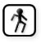
Behaviour Patterns
Avoid doing things you would like to
Pace around/Find it hard to relax
Snap at people too easily
Get easily flustered
Talk very quickly

If you have ticked a number of these boxes you may be experiencing symptoms of anxiety. However don't be alarmed, this is very common and there are things you can do to improve your situation. You will find some useful strategies in this workbook.
What is anxiety?
Anxiety is an unpleasant feeling that we all experience at times. It is a word often used to describe when we feel 'uptight', 'irritable', 'nervous', 'tense', or 'wound up'. When we are anxious we normally experience a variety of uncomfortable physical sensations. These include:
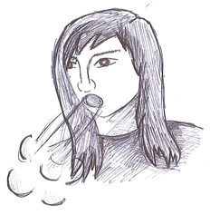
- Increased heart rate
- Muscular tension
- Sweating
- Trembling
- Feelings of breathlessness
As well as this, anxiety affects us mentally too. For example, when anxious, we often worry for large periods of time, so much so that our worry can feel out of control. These worries are often about a variety of issues and commonly our mind jumps quickly from one worry to another.
Anxiety also influences how we behave. For instance, when we feel anxious, we often avoid doing things that we want to because we are worried about how they will turn out. Although short experiences of anxiety are part and parcel of daily life, it becomes challenging when anxiety begins to follow people around and is a regular feature in their lives.

What causes anxiety?
Life Events:
Often we develop anxiety following a series of stressful life events. This is especially true if we experience many different pressures all at once. For example, if someone has work pressures, financial difficulties, and relationship problems, all at the same time, it is perhaps unsurprising that they become anxious. When thinking about it in this way, anxiety is often the result of feeling as though we cannot cope with the demands placed upon us.
In addition, people can learn to be anxious based on their life experiences. For example, if someone has faced workplace bullying in the past, they may be more likely to suffer anxiety when beginning a new job.
Thinking Styles:
Some people may have a thinking style that lends itself to experiencing anxiety. For example, anxious people have a tendency to expect that the worst possible scenario will always occur. They also feel like they must constantly be on guard in case something bad happens. They believe that by thinking about all the things that could go wrong, they will be better prepared to cope if it happens. However thinking in these ways mean they are on regular alert and find it difficult to relax and 'switch off'.
Evolutionary Reasons:
We also experience anxiety because of its evolutionary benefits. Put another way, although anxiety is largely an unpleasant experience, it also has positive benefits that have been useful to humans over the centuries. For example, when we are under threat or feel in danger (e.g. hear a burglar), we automatically become anxious. As a result, our heart beats more quickly which supplies blood to our muscles (which helps us run away from or fight the burglar); we sweat (which cools us down during this process); and our breathing changes (which ensures oxygen is delivered to our muscles quickly � again preparing us for a quick response). When looking at anxiety in this way, you can quickly see how it can be very useful in certain situations.
Biological Reasons:
It has also been suggested that anxiety has familial ties. In other words, if someone in your immediate family is an anxious person, there is an increased chance that you will have similar personality traits.
In reality it is likely that a combination of all these factors influence someone's anxiety levels. However, in some ways it is less important to know what causes anxiety, and more important to know what stops us overcoming it.

What keeps our anxiety going?
Some people have a style of thinking which lends itself to experiencing anxiety. For example, it appears that some people are more likely to overestimate the likelihood of bad things happening than others. It is easy to see how regularly presuming the worst in this way would make someone feel anxious. Unfortunately, when we do feel anxious, we become even less likely to think as clearly as we would like and a vicious cycle occurs.
Anxious people also sometimes believe that worrying has a protective function. More specifically, they believe that being on the 'look out' for danger can help them to recognise and avoid it. Unfortunately, when searching for danger in this way, they soon begin seeing potential danger in many relatively safe situations which of course makes them feel anxious. They may also believe that by considering everything that could go wrong; they will be better prepared to cope when it does. However, often these beliefs mean a lot of extra time is spent worrying than is necessary, as many of our worries never come true. Of course, the more time we spend worrying, the more anxious we feel.
Another way someone's thinking style can keep their anxiety going is because they become 'worried about worrying'. Here, people tend to worry that they are doing harm to themselves (e.g. going mad) by worrying so often (which is not the case) and a vicious cycle occurs. Similarly, people often worry about the physical symptoms they experience when they are anxious (e.g. breathlessness, rapid heart rate etc). Unfortunately, worrying about these symptoms (which are perfectly safe and natural bodily reactions), only makes them feel worse, again creating a vicious cycle of anxiety.
One other important factor that can keep people's anxiety going is that they often change their behaviour as a result of their anxiety. For example, they may avoid going to a party because they have spotted many potential 'dangers' (e.g. �what if no one likes me�). Similarly, they may put off completing an assignment because they worry about it being negatively evaluated. Unfortunately because people tend to use such avoidance strategies, they can never see that things would often go better than they thought and their anxiety remains as a result.
Not having enough free time to relax and do the things we enjoy we can also contribute to our higher anxiety levels. On the other hand, having too much free time can mean we have lots of opportunities to engage in worry and feel anxious.
When looking more closely at anxiety, you can begin to see that our thoughts, feelings, behaviours and physical symptoms all interact and combine to keep our anxiety going. See the diagram overleaf.
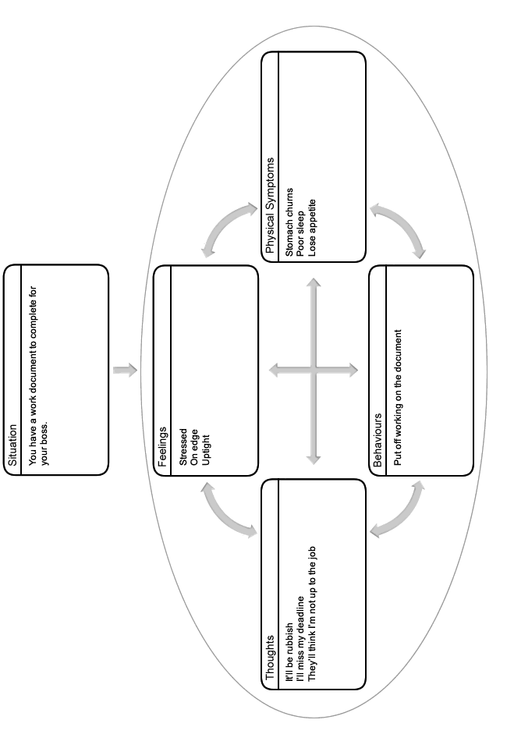
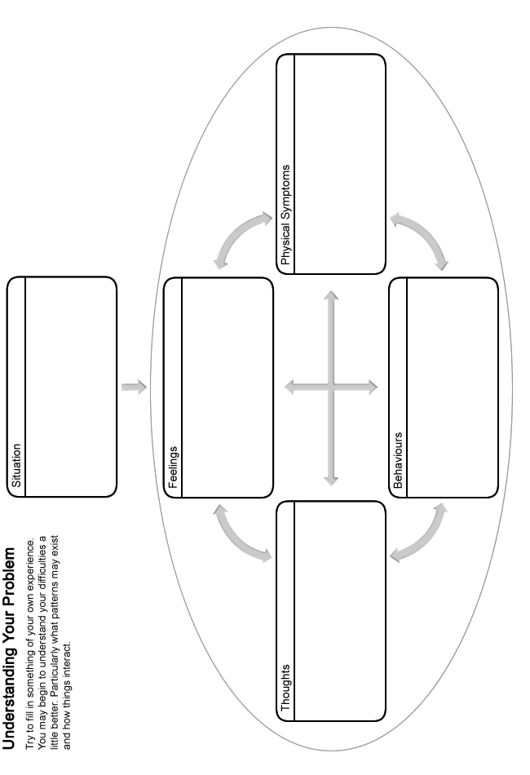
How can I reduce my anxiety?
Fortunately, there are a number of strategies that we can use to reduce our anxiety. These include:
- Understanding more about anxiety.
- Learning how to challenge your unhelpful thoughts and see things in a more realistic light.
- Improving your problem solving skills.
- Learning how to reduce the amount of time you spend worrying.
- Learning how you can feel more relaxed (physically and mentally).
- Learning how to stop avoiding the things that make you anxious.
When going through this booklet it can sometimes be more helpful to try out the ideas above one at a time, rather and trying to learn them all at once. However simply take things at your own pace.
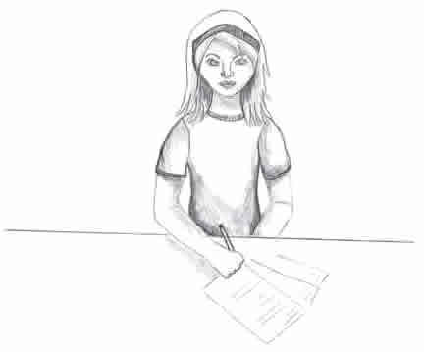
Understanding anxiety
Anxiety is undoubtedly an unpleasant feeling, but it is something that everyone experiences. Of course, some people experience anxiety more regularly than others, but it is a completely natural experience that is part and parcel of daily life. Due to the unpleasant nature of anxiety, people often worry that experiencing it is harmful. For example they may fear that regularly worrying will make them go mad or that the physical symptoms of anxiety (e.g. heart racing) are signs of a serious health problem. Such fears naturally make people even more anxious which creates a vicious cycle of anxiety.
However, when exploring anxiety more closely, we can see that it is a very healthy response which actually helps to protect us. By learning more about anxiety and why we experience it in the first place, we can see that it is not harmful. This can help us to be less fearful of the symptoms which in turn has a positive affect on our overall anxiety levels. If however you are concerned that some of your symptoms are not caused by anxiety, contact your GP if necessary.
The symptoms we experience when anxious are often referred to as the 'fight or flight' response. This comes from the idea that people primarily experience anxiety to help them either fight or run away from danger. For example, if you saw a burglar, two options open to you would be to either - fight them off (fight) or try to run away (flight). Our fight or flight response would kick in to help us at this point. For example:
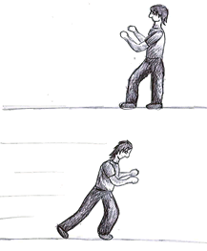
- Our hearts would begin beating more quickly (supplying blood to our muscles).
- We would sweat (to cool us down).
- Our muscles would become tense (ready for action).
- We would take deeper breaths (to supply oxygen to our muscles).
In essence, all of these responses would aid our escape or improve our ability to stay and fight the intruder. When considered in this way, we can see how the symptoms of anxiety are helpful to us. Indeed, all of the physical symptoms we experience when anxious play a helpful role in protecting us in such circumstances.
This fight or flight response was likely even more vital to human survival back in the days of early man, when people had to hunt for their food and were under a greater threat from predators. Nowadays we do not face the same threats, but unfortunately, our bodies and minds have not caught up with these changes. As a result, we now experience anxiety in situations where it is not necessarily as helpful because we cannot fight or run away from them (e.g. work or financial pressures). However, the one thing that has stayed true is the fact that these symptoms are not dangerous; it is in many ways the right response but at the wrong time. Remembering this can help you to be less fearful of the symptoms of anxiety which will allow them to pass sooner.
Challenging unhelpful thoughts
The way that we think about things has an impact on our anxiety levels. Many of these thoughts occur outside of our control, and can be negative or unhelpful. It is therefore important to remember that they are just thoughts, without any real basis, and are not necessarily facts. Even though we may believe a lot of our unhelpful thoughts when we are anxious, it is good to remember that they should be questioned as they are often based on wrong assumptions.
The following section will help you begin to recognise if you are thinking about things in an unhelpful or unrealistic way, and discuss how you can start to make changes to this. By doing so, you can learn to see things in a more realistic light which can help to reduce your anxiety levels. You might have unhelpful thoughts about all kinds of things. Here are some examples:
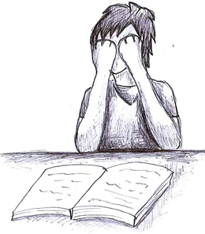
Being judged negatively by others:
- They think I'm useless
- They won't like me
Being unable to cope:
- I'll make a fool of myself
- I'm too anxious to manage that
- I'll have a panic attack
Something terrible happening:
- What if I have an accident?
- What if I lose my job?
It is clear to see how this kind of thinking might make us anxious. Do you ever think in any of the ways outlined above? Fill in your examples below:
You might find it difficult to identify an unhelpful thought. Try thinking about a time when you were feeling anxious. Consider what was running through your mind at that time.

Patterns of unhelpful thinking
First you need to be able to recognise an unhelpful thought. Then you can challenge it. Being aware of the common patterns that unhelpful thoughts follow can help you to recognise when you have them. Here are some of the common patterns that our unhelpful thoughts follow:
Predicting the Future:
When we are feeling anxious, it is common for us to spend a lot of time thinking about the future and predicting what could go wrong, rather than just letting things be. In the end most of our predictions don't happen and we have wasted time and energy being worried and upset about them. For example:
- Assuming you will perform poorly at your job interview.
- Spending the week before an exam predicting you will fail, despite all your hard work studying and your previous good grades.
Mind Reading:
This means that you make assumptions about others' beliefs without having any real evidence to support them. For example:
- My boss thinks I'm stupid.
- People think I'm weird.
Such ways of thinking naturally make us apprehensive.
Catastrophising:
People commonly 'catastrophise' when they are anxious, which basically means that they often blow things out of proportion. For example:
- They assume that something that has happened is far worse than it really is (e.g. that their friend is going to dislike them because they cancelled a night out).
- They may think that something terrible is going to happen in the future, when, in reality, there is very little evidence to support it (e.g. I'm going to get into serious trouble for calling in sick).
Focusing on the Negatives:
Anxious people often have a tendency to focus on the negatives which keeps their anxiety going. For example:
- They focus on the one person at work who doesn't like them, ignoring that they are very popular with the rest of their colleagues.
Should Statements:
People often imagine how they would like things to be or how they 'should be' rather than accepting how things really are. For example:
- I should have got an A in History.
- I should never be anxious.
Unfortunately when we do this, we are simply applying extra pressure to ourselves that can result in anxiety. Instead it can sometimes help to accept that things can't always be perfect.
Over Generalising:
Based on one isolated incident you assume that all others will follow a similar pattern in the future. For example:
- When enrolling on a college course, you meet a future classmate who you find irritating. As a result, you worry that everyone in the class will be the same and you won't make any friends.
What If Statements:
Have you ever wondered "what if" something bad happens? For example:
- What if I have a panic attack at the party?
- What if I don't make friends when I start my new job?
This type of thought can often make us avoid going places or doing the things that we would like.
Labelling:
Do you find that you attach negative labels to yourself? For example:
- I'm weak.
- I'm a waste of space.
- I'm always anxious.
Labels like these really influence how we see ourselves and can heighten our anxiety levels.
Do any of your unhelpful thoughts follow some of these patterns? Jot down any examples you can think of into the box below:
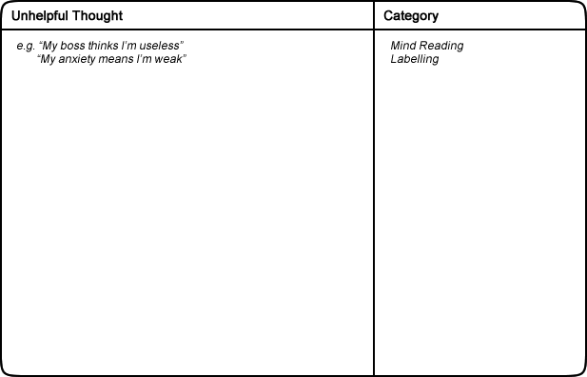
We can learn techniques to challenge these unhelpful thoughts. This can help to reduce your anxiety levels. The next part of this handout will discuss how we can go about challenging our unhelpful thoughts. You may come up with a more balanced thought that is accurate and based on evidence.

How to challenge unhelpful thoughts
Once you have recognised an unhelpful thought the next stage is to challenge it. To do this, you can ask yourself a serious of questions. See the example below:
Situation: The end of year exams are approaching.
How you feel: Nervous, stressed and apprehensive.
Unhelpful thought: I'll definitely fail my exams miserably!
Challenges to an unhelpful thought
Now you can challenge your unhelpful thoughts by asking these questions.
Is there any evidence that contradicts this thought?
- I've always done well in my previous exams.
- I've been scoring well in my coursework.
Can you identify any of the patterns of unhelpful thinking described earlier?
- I'm 'predicting the future'. I have no evidence to suggest I'll fail.
What would you say to a friend who had this thought in a similar situation?
- I'd say don't be silly, you've always done well. As long as you've studied hard, you should be fine. Besides, you can only try your best.
What are the costs and benefits of thinking in this way?
- Costs: It's making me feel sick with worry.
- Benefits: I can't really think of any.
How will you feel about this in 6 months time?
- I'll probably look back and laugh about how silly I was being.
Is there another way of looking at this situation?
- I've always done well in the past so I should be ok. I can only do my best anyway; after all I've studied hard. At worst, I'll just have to re-sit next year.
Once you have asked yourself these questions, you should read through your answers. Try to come up with a more balanced or rational view. For example:
Worrying about failing is doing me no good. I've always done well before so I should be fine, especially since I've prepared properly.
Try to apply these questions to the unhelpful thoughts that you notice. It can help to reduce your anxiety levels. You can use this technique to test your thoughts are realistic and balanced.
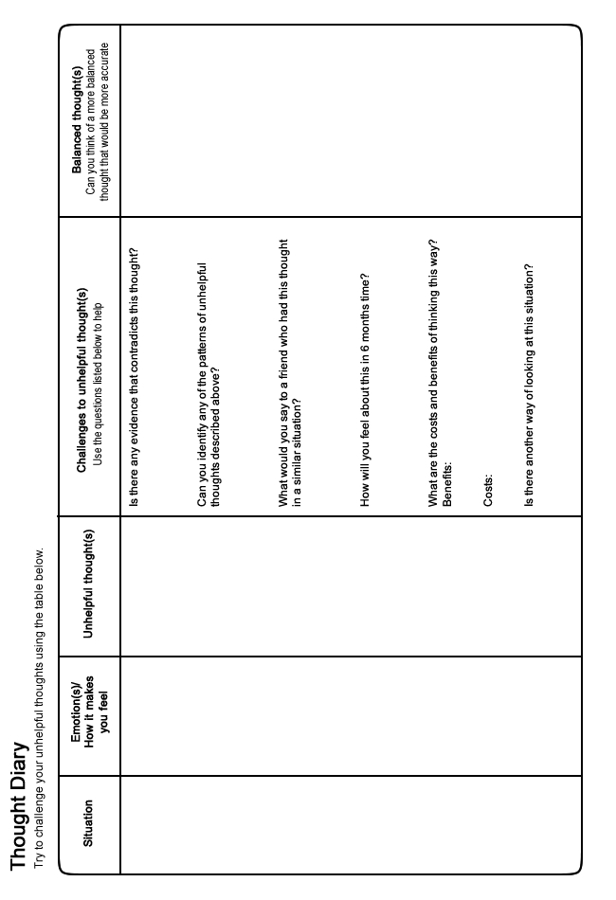
Problem Solving
You might find it more difficult to cope if you have lots of problems that you can't seem to get on top of. This can have a clear impact on our anxiety levels. Struggling with unresolved problems can often make us feel worse. We can end up worrying or ruminating over our problems without finding a way to resolve them. This can make us feel even more upset, and can end up interfering with our sleep.
It can help to develop a structured way of working through a problem. Beginning to overcome some of your problems might help you to feel better. You can improve your problem solving skills by learning to apply the steps outlined here.
Identify your problem
The first thing to ask yourself is � "what is the problem?" Try to be as specific as possible. For example:
- "I owe �400 to my friend."
- "I am going to miss this deadline."
Come up with possible solutions
Try to list every way that you can think to overcome your problem. Don't worry about how unrealistic an idea seems. Write down anything and everything. The best solutions are likely to be the ones you think of yourself. This is because nobody really knows your situation as well as you do. It may help to consider:
- How you might have solved similar problems in the past.
- What your friends or family would advise.
- How you would like to see yourself tackling the problem.
Choose a solution
Next you need to select the best solution from your list. Think carefully about each option. It is useful to go through all the reasons 'for' and 'against' each idea. This will help you to make a good decision and select the best solution.
After this you may find that you are still unsure. Perhaps a couple of approaches seem equally good. Try to pick one to begin with. If it doesn't work then you can always go back and try out a different one later.
Break down your solution
To help you carry out your chosen solution, it can be useful to break it down into smaller steps. This can make it easier and more manageable to follow through. The number of steps required will vary depending on the solution and how complex it is. For example: Someone with debt may have decided to try and resolve their problem by getting a part time job. This would require several steps.
- Buying a newspaper with job adverts.
- Choosing which jobs to apply for.
- Creating a CV.
- Sending out their CV.
- Buying interview clothes.
- Preparing answers to potential interview questions.
Try out your solution and review the outcome
Follow the steps required to carry out your solution. Simply take them one at a time. Go at your own pace and don't allow yourself to feel too rushed.
Once you have completed all the steps, you should then review the outcome. If you have successfully resolved your problem then great. If the problem still exists then don't give up.
- Is there another solution on your list that you could try?
- Is there a different solution that you have yet to consider?
- Can you ask someone else if they have any ideas or advice?
- Can you combine any of your solutions?
It is useful to remember that not all problems are within our control. This can make it really difficult if not impossible to resolve using the steps above. Perhaps you will have to wait, or ask someone else to take action instead. In such a situation, try not to worry. Nothing can be gained from worrying about something that you have no control over.
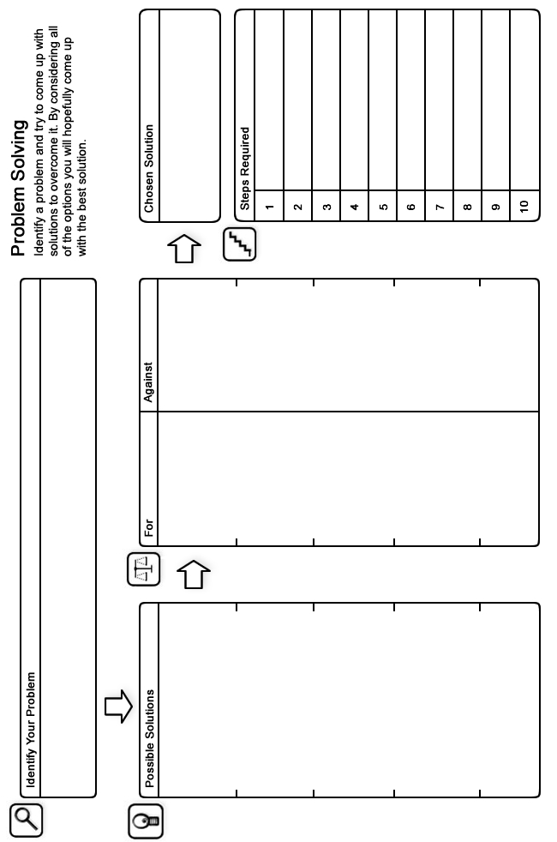
Limiting the time you spend worrying
Anxious people tend to spend much of their time worrying. Sometimes they worry to the point that they find it very hard to 'switch off' and relax. Indeed, one of the most frustrating things about feeling anxious is the seemingly uncontrollable worry that often occurs alongside it. Therefore, if we can reduce the amount of time we spend worrying, we can reduce our anxiety levels.
One way you can do this is to assign 'worry time'. This involves setting aside between fifteen and twenty minutes each day that you will allow yourself to worry. Any worries that pop into your head outside of 'worry time' should simply be noted and forgot about until later that day when you try to resolve them during your 'worry time'. By noting them down, you can feel safe in the knowledge that you won't forget about attempting to resolve them later on. This should free up time during the day that is normally wasted worrying. Then - when your 'worry time' arrives, you should allow yourself to think about the things that have been worrying you that day and try to resolve them. 'Worry time' not only helps to reduce the time you spend worrying, but also proves that you can have more control of whether you engage in worry or not. It also shows that worry is often unnecessary. This is because when you come back to consider your problems with a 'fresh eye', many of them have often resolved themselves or simply seem less important. See the steps below for more details:
- Decide a time in the day that you will have your 'worry time'.
- At other times, simply note down any worries that pop into your head and try to forget about them.
- Once your 'worry time' arrives, choose how long you will allow yourself to 'worry' (try to keep it no longer that 15-20 minutes). Begin timing yourself so your 'worry time' doesn't overrun.
- During worry time, try to resolve your worries proactively. Simply try to come up with solutions to your worries if possible. Using a pen and pad to jot down solutions can be helpful.
- Stop as soon as your 'worry time' is finished. If any worries still feel unresolved, simply carry them over to tomorrow's 'worry time'.
Here are some handy hints to help you with your 'worry time'.
- If you find it difficult to switch off from all of your worries during the day, don't fret, as this should improve with time and practice.
- It may be useful to use the problem solving section in this guide during 'worry time'.
- When it comes to 'worry time', feel free to cut it short if you have resolved all of your worries early.
- Often things that have worried us at one point in the day seem less problematic when we re-visit them during 'worry time'. If this happens � great � simply forget about them.
- Remember, it is usually not possible to resolve every single worry or problem that you have. So if something is outside your control (or has already happened), try not to worry as you have done all you can. There is also the possibility that your worry won't even come true in the first place.
Relaxation
It is important to make time to relax and do activities that are enjoyable. This can help to reduce your anxiety levels by calming the body and mind. It can also help you to sleep. Without taking the time to unwind, it is easy to feel overwhelmed and stressed.
Relaxation can involve doing something that you enjoy, or just being by yourself. Good examples might be reading a book or having a bath. Exercise is also particularly effective at helping us to relax. What you do does not really matter. Try to choose something that you will look forward to and that gives you a break. Doing an activity that you enjoy will also give you less time to spend worrying. Here are a list of activities that might help you to relax.
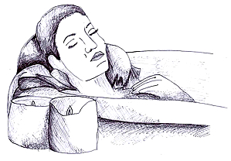
Suggestions:
- Do some exercise (e.g. swim, cycle)
- Read a book
- Watch your favourite TV show
- Go to the cinema
- Do something creative (e.g. draw, paint)
- Visit a friend or family member
- Have a bath
Try to add some of your own ideas into the box below. You will know what works best for you.
Try to find time to relax every day. This might seem difficult, but it is worth making time for. It can help you to feel a lot better. There are audio relaxation guides available that you might find a helpful support.
There are also some exercises described in the next few pages. They are specifically designed to help you to relax. However, you should stop the exercise if at any time you begin to experience discomfort or pain.

Controlled breathing
This simple technique involves focusing on and slowing down our breathing patterns. Many people find this simple exercise very relaxing. It can be particularly helpful for those who feel dizzy or light headed when they feel worried or stressed. This sometimes happens because people's breathing changes and gets quicker when they feel distressed.
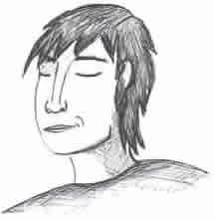
This can be an uncomfortable and unpleasant experience. It can make people even more on edge, and a vicious cycle can occur. Learning controlled breathing exercises can help you to manage these feelings more effectively. It can also help to give your mind and body a chance to calm down.
Remember, you can use this exercise to help you relax at any time. You could even use it to help you get off to sleep. However, it is particularly useful if you ever feel light-headed, dizzy or faint.
Beginning
Get into a comfortable position.
Middle
Work out a stable breathing rhythm. Perhaps try to breathe in for three seconds, hold this breathe for two seconds, and then breathe out for three seconds. It can be helpful to count as you do this (e.g. IN: 1-2-3, HOLD: 1-2, OUT: 1-2-3, HOLD: 1-2).
Ending
Repeat this action for a few minutes. You should soon begin to feel more relaxed. If you were feeling dizzy then this should also get better after a few minutes.

Muscular relaxation
Tension often builds up when we feel upset or stressed. These symptoms can be painful and can cause anxiety in themselves. Muscular relaxation exercises can help you to control such unpleasant symptoms. They can reduce physical tension and help you to relax in general.
During this exercise you have to tense and then relax different muscles in your body. You should focus on the feelings that you experience whilst doing this. With practice you will then be more able to recognise and respond to the onset of tension.
You can work through as many muscle groups as you like. Don't feel that you have to cover every muscle in your whole body. It can be helpful to stick to the same muscle groups each time you practice. That way you can get into a routine which you can easily remember. If you practice this nearly every day you will probably notice an improvement after a couple of weeks.
Beginning
Find somewhere comfortable and quiet where you won't be interrupted. You can either sit or lie down to practice this exercise. Begin by focusing on your breathing. Try to have a slow and comfortable pace. You could use the controlled breathing technique described earlier. Do this for a few minutes to prepare for the muscular relaxation exercise.
Middle
Try to tense each muscle group for around five seconds. Don't tense the muscle too tight. Focus on the sensations that this brings. Then relax your muscles for a similar length of time, and again, focus on how this feels. Then move onto the next muscle group. Try to remember to keep your breathing at a comfortable pace throughout. Below are some suggestions of muscle groups that you may wish to work through:
- Legs - point your toes and tense your muscles as if you were trying to stand up.
- Stomach - tense your stomach muscles.
- Arms - make fists and tense your muscles as if you were trying to lift something.
- Shoulders - shrug your shoulders. Lift them up towards your ears.
- Face - make a frowning expression. Squeeze your eyes shut and screw up your nose. Clench your teeth.
Ending
It can be helpful to spend a few minutes just lying quietly in a relaxed state. See if you can notice any tension in your body and try to relax it. Otherwise, just let the tension be. If your mind wanders, try to bring your concentration back to your breathing.
Finally, count down silently and slowly: 5-4�3�2�1-0, and come out of the relaxation in your own time. See if it's possible to carry that relaxed feeling into whatever you do next.
Distraction
Distraction is a good technique to fend off symptoms of anxiety and stress when they feel overwhelming. This can also give you space to deal with a situation in a more considered and positive manner. It is also helpful when you don't have the space or time to use a more proactive approach, such as a relaxation exercise.
Distraction simply involves trying to take your mind off uncomfortable symptoms or thoughts. You can do this by trying to focus on something unrelated. Often this helps them to pass. It is still important to remember that the symptoms of anxiety are not harmful or dangerous. Even if you didn't use distraction or relaxation techniques, nothing terrible would happen.
Ideas to help distract you from your troubling thoughts or anxiety include:
- Try to appreciate small details in your surroundings.
- Count backwards from 1000 in multiples of 7.
- Focus on your breathing, for example, how it feels to breathe in and out.
- Count things that you can see that begin with a particular letter.
- Visualise being in a pleasant, safe and comfortable environment (e.g. being on a beach).
- Listen to your favourite music. Try to pick out all the different instruments and sounds that you can hear.
As with any relaxation exercise, it may take a few minutes before you begin to feel like it's working.

Reducing avoidance
People often get into the habit of avoiding situations that cause them difficulty. This coping strategy can unfortunately make the problem worse. This is because the longer we avoid something, the more intimidating it becomes. By avoiding situations we also stop ourselves from proving that we can cope in them. As a result our anxiety towards the situation continues and our confidence remains low. Take the example below:
Someone who tends to worry about being judged negatively by others.
- May avoid going out socially in case people don't like them or they make a fool of themselves. For instance, they may avoid going to work nights out, parties, restaurants, or taking part in a hobby.
- May avoid speaking when in large groups, instead staying quiet and not really 'being themselves'.
- May avoid all performance situations, such as giving a speech or showing off a piece of work, due to their fear of being negatively evaluated.
By avoiding all of these related situations, they never have a chance to practice in them or prove that they could cope well.
It is easy to see how using avoidance as a strategy to cope can soon begin to have a negative impact on people's lives as they start to avoid more and more situations. If instead we confront difficult situations then it is possible to build up our confidence. This will help your anxiety to reduce significantly.
List the things that you avoid
Come up with a list of the situations that you often try to escape from or avoid. Use box 1 on page 28 to create your list. For example:
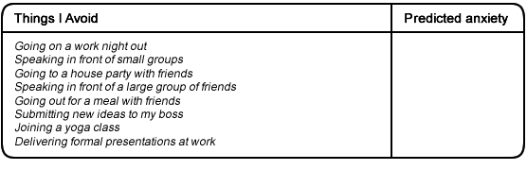
Ranking these situations
Rank your list of situations in order of difficulty. From the least anxiety provoking to the most anxiety provoking on a scale of 0-100. 0 = no anxiety and 100 = extreme anxiety. Use box 2 (page 28).
For example:
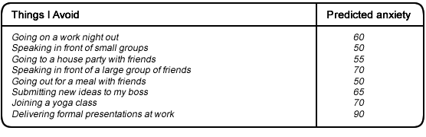
Once you have done this, try to organise your items from least anxiety provoking to most anxiety provoking. You can use box 3 on page 28 to do this.
Confronting the lowest ranked situation
Try to confront the lowest ranked item on your list. This will be the item that causes you least anxiety. You will likely find that although your anxiety might initially rise, it will drop if you remain in the situation for long enough. Try to stay with the situation until your anxiety has reduced by at least half.
Repeating this task
Repeat the task as often as possible (every day if you can). Try not to leave too long between times when you confront this item. This is because the more you confront something, the more your fear will reduce. You should notice your anxiety getting less and less each time you do so. You may find eventually that it will cause you little or no anxiety at all.
Moving on to the next lowest item
When you feel comfortable with an item, try to move on to the next item on your list. Working through your list you will begin to feel anxious in fewer and fewer situations. You should find that your confidence grows as you move on from each item. You should find that tasks ranked as more difficult seem more manageable as you progress.
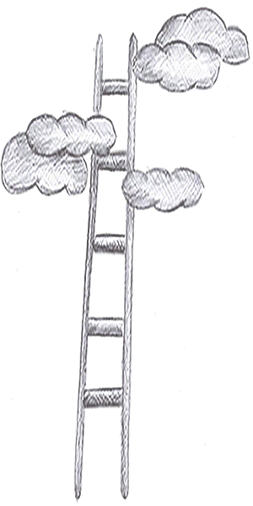
Things to consider:
- Don't fear the symptoms of anxiety. Anxiety is a natural and healthy reaction that is not dangerous.
- Try not to escape situations you fear half-way through. Stay, and your anxiety will eventually decrease.
- Your anxiety will reduce each time you confront a feared situation. Try to confront your fears as often as possible.
- You may also find it helpful to challenge any unhelpful thoughts as you face a fear.
- Look out for other situations that you avoid due to anxiety. Try to gradually reduce your avoidance more and more.
- You may confront an item on your list which doesn't go as well as you had hoped. Try not to give up. Persevere, and it should eventually get easier.
- If an item on your list seems too hard, see if you can put in an extra step or two before it. This will allow your confidence to rise further before you face it.
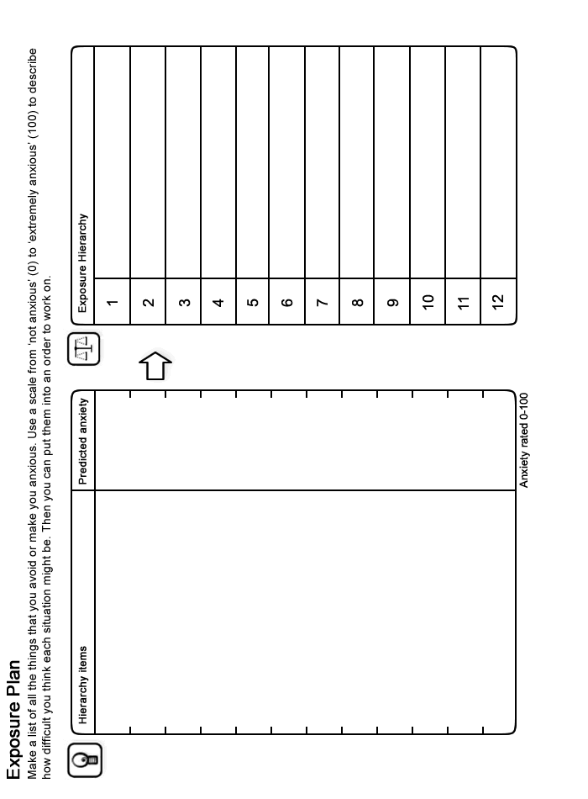
Final Word
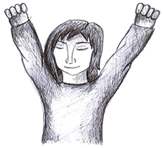
We hope that you found some of the ideas in this booklet useful. You can continue to use the techniques you found helpful long into the future and they should continue to benefit you. If some of the ideas are not particularly helpful at first, it is perhaps worth sticking with them for a few weeks to give them a chance to work. If however you feel your situation remains largely unchanged or if you did not find this booklet useful, you should speak to your GP who can tell you about the other options available which you could find helpful.
Further Information and Resources
For further information and self-help resources go to Moodjuice online:
http://www.moodjuice.scot.nhs.uk
Moodjuice is a website designed to offer information and advice to those experiencing troublesome thoughts, feelings and behaviours. In the site you can explore various aspects of your life that may be causing you distress and obtain information that will allow you to help yourself. This includes details of organisations, services and other resources that can offer support. This self help guide comes from a series that you can access and print from Moodjuice. Other titles available include:
- Depression
- Anxiety
- Stress
- Panic
- Sleep Problems
- Bereavement
- Anger Problems
- Social Anxiety
- Phobias
- Traumatic Stress
- Obsessions and Compulsions
- Chronic Pain
Some Useful Organisations
The following organisations or services may be able to offer support, information and advice.
Samaritans
Samaritans provides confidential emotional support, 24 hours a day for people who are experiencing feelings of distress or despair, including those which may lead to suicide. You don't have to be suicidal to call us. We are here for you if you're worried about something, feel upset or confused, or you just want to talk to someone.
Phone:
116123

Web Site:
http://www.samaritans.org
Anxiety UK
National charity established in 1970 to provide support and services to those suffering from all anxiety disorders, obsessive compulsive disorder, generalised anxiety disorder, panic attacks, social phobia, simple phobia, phobia and tranquiliser issues.
Phone:
08444 775 774

Web Site:
http://www.anxietyuk.org.uk/
Breathing Space
Breathing Space is a free, confidential phone line you can call when you're feeling down. You might be worried about something - money, work, relationships, exams - or maybe you're just feeling fed up and can't put your finger on why.
Phone:
0800 83 85 87

Web Site:
http://www.breathingspacescotland.co.uk
Living Life to the Full
Living Life to the Full is an online life skills course made up of several different modules designed to help develop key skills and tackle some of the problems we all face from time to time.
Web Site:
http://www.llttf.com/
Further Reading
The following books may be able to offer support, information and advice.
Feel the Fear and Do It Anyway
How to turn your fear and indecision into confidence and action
Author: S Jeffers
Published: 2011
How to Stop Worrying
A guide to making worry work for you, helping you to avoid stress and anxiety. The author sets out to teach how to understand fear and face the possibilities of life calmly.
Author: Frank Tallis
Published: 2009
Managing Anxiety
Book teachs self-help skills and methods of controlling anxiety.
Author: Helen Kennerley
Published: 1995
Overcoming Anxiety
A self-help guide using cognitive behavioural techniques to help people take charge of their own recovery. This book explains why anxiety is a major problem for some people and not for others. It describes the various forms that anxiety problems may take, including panic attacks and phobias, and then guides the reader through a series of steps to enable them to overcome problem fears and anxieties of all kinds. The book contains many illustrative quotes from people who have had anxiety problems, allowing readers to realise that many others have shared similar experiences and have overcome their difficulties.
Author: Helen Kennerley
Published: 2009
Overcoming Anxiety, Stress and Panic: A Five Areas Approach
Divided into workbooks that are designed to help those experiencing mild to moderate levels of anxiety and panic, this title is easily accessible with boxes, checklists and bullet points to make the information easier to understand. The first workbooks should aid the reader in identifying and assessing the extent of their problem. The reader can then chose which workbooks may be most helpful and work on the exercises at their own pace.
Author: Chris Williams
Published: 2009
Overcoming Panic
A complete course to help the reader beat panic attacks and the stresses they cause. The author, who has both researched and taught self-help techniques, describes clinically-proven therapy techniques. This book provides a step-by-step management program that provides the necessary skills for overcoming and preventing panic attacks and associated agoraphobia.
Author: Derrick Silove
Published: 2009
Overcoming Panic, Anxiety and Phobias
This practical handbook, recommended for people whose lives are upset by worry, fear, or panic, offers coping strategies based on the latest clinical research. Personal stories of recovery, worksheets for recording symptoms and progress, and information on finding professional help make this book a must-read for anxiety sufferers who want to regain control of their life.
Author: Carol Goldman & Shirley Babior
Published: 2008
Overcoming Shyness and Social Phobia: A Step-by-step Guide
This book provides a detailed programme for eliminating social anxieties. It is based on the latest cognitive behavioural treatments for social phobia. The book is written in simple language and provides a commonsense approach to treatment. Four people with social phobia are introduced at the beginning and these cases are followed throughout the book, illustrating the application of each technique. The book also includes progress sheets and monitoring forms for users to copy. Each section concludes with homework tasks and assignments for users to practice.
Author: Ronald Rapee
Published: 1998
Self Help for your Nerves
Essential guide for everything you need to know to keep relaxed through every day life Repackage of the phenomenally successful guide to dealing with nervous illness -- Self Help for Your Nerves. This guide offers the most comprehensive insight and advice into coping with nervous stress. Sufferers of nervous illness regard Self Help for Your Nerves as their bible -- many believe that if they had found it earlier they would have been saved years of unnecessary suffering. Dr Claire Weekes looks at: How the Nervous System Works What is Nervous Illness Common factors in the development of nervous illness Recurring Nervous Attacks Plus important chapters on depression, sorrow, guilt and disgrace, obsessions, sleeplessness, confidence, loneliness and agoraphobia. The book also shows the Dr Claire Weekes method, a practical programme on learning to take your place among people without fear.
Author: C Weeks
Published: 1995
The Anxiety and Phobia Workbook
This is a revision of the best-selling classic. It provides step-by-step help for sufferers of anxiety and phobic disorders. This edition offers the latest treatment strategies for the whole range of these problems - panic disorder, agoraphobia, generalised anxiety disorder, and obsessive-compulsive disorder - with revisions that include updated information on medications, mindfulness training, and health-related conditions that aggravate anxiety.
Author: Edmund J Bourne
Published: 2005

