Choose a Different Path:

Building Resilience by Finding Positive Solutions to Stress and Anxiety

A Guide for Young People and Parents
What is Stress and Anxiety?

Stress and Anxiety is that unpleasant feeling that affects us all when we’re faced with a scary event or thought.

We might feel stressed about a test or exam, a presentation, musical performance or match. Keeping up with homework, going to a party, making and keeping friends, having the right clothes, phone, the number of likes on Facebook……………..the list is endless!!

Stress is your mind and body’s response to these things – they are called stressors. Sometimes the stressor is obvious – “I have a test tomorrow” but sometimes you might feel anxious and not really know or be able to explain why.

It’s a horrible feeling but you are not alone!

FACT:

96% of 1300 secondary pupils admitted feeling stressed and anxious.

ChildLine National Exam Stress Survey

Crucially stress is your body’s response to perceived threat that is to say we don’t all experience stress the same way or feel stressed by the same things. For example would it worry you to attend a party where you didn’t know many people? Would you find it stressful to answer a question in front other people in class? Would you feel nervous about joining a new club? For some the answer would be a loud ‘YES’ while others would not worry about these things. This tells us that we choose to let our worries have a negative impact on our lives. While stress cannot (and should not) be avoided, we can choose how we cope with it.

Do you recognise any of these physical feelings associated with your stress and anxiety?

Heart beating faster

Feeling hotter and sweaty

Sweaty palms

Trembling

Butterflies in stomach

Feeling dizzy and lightheaded

Going to the toilet more frequently

Unable to think clearly

These physical feelings can be frightening so we assume they are harmful which just reinforces the idea that stress and anxiety are negative. In fact stress is a very healthy response which actually helps to protect us!!

The FIGHT OR FLIGHT MECHANISM works like this…….

https://www.youtube.com/watch?v=jEHwB1PG_-Q

The human body responds to stressors by activating the nervous system and producing more of the hormones adrenaline and cortisol. These hormones cause these physical changes to occur in order to react quickly and effectively to handle the pressure of the moment.

What do these hormones do to our bodies and brains?
- They make your heart beat faster to supply more blood to the muscles.
- They produce more sweat to cool you down.
- They tense our muscles to get them ready for action.
- They make you take deeper and quicker breaths to supply more oxygen to your muscles.
- They shut down body functions that aren't needed at the time e.g. digestion.
- They shut off the thinking part of your brain so you can make a quicker response and not be caught up in slow decision making!
This means under pressure we can respond positively! And not only that! Brief stressful events actually improve the performance of our brains. Understanding how your body reacts to stress will help you to manage the physical symptoms. These feelings will pass quite quickly if you can acknowledge them and why they happen!!
So……….stress actually helps us to adapt, becoming stronger and more resilient in the process.

RESEARCH FACT

A study compared 2 groups of people who were told to sit a maths test, do a presentation and sing karaoke

Group 1 were told to tell themselves that they FELT EXCITED

Group 2 were told nothing

So what happened?

Group 1 (the students who told themselves their feelings were excitement rather than nerves) performed better and experienced fewer symptoms of stress and anxiety!!

But the problem is if this stress response is activated regularly or not turned off properly then the physical feelings don’t go away and we feel in a permanent state of anxiety. If we don’t do something to deal with it over time it can have an impact on our mental and physical wellbeing and school achievement.

The good news is you can do something about it! You can take control of how your body responds. You can use stress to your advantage and you can learn to turn off your stress response when it’s becoming a problem by learning about the Cognitive Behavioural Model (CBT).

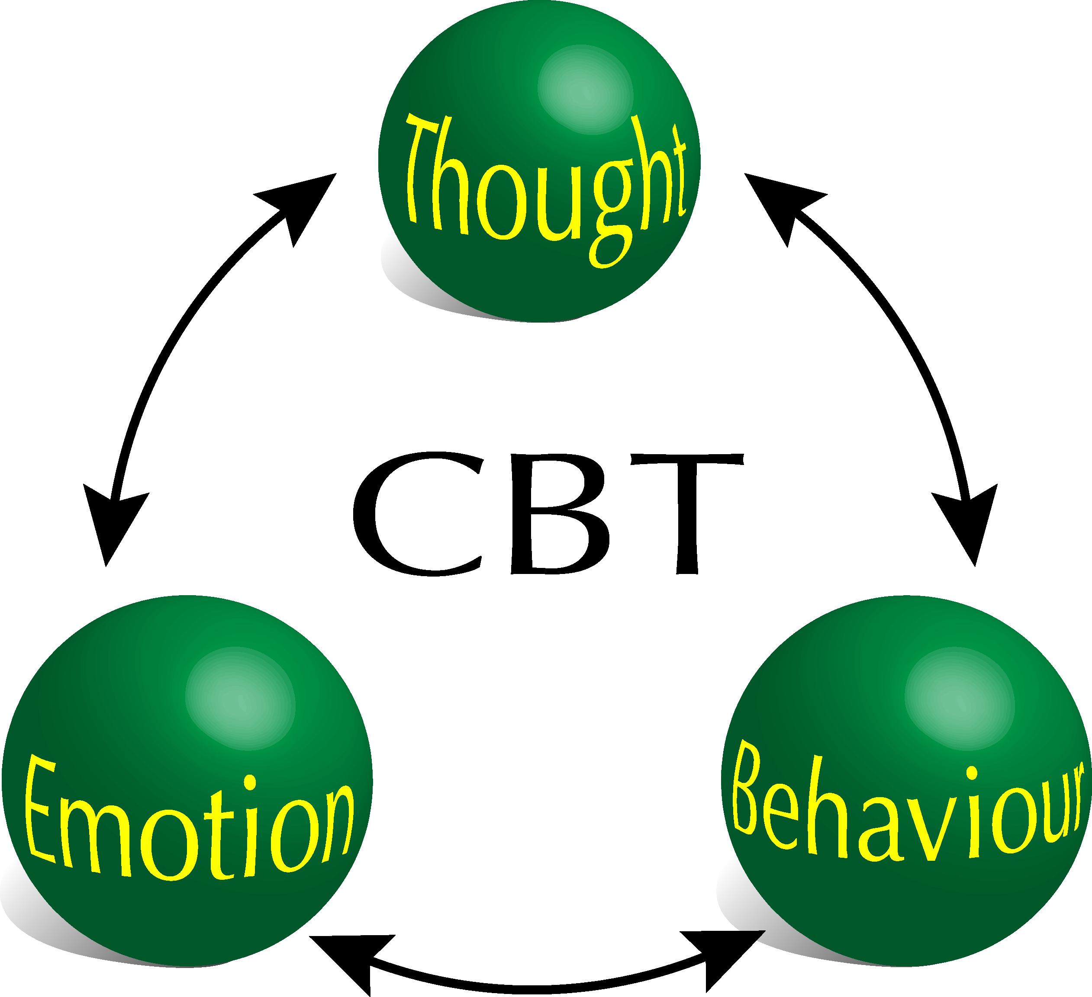

CBT is based on the idea that how we think (thought), how we feel (emotion) and how we act (behavior) all interact together and influence each other. So if we think we are going to do badly in something this will make us feel bad and we are likely to behave in unhelpful ways (which then keeps us feeling bad and thinking negative thoughts). But if we can think more positively this will have a more positive impact on how we feel and behave.

Making small changes in even 1 of these 3 areas can make a big difference!

Behaviour – Go against your instinct to hide away and avoid the scary situation or introduce activities to your day which make you feel better

Thoughts – Challenge those negative thoughts or acknowledge that they are merely thoughts

Emotion – Override your body’s reaction to stress by practicing some relaxation techniques, mindfulness or visualisation techniques

So, Let’s Start Choosing a Different Path……..

Changing how we BEHAVE
One of the hardest things to do when we feel anxious is to make changes to our behaviour. You probably want to:
- Study every minutes of the day to prepare for an exam including avoiding sleep
- Avoid studying altogether because you’re convinced you’ll fail anyway
- Hide away from people because crowds of people are too scary
- Eat more looking for short bursts of energy to improve your mood
- Smoke or drink because it takes away the pain for a while
- Shout at people who you feel are really not helping
- Keep looking at that Facebook to see if anyone else has liked your post
- Avoid exercise because you really can’t face it and you don’t have the time
The key to changing behaviour is to do it slowly. Pick one small thing to change or do more of and make a plan of how you will build it up so you are doing it more regularly. The Plan at the end of this section will help you.
Exercise
Exercise decreases the hormones which make us feel stressed (e.g. cortisol) and increases the hormones which make us feel happy (e.g. endorphins, adrenalin, serotonin). So when you exercise your mood is boosted naturally. As we have seen earlier, stress and anxiety are natural biological responses so our best defence are also natural and biological.
Cardiovascular exercise which gets your heart rate up e.g. running, dancing, swimming, cycling, walking helps to release these chemicals. Yoga is also great for reducing tension while improving mood.
But it doesn’t really matter – any kind of exercise will make a difference to your mood. Try to include it in your daily routine and try for around 30 minutes per day. And you don’t need to join a gym or a sports club just try walking a bit further or cycle to the shop instead of taking the car or bus.
Diet
Making small changes to your diet can make a big difference to your mood.
Tryptophan is an essential amino acid which is used by the body to create serotonin. This is a hormone that relaxes the brain, boosts mood and reduces anxiety levels. Foods high in proteins naturally contain tryptophan. Complex carbohydrates enhance the absorption of tryptophan into the body and our brains require adequate amount of vitamin C to convert tryptophan into serotonin. Various vitamins and minerals also help the body to more efficiently battle the effects of low mood and anxiety.
So what should you eat?
- Nuts especially Brazil nuts (perfect protein and high in vitamin b1). Other protein rich foods include almonds, sunflower seeds, sesame seeds, milk and red meat
- Oily fish e.g. tuna, cod, salmon
- Spinach, halibut, pumpkin seeds, basil, chamomile and peppermint (contains magnesium which helps to keep our nerves and muscles relaxed)
- Dark chocolate contains tryptophan. Best to go for chocolate high in cocoa solid but low in sugar to get the maximum goodness without the sugar crash later!
- Complex carbohydrates such as oats, brown rice, unrefined grains
- Milk also contains the protein tryptophan and can also help you sleep better!
- Shellfish especially shrimps
- Broccoli, avocado, banana, kale, brussel sprouts, cabbage and tomatoes have loads of natural potassium which can fend off irritability and anxiety
- Green tea is rich in L-theanine which is an amino acid found to reduce stress, promote relaxation and enhance mood
- Foods rich in vitamin C include kiwi fruit, strawberries, papaya, orange, grapefruit and guava

Sleep
FACT:
Melatonin is a hormone which is released in our brains usually one to 2 hours before bedtime and we need this for sleep. How we behave directly impacts the release of melatonin.

We’ve heard it all before – we need more sleep! But when we’re stressed sleep seems like the hardest thing in the world. So how do we break this vicious cycle and ensure we have a healthy supply of melatonin?

Check for bad habits and make small changes to your sleep hygiene:
- Watching tv and using phones and tablets late in the evening sends signals to our brain that it’s daytime. That’s because these devices emit a blue light which actually delays the release of melatonin.
- Snacking on sugary snacks and drinks or caffeine in the evening temporarily boost your energy levels and can keep you awake for hours
- Having different bedtime routines – most of us enjoy a later night and a lie in at the weekend and that change in routine shouldn’t impact our sleep too much. However, as much as possible during the week try to get to bed and get up around the same time. Again, this is related to the efficient release of melatonin. And if you are someone who struggles with sleep you might need to sacrifice those late nights at the weekend temporarily while you find a better sleep routine. Your physical and mental health is worth it!
- It’s a virtually impossible task but if you have not had a good nights sleep do not sleep during the day. Very quickly your body will adjust to that routine and it’s much more difficult to reverse it. Sitting around the house doing nothing will make you feel sleepier so make a list of daily goals, exercise and activities and stick it to the fridge or wall. If you feel sleepy pick an activity to take your mind off the fatigue.
- Try doing something different before bed. For example:
  - Read a book
  - Listen to music
  - Relaxation – breathing or mindfulness exercises
  - Have a bath
  - Do a jigsaw, draw or do something creative
- If the problem is severe and long term you might want to discuss this with your GP. Melatonin can be prescribed but without making changes to your sleep routine as well it’s unlikely to have a positive impact.

REMEMBER – sleep is important but you’ll be surprised by how well your body copes in the short term with lack of sleep. Fight the urge to nap during the day and you’ll soon benefit from a better rest at night.

RESEARCH FACT:

Research has found that doing kind things for others makes children and young people happy and these children are more popular with peers.

Daily Activities

The activities we do on a daily basis and take for granted are usually the first things we give up when our mood is low or we feel anxious. Think of these activities as energy boosters – we get those happy hormones from doing things we enjoy so they give us an energy boost. Think about your energy boosting activities and make a plan as to how you will fit these into your week and who you might need to help or motivate you.
- Listening to music
- Reading a story
- Spending time with a friends, family, pets
- Exercise
- Having a warm bath or shower
- Watching TV, going to the cinema or listening to the radio
- Pursuing a hobby e.g. musical instrument, a collection, craft, gardening, etc.
- Praying, meditating or attending a religious meeting/service
- Do something nice for someone else
Laugh
Laughter boosts our immune system, reduces stress and anxiety and improves our relationships. It distracts us from our stresses and gives us a break from them but not just that. Laughing releases hormones which fight off cortisol – so our body and mind can relax! Sometimes laughing can be the last thing we feel like doing so start small – smile! Then think about all of the things that make (or used to make) you laugh. It might be a programme, a person or a photograph. Make a laughter list and try to laugh every day.

Talk to Someone

Sometimes we might feel ashamed, guilty about burdening others, scared about what they might say or unsure where to start but talking to someone about how you feel will help. You might prefer to speak to someone you know well or you might prefer to make contact with someone who doesn’t know you so well like a counsellor or help line. These helplines are free and confidential:
Childline
Comforts, advises and protects children 24 hours a day and offers free confidential counselling.
Phone 0800 1111 (24 hours)

The Mix
Information, support and listening for people under 25.
Phone 0808 808 4994 (24 hours)

Samaritans
24 hour confidential listening and support for anyone who needs it.
jo@samaritans.org Phone 116 123 (24 hours)

B-eat
The UK's eating disorder charity. They have online support groups and a helpline for anyone under 18.
Phone 0345 634 7650 (4pm – 10pm 365 days a year)
Email fyp@b-eat.co.uk

Frank
Confidental information and advice about drugs and substance abuse, whether it's for you or someone else.
0800 7766 00 (24 hours, won't show up on your phone bill)

Stonewall
The UK charity for gay, lesbian, bisexual and transgender people and their allies. They offer information and support.
Phone 0207 593 1850 (Mon-Fri 9.30-5.30)

Changing how we THINK

Negative Cycles
Our behaviour is affected by our thoughts and feelings. Thinking about our thoughts and feelings is a VERY EFFECTIVE way of helping to overcome problems.
Often we have unhelpful ways of thinking, which leads to worried, anxious, sad, angry, or uncomfortable feelings. These feelings are unpleasant and makes us more likely to use unhelpful coping strategies (behaviour). This is the NEGATIVE CYCLE.
For example:
Unhelpful Thoughts
These include thoughts about:
Myself – “I’m bad at maths”
My ability to cope – “I can’t handle all the work!”
The future – “If I don’t get into Uni, my life is ruined”
The event/situation – “I only passed that time because the exam was easy”

Feelings
Stressed
Anxious
Irritable
Overwhelmed
Physical Symptoms
Sleeping problems
Sore stomach
Difficulty concentrating

Behaviours
Avoid studying or over-study
Shout at parents who don’t understand
Avoid spending time with friends

My Negative Cycle – Try it out with a situation you have found difficult to manage
The Difficult Situation Was:

My Thoughts

My Feelings
My Physical Symptoms

My Behaviours

Unhelpful thinking patterns
Recognising patterns in your thinking can help you to understand how these are influencing your feelings and behaviour. It’s an important 1st step in making positive changes in your perception of events.
Do you do any of these?

Once you’ve identified your own unhelpful thinking patterns you can start to challenge these and create patterns of thinking which are more helpful for you.
 | Never | Some- times | Always
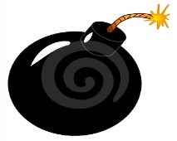
Do you blow things out of proportion?
“Another bad mark in English – I can’t do anything right!”
Do you assume what other people must be thinking?
“They are definitely laughing about me”
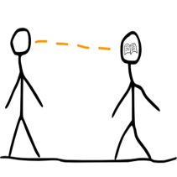
“The only reason she invited me to the party is because she feels sorry for me”
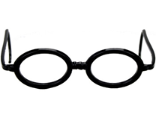
Do you see life through negative glasses?
“I had an argument with my friend on the way home from school so the whole day was a disaster”
“I only did ok in the test because I was lucky with the topics that came up”

Challenging unhelpful thoughts

The situation: Briefly describe the situation that led to your unpleasant feelings.

Initial thought: What thought first popped into your head? Is this a helpful or unhelpful thought?

Unhelpful thinking pattern: Can you identify which negative thinking pattern you’re using?

Challenge your thinking. Is this thought accurate? Look for evidence which supports the thought (for) and which contradicts the thought (against). Make sure you see the whole picture.
Evidence for:
__________________________________________________________________________
__________________________________________________________________________
__________________________________________________________________________
Evidence against:
___________________________________________________________________________
____________________________________________________________________________
____________________________________________________________________________
Alternative thinking. Can you think of a more helpful/positive way to think about the situation?

Thought Diary
It will take practice to hear and recognise these unhelpful thinking patterns. Use a Thought Diary to learn how to pay closer attention to your thoughts. Note down helpful thoughts too so you can see your progress!
 | Situation | Thought | Unhelpful Thinking Pattern?
Monday

Tuesday
Wednesday
Thursday
Friday
Saturday
Sunday

Thoughts

Use Stress to Your Advantage

Consider this…..the feelings you are experiencing are not stress, they are normal nerves about how you will perform at something. These nerves will help you perform better not worse. Tell yourself I am excited about this and your brain and then your body will respond more positively

Identify and Acknowledge Your Unhelpful Thoughts

Tell yourself

“This is just a thought. It can’t hurt me.”

Give your unhelpful thoughts a name

“This is just a blob trying to trip me up. I won’t let it.” (the funnier or more unusual the better as it will make you laugh or distract you from the thought!)

Write the thought down

Make a thoughts box which you can put a lid on. Allocate time to come back to it if necessary but while it’s in the box you can make room for more helpful thoughts and behaviours. Sometimes when you see the thought written down you can see how unhelpful it is.

Turn up the volume on more helpful or powerful thoughts

Make a list of all the things you are good at or proud of and turn these into positive thoughts. Be creative and design a poster using pens, magazines, photographs, craft materials – you’ll enjoy creating something that highlights all the best bits about you and you’ll have something to refer to when you need a reminder of how great you are!
Helpful Thoughts
“I will do my best” “I can do this” “I am excited about this”
“I have done well in the past I can do well again”
“I am a good person” “I’ll be so proud of myself”
“I have

Try These Thought Challengers
What would I say to a friend in this situation?
IS TIs there evidence that goes against this thought?
Is this thought making me feel good about myself?
Is there another way of looking at this?
Take Control of Your Focus
RESEARCH FACT:
In a study of 520 smartphone users, those who had their phone on the desk beside them performed worse in tests of working memory and intelligence than those whose phones were not in their line of sight. The distraction of our phones actually negatively impacts our ability to think and concentrate.
A researcher at the University of California calculated that it can take around 23 minutes to fully refocus on a task after being distracted.

Feeling overwhelmed by the all the things we have to achieve, not meeting our own expectations or those of others and feeling unproductive, lacking in focus are all triggers and symptoms of stress and anxiety. Taking control of your focus and making some simple changes in your daily routine will help you feel more in control of the to do list.
Taking Control of Your Focus
Simplify Your To Do List!
When we have too much to do we can often achieve very little. Make a list of everything you need to do (getting it out of the jumble in your head and onto paper will help to clarify all of your jobs). Then make a second smaller list of the things you can realistically achieve in a day or half day. Ticking each one off as achieve them will give you a real sense of satisfaction and improve your motivation. Include mundane tasks (get dressed) or tasks you’ve already done so you can tick them off quickly – your already on your way to completing your to do list!! Don’t forget to reward yourself for doing so well.
Where’s Your Phone?
We have information and knowledge at our fingertips 24 hours a day and it’s brilliant. But with the benefits of instant contact with friends and family, our favourite music and content on demand and worldwide connection comes the potential negative impact on our emotional wellbeing, cognitive development, concentration and physical health. We don’t know enough about this yet but research is slowly emerging which suggests that time spent online is detracting from activities which we know boost our mood.
- It’s hard but try to have ‘device-free’ time every day and make this time for your Energy Boosting activities
- When you are completing homework, studying or trying to achieve one of your tasks (see above) put your phone out of sight – you will get the job done quicker and better!

My Plan
Don’t try to do too much. When you set yourself too many goals you are more likely to fail and this will just compound that overwhelming feeling. Just pick 1 or 2 areas to work on for now. Once you’ve achieved your goal you can tick it off and create another goal.
I am going to make the following small changes to
Exercise

Diet

Sleep

My Energy Boosting Activities

My Thinking

Taking Control of My Concentration

Relaxation Techniques
Relaxation techniques are beneficial from a physiological perspective. We know what happens to our bodies when we experience a difficult situation so we can counteract this response by using techniques which actively lower blood pressure, reduce heart rate, improve blood flow and re-engage the prefrontal cortex in our brains allowing us to think more clearly.
If you practice enough these techniques will become effective not just for reducing the effects of stress but can actually prevent the harmful stress response being activated. Try out a few different techniques and see what works for you. Make sure you practice regularly.

Visual Meditation – Golden Thread

This technique shifts the mind away from the worry and worrying thoughts which are often difficult to ignore. It forces the mind to focus on an alternative. Don’t worry if the intruding thoughts creep in, acknowledge them and gently shift the mind back to the distracting thought.

Take 3 deep breaths, inhale through nose, exhale through mouth

Count to 5 on the inhalation and 10 on the exhalation – exhalation should always be double the length of the inhalation

When the breath feels comfortable imagine on the exhalation you are blowing a very fine gold thread from your lips, watch the gold thread flutter on the breath not leaving your lips, let the thread flutter up and down and side to side always bringing your thought back to the thread

As you are preparing to come out of meditation imagine the thread floating away from your lips, watch as it dips and floats until it is out of sight

If you wish imagine the thread floating through a place you think of as a ‘safe’ or relaxing place

Take 3 more deep breaths and slowly open your eyes taking time to adjust to your surroundings

Guided Imagery

Guided Imagery can take you on a mental mini-vacation that relaxes your body and soothes your mind.

- Get into a comfortable position.
- Close your eyes. Take in a deep, cleansing breath, expanding your stomach and keeping your shoulders relaxed, and hold it in for the count of 6. Exhale. As you breathe, inhale through your nose and exhale through your mouth, still expanding your stomach rather than moving your shoulders up and down. As you inhale, imagine that you are breathing in peace, and as you exhale, imagine that you are breathing out stress.
- Once you get to a relaxed state, begin to imagine yourself amidst the most relaxing environment you can imagine. For some, this may be floating in the cool, clear waters off a remote tropical island, with soothing music playing in the background. For others, this might be sitting by a fire in a secluded snow cabin, deep in the woods, sipping hot chocolate and reading a novel, while wrapped in a plush blanket and fuzzy slippers.
- As you imagine your scene, try to involve all your senses. What does it look like? How does it feel? What special scents are involved? Do you hear the roar of a fire, the splash of a waterfall, or the sounds of birds? Make your vision so real you can even taste it!
- Stay here for as long as you like. Enjoy your “surroundings” and let yourself be far away from all your stresses. When you are ready to come back to reality, count back from 10, and tell yourself that when you get to one, you’ll feel serene and alert, and enjoy the rest of your day. When you return, you’ll feel more calm and refreshed, like returning from a holiday without having even left the room.

Progressive Muscle Relaxation

Progressive Muscle Relaxation teaches you to relax your muscles through a two-step process. First, you deliberately apply tension to certain muscle groups, and then you stop the tension and turn your attention to noticing how the muscles relax as the tension flows away. It is a great technique for reducing overall body tension.

Sit or lie down and make yourself comfortable

Begin by tensing all the muscles in your face. Make a tight grimace, close your eyes as tightly as possible, clench your teeth, even move your ears up if you can. Hold this for the count of eight as you inhale.

Now exhale, and relax completely. Let your face go completely lax, as though you were sleeping. Feel the tension seep from your facial muscles, and enjoy the feeling.

Next, completely tense your neck and shoulders, again inhaling and counting to eight. Then exhale and relax.

Continue down your body, repeating the procedure with the following muscle groups:

Chest

Abdomen

Entire right arm

Right forearm and hand (making a fist)

Right hand

Entire left arm

Left forearm and hand (again making a fist)

Left hand

Buttocks

Entire right leg

Lower right leg and foot

Right foot

Entire left leg

Lower left leg and foot

Left foot

For the shortened version, which includes just four main muscle groups:

Face

Neck, shoulders and arms

Abdomen and chest

Bottom, legs and feet.

Balloon Breathing
Find a comfortable position and close the eyes.
Start to think about the breath, become more aware of how you breathe in and out taking 3 deeper breaths.
Imagine a deflated balloon, it can be any colour you like perhaps the favourite colour or a colour you find relaxing. Pick up the balloon and put it to the mouth taking a deep breath in. Breathe out slowly imagining the balloon getting gradually bigger. Practice making the breath out longer than the breath in so that each time you breathe out the balloon gets bigger and bigger. As you do this imagine the balloon turns into a shape. It can be any shape you want but make it a shape that makes you happy. It might be an animal, an object or even a person. See the balloon getting bigger and bigger and feel the warmth and happiness that the shape and colour gives you. Continue to breathe deeply now keeping the balloon at a constant size but enjoy seeing the balloon dance around on the breath. Now imagine the balloon drifting away. Watch it dance on the breeze, move up and down and around as it drifts further away. As you watch it float away imagine it is taking all the worries with you leaving you feeling calm, relaxed and happy.
Count to 5 slowly before you open the eyes.

Happy Room
Find a comfortable position and close the eyes.
Start to think about the breath, become more aware of how you breathe in and out taking 3 deeper breaths.
Now imagine walking into a room which makes you feel really happy, calm and relaxed. Take a moment to look around the room. What things do you see? See everything really clearly in colour. What smells do you notice? What sounds do you hear? Take time to touch things. How do they feel? Walk around and explore the whole room and enjoy the sensation of feeling happy and calm. Choose a comfortable place to sit down and take a few moments to look around the room. Feel relaxed as you take in the room, all the sights, sounds and smells. Breathe in calm and breathe out stress and frustration. As you breathe out imagine the frustration and stress slipping out of the room leaving you feeling only happy and calm.
Take the attention back to the breathing and count to 5 slowly before you open the eyes.

