A Curriculum for Excellence

How to help your
Second Level Learner
With
Numeracy & Mathematics

St. Mark’s Primary School

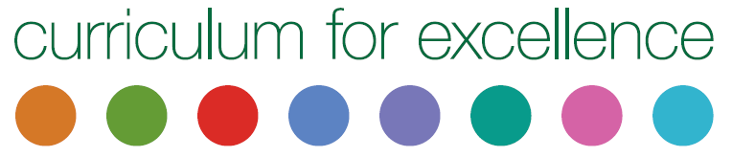
Helping your child with
Numeracy & Mathematics
Second Level

This leaflet will give you some ideas about how to support your child’s learning in Numeracy & Mathematics in small, fun, practical ways at home.

Please be encouraged to talk to your child about Numeracy & Mathematics; their skills, confidence and fluency can be developed greatly by doing so. We should be encouraging our learners to use the language of Mathematics wherever possible; like learning a foreign language, it needs to be used to become natural.

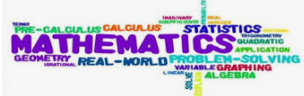

Multiplication and Division
Helping your child to learn multiplication and division facts and regularly going over them will benefit them enormously. They should learn to recite them in order as well as give ‘quickfire’ answers when they are jumbled up (e.g. “What are seven eights?”, “How many nine’s make 81?”). This can be done on car journeys or whenever there is a spare 5 minutes. The focus is on cementing their confidence and knowledge of multiplication and division facts.

Number work at home
Children’s number skills can be supported in all sorts of fun ways at home. Board games are a great way of making them familiar with the number system and addition and subtraction. Children can really enjoy inventing their own.
Playing cards are also great to use. There are a huge number of games that will encourage children’s number skills.
Quiz your child on numbers up to 1,000,000. Write a variety of numbers and ask which digit is the ten, the hundred thousand, the thousand etc..
Fractions, decimals and percentages
Encourage use of equivalent forms of common fractions to solve problems relating to time, measurement, money etc. For example, what is three quarters expressed in a variety of ways? = 0.75 = 75%.

Shape
Ask your child to identify a range of 2D and 3D shapes they can spot in their local environment or further afield. Ask them to identify different types of angles, lines of symmetry and parallel & perpendicular lines.

Money
Give you child a task to compare costs and determine affordability of an activity or project. Ensure that they stay within a given budget!
Talk to your child about the benefits and risks of using bank cards
and digital technologies.
Go shopping in the sales – what is the sale price if there is 10% off?

Time
Make sure that there are both traditional and digital clocks around the house for your child to practise reading the time to the nearest minute.
Use timetables and TV guides that use both 12 and 24 hour clock times. Use both 12 and 24 hour notations to calculate durations of activities.
Give your child projects to do- ask them to use electronic and paper-based timetables and calendars to plan events or activities.
Measure
Cooking is a great way for your child to practise weighing and measuring in grams and kilograms. It’s a terrific way to learn to accurately read scales and measure out capacities in litres and centilitres. Following recipes will also make your child familiar with measurements, including imperial measurements, with increased confidence encourage estimation of their measures and then check them with appropriate materials. Ask your child to record the weights of ingredients in different ways, i.e. 3.009kg=3009g.

Useful websites
Sumdog
Topmarks
BBC Bitsized

