**Openers**

An opener is the first word or phrase used in a sentence. There are lots of different ways of opening sentences. When children begin to write, most sentences initially begin with ‘I, they, he/she, then’. Older children will be introduced to Power Openers. Here we ask children to use connectives to start sentences. We would develop this skills by showing them how to use words ending with **ly, ing** or **ed**.

**Punctuation**

Using a wide variety of punctuation is important to add variety and interest to your child’s writing. We provide the children with lots of examples of where punctuation is used effectively and model how to use them. The pyramid below shows differentiation in punctuation. It starts at the top with basic punctuation and progresses down to using complex skills such as speech marks and brackets.

**St Mark’s Primary School**

**How can you help?**

• Look out for different types of openers when reading with your child. Why has the author chosen to start the sentence in that way?

• Ask your child to use the openers you have found and to use them to start their own sentences.



**Helpful Hints for Writing**

In St Mark’s Primary we use an approach to Writing which is based on child-centred, interactive learning with a focus on four core targets of **V**ocabulary, **C**onnectives, **O**peners and **P**unctuation. Your children may refer to this as VCOP.

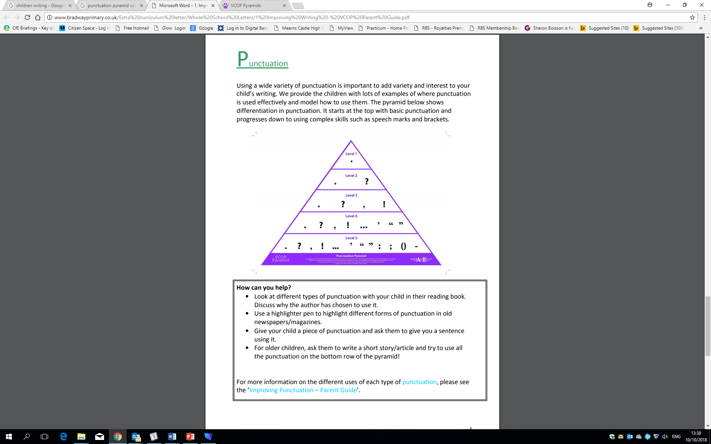

**How can you help?**

• Look at different types of punctuation with your child in their reading book. Discuss why the author has chosen to use it.

• Use a highlighter pen to highlight different forms of punctuation in old newspapers/magazines.

• Give your child a piece of punctuation and ask them to give you a sentence using it.

• For older children, ask them to write a short story/article and try to use all the punctuation on the bottom row of the pyramid!

*In St Mark’s Primary we value love, faith and understanding*

**How can you help?**

• Try to search for connectives in the stories you read at home. Use a highlighter pen to highlight connectives in old newspapers/magazines.   
• Give your child a connective and ask them to use it in a sentence.   
• Think about connectives that have a similar meaning. For example, which connectives could be used instead of ‘but’? (however)   
• Try rearranging sentences with the connectives at the start. E.g. *The little boy shivered, despite it being warm in the cave. Despite it being warm in the cave, the little boy shivered.*

**How can you help?**

* Read to, and with, your child.
* Talk about and write down interesting (wow) words in the stories you are reading at home.
* Ask your child to try using the words you have found in a sentence.
* When you use a word your child is unfamiliar with, discuss what it means with them (encourage them to use the word in a sentence).
* Discuss with them words that you would use in different situations (e.g. formal, informal).
* Have a mini-quiz: ‘How many words can you think of instead of ‘said’?’ or ‘went’, ‘nice’, ‘good’. Put each one in a sentence.
* Give your child two different words and ask them to make different a sentence from them. E.g.: ‘magical’ and ‘boy’
* Encourage your child to look up vocabulary to find possible synonyms (a word or phrase that means the same).

**Connectives**

Connective is the name for any word that links clauses or sentences together. There are two main groups of connectives: ***Conjunctions and Connecting Adverbs***

**Conjunctions** are words that are used to link clauses within a sentence. There are two main kinds:

**Co-ordinating conjunctions** – link two main clauses to make compound sentences. *e.g. and, but, or, so, for, nor, yet I was angry but I didn’t say anything*.

**Subordinating conjunctions** - go at the start of a subordinate clause. They work to link the subordinating clause to the main clause. *e.g. when, while, before, after, since, until, if, because, although, that We were hungry when we got home. When we got home, we were hungry*. (Commas are used when the subordinating clause is first).

**Connecting adverbs** link the ideas in two sentences together but the two sentences still remain separate. e.g*. also, furthermore, moreover, however, nevertheless, on the other hand, besides, anyway, after all, for example, in other words, that is to say, first of all, finally, therefore, consequently, as a result, just then, meanwhile, later Commas are often used to mark off connecting adverbs. I was angry. However, I didn’t say anything.*

**Vocabulary**It is important that children begin to think carefully about the vocabulary they choose and the effect that it has on the reader. We promote the use of “WOW” words in writing. These are words that are ambitious for the children to use; they can ‘upgrade’ their nouns, adjectives, verbs and adverbs:

**Noun** - A word that names a person, place or thing: The exhausted, frightened youngster trudged slowly through the thick mud.

**Adjective** – A word used to describe a person, place or thing: The exhausted, frightened youngster trudged slowly through the thick mud.

**Verb** - A word to describe action; what is happening in the sentence: The exhausted, frightened youngster trudged slowly through the thick mud.

**Adverb** - A word to describe how the action is taking place: The exhausted, frightened youngster trudged slowly through the thick mud.