How can you help?

**Jokes**

Generating an interest in words and how they work can encourage a love of language in children. Lots of jokes are based upon word play. Share them with your child and discuss how the play on words make them funny!

*‘The man who recently fell into an upholstery machine is now fully recovered.’*

*‘I couldn’t quite remember how to throw a boomerang, but I knew eventually it would come back to me.’*

‘*He didn’t tell his mother that he had eaten the glue. His lips were sealed.’*

*‘What did the triangle say to the circle? ‘You’re so pointless!’’*

Can children think of any of their own jokes using word play?

**Listening and Talking**

In conversation, children will be exposed to new vocabulary. Encourage

your child to discuss and debate with you; model using interesting vocabulary, specific to the subject.

Choose subjects that they may feel strongly about, and encourage them to elaborate on their ideas to support their argument,

e.g. *Should the school day be made longer? Is homework necessary?*

**Overused Words**

One way to develop more interesting writing is to focus on overused words. You may be surprised at the extent of your child’s vocabulary; however, though they may know the meanings of many words, they often don't employ them in their writing.

Read over the following sentence:

*The book was very interesting.*

There are other ways to convey the same message:

e.g. *The book covered fascinating information.*

*e.g. This work, which was actually one of Mark Twain's first endeavours, was captivating.*

Some words are specific enough, but they are so overused they are just

plain boring. While it would be awkward to avoid these words all the

time, children should take care to substitute more interesting words

whenever appropriate.

Some overused words:

*Amazing, awfully, bad, beautiful, big, fine, good, great, happy, Interesting, look, nice, quite, really, said, so, very, well, went*

**St Mark’s Primary School**



**Strategies for Improving Vocabulary**

***Noun and Verbs***

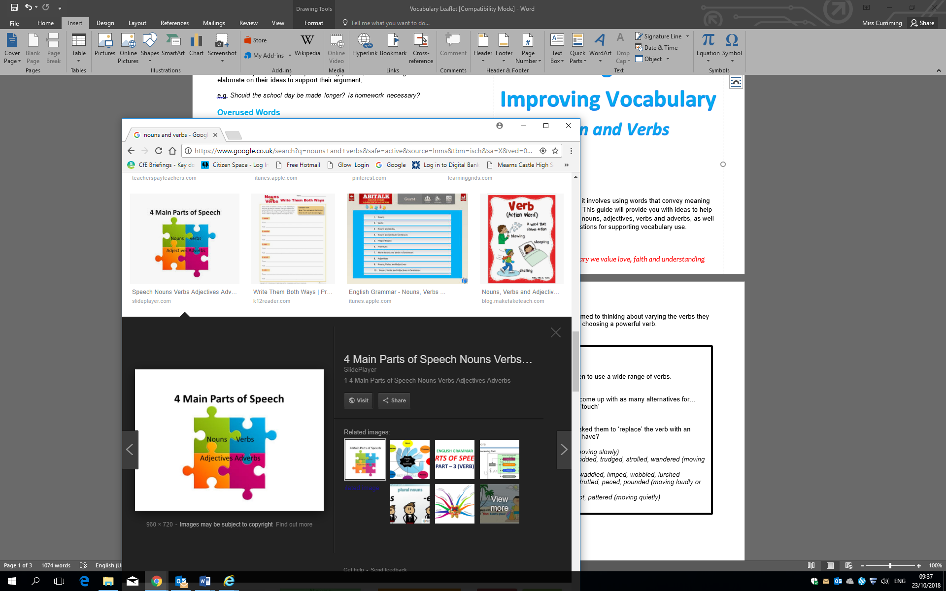

Skilful writing is not easy; it involves using words that convey meaning vividly but also accurately. This guide will provide you with ideas to help develop your child’s use of nouns, adjectives, verbs and adverbs, as well as general suggestions for supporting vocabulary use.

*In St Mark’s Primary we value love, faith and understanding*

**How can you help?**

Have fun with verbs!

Play games that require children to use a wide range of verbs.

For example:

Synonym race

Give your child 30 seconds to come up with as many alternatives for…

‘look’, ‘said’, ‘went’, ‘got’, ‘ate’, ‘touch’

Replace the verb

Choose verbs in a book and asked them to ‘replace’ the verb with an alternative. What effect does it have?

e.g.

*He went over to the window (moving slowly)*

*shuffled, crept, meandered, plodded, trudged, strolled, wandered (moving unsteadily)*

*lumbered, toddled, doddered, waddled, limped, wobbled, lurched*

*stomped, marched, traipsed, strutted, paced, pounded (moving loudly or quickly)*

*prowled, sneaked, tiptoed, crept, pattered (moving quietly)*

**Verbs**

Children need to become accustomed to thinking about varying the verbs they use. Good writing often hinges on choosing a powerful verb. 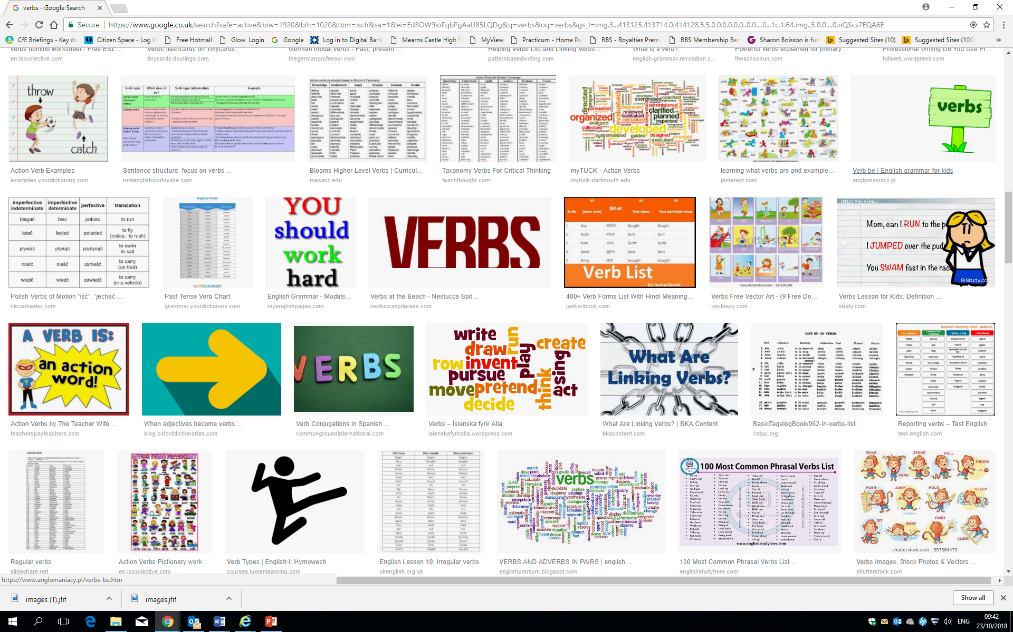

**How can you help?**

* Play games that require children to use a wide range of nouns. For example: Alphabet nouns
* Choose a category, e.g. transport, countries, food.
* Take it in turns to go through the alphabet, thinking of a noun from the category. It would look something like this:

Transport A – aeroplane B - bicycle C – car D – dodgem! E – PASS (If a player can not think of a noun for the letter, they pass. The other player scores a point and then starts at the next letter) F - Ferry Stop the Bus

* Draw a table like the one below onto a piece of paper (one for each player).
* Choose a letter (e.g. ‘t’ – see grid below)
* Players have to think of one item to go in each category beginning with the set letter.
* The first person to complete the row shouts, “Stop the Bus!”
* Check their answers. If they are all okay, that person wins a point. If there are any mistakes in their words, let the game continue for another few minutes.

|  |  |  |  |  |  |  |
| --- | --- | --- | --- | --- | --- | --- |
|  | **Animals** | **Colours** | **Food** | **Clothes** | **Countries** | **Sports** |
| **T** | Tiger | Turquoise | Tuna | Trousers | Tunisia | Tennis |
| **G** | Gorilla | Green | Gherkin | Gilet | Greece | Golf |

**Nouns**

Writing can be made more concise and accurate, by choosing precise nouns: e.g. The dog barked frantically.

The Alsatian, Labrador, Rottweiler, Jack Russell…

The man stepped out of the car. ….the Bentley, Nissan Micra, Limousine

**Adjectives**

Adjectives add information and detail to a noun. They can make our writing clear and interesting. However, children need to begin to use them discerningly, as they can also make our writing confusing, cluttered and less likely to have an effect.

**To Describe Taste**

bitter, bland, delicious, fruity, gingery, minty, pickled, salty, sour, spicy,

sweet, tangy, tasty, yummy

**To Describe Touch:**

boiling, breezy, bumpy, chilly, cold, cool, damaged, damp, dirty, dry,

dusty, filthy, flaky, fluffy, freezing, fuzzy, greasy, hard, hot, icy, loose,

melted, painful, plastic, prickly, rough, sharp, silky, slick, slimy, slippery,

smooth, soft, solid, steady, sticky, tender, tight, uneven, warm, wet

**To Describe Sound**

blaring, deafening, faint, high-pitched, hissing, hoarse, hushed, husky,

loud, melodic, moaning, muffled, mute, noisy, purring, quiet, raspy,

resonant, screeching, shrill, silent, soft, squeaking, squealing,

thundering, voiceless, whispering

**To Describe Colour**

azure, black, blue, bright, brown, crimson, dark, drab, dull, gold, grey,

green, indigo, lavender, light, magenta, multi-coloured, mustard, orange,

pink, pinkish, purple, red, rosy, scarlet, silver, turquoise, violet, white,

yellow

**To Describe Size**

abundant, fat, giant, gigantic, great, huge, immense, jumbo, large, little,

long, majestic, mammoth, massive, miniature, petite, puny, scrawny,

short, small, tall, teeny, thin, tiny, vast

**To Describe Shape**

blobby, broad, circular, crooked, curved, cylindrical, deep, distorted, flat,

fluffy, globular, hollow, low, narrow, oval, rotund, round, skinny, square,

steep, straight, triangular, wide

**To Describe an Amount**

all, ample, astronomical, bountiful, considerable, copious, countless,

enough, every, few, full, heavy, hundreds, large, light, limited,

little, many, measly, mere, multiple, myriad, numerous, paltry,

plentiful, profuse, several, sizable, some, sparse, substantial, teeming

**To Describe a Person or Personality**

aggressive, ambitious, angelic, brainy, breathless, busy, calm, capable,

careless, cautious, cheerful, clever, concerned, crazy, curious, deep,

delightful, determined, different, diligent, energetic, erratic, evil,

exuberant, famous, fearless, fragile, frank, functional, gabby, generous,

gifted, helpful, hesitant, innocent, inquisitive, insane, jaunty, macho,

modern, mushy, naughty, odd, old, open, powerful, puzzled, restless,

rich, righteous, romantic, rustic, ruthless, sassy, secretive, sedate, shy,

sleepy, sombre, stingy, swanky, tame, terrific, uninterested, vague,

vivacious, wild