**Reading**

Reading to and with children is extremely important to the development of vocabulary. For further information on reading with your child, please refer to the following leaflets:-

* *Reading Skills*
* *How can I help my child become a Thinking Reader*

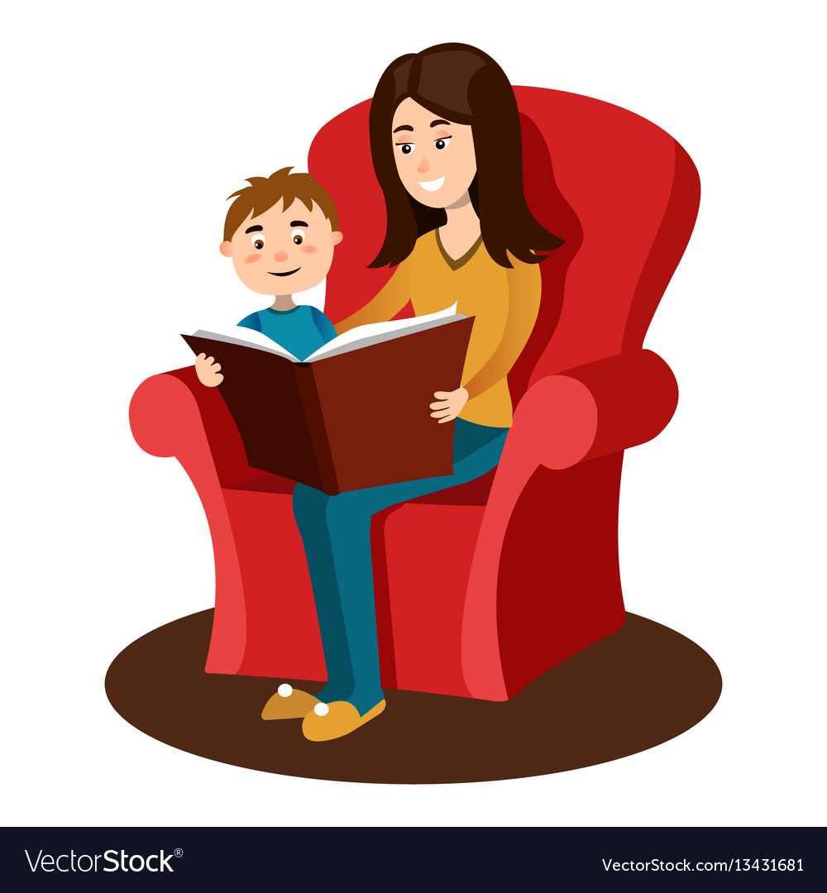

**Overused Words**

One way to develop more interesting writing is to avoid overused words. You may be surprised at the extent of your child’s vocabulary; however, though they may know the meanings of many words, they often don't employ them in their writing.

Read over the following sentence:

The book was very interesting.

There are other ways to convey the same message:

e.g. *The book covered fascinating information.*

*e.g. This work, which was actually one of Mark Twain's first*

**St Mark’s Primary School**



**Strategies for Improving Vocabulary**

***Adverbs***

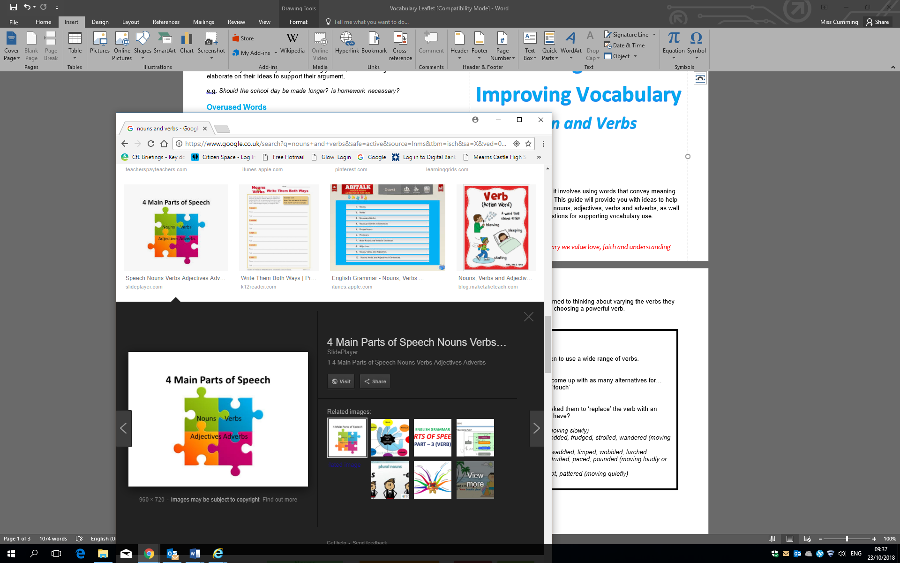

Skilful writing is not easy; it involves using words that convey meaning vividly but also accurately. This guide will provide you with ideas to help develop your child’s use of nouns, adjectives, verbs and adverbs, as well as general suggestions for supporting vocabulary use.

*In St Mark’s Primary we value love, faith and understanding*

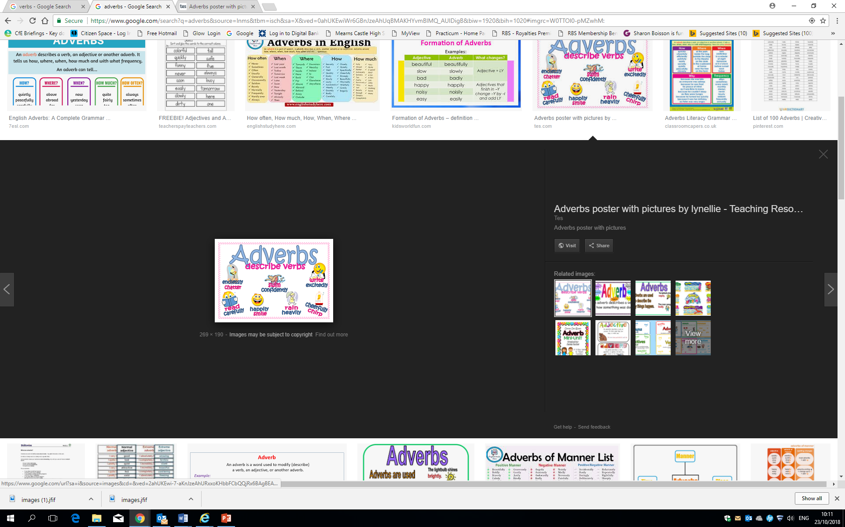

**Adverbs**

Adverbs add further detail and depth to writing by describing the way something happens. Mastering adverbs really gives children the impetus

and confidence to make their own writing more colourful and interesting.

**How can you help?**

Play games that require children to use a wide range of adverbs.

For example:

Charades

* Choose a verb to act out, e.g. danced, walked
* Brainstorm a list of adverbs that might go with the verb to describe how it was being done, e.g. wildly, softly, excitedly, happily
* Take it in turn to perform the charade in the manner of the adverb.
* Can the other players guess which adverb they are acting out?
* Take it in turns

Quick fire adverbs

Quickly call out verbs – your child must respond with an appropriate adverb without hesitating or repeating

*e.g. eat – messily, play – noisily, sleep – peacefully, dance – wildly*

General Vocabulary Builders

**Jokes**

Generating an interest in words and how they work can encourage a love of language in children. Lots of jokes are based upon word play.

Share them with your child and discuss how the play on words make

them funny!

*‘The man who recently fell into an upholstery machine is now fully recovered.’*

*‘I couldn’t quite remember how to throw a boomerang, but I knew eventually it would come back to me.’*

*‘He didn’t tell his mother that he had eaten the glue. His lips were sealed.’*

*‘What did the triangle say to the circle? ‘You’re so pointless!’’*

Can children think of any of their own jokes using word play?

**Listening and Talking**

In conversation, children will be exposed to new vocabulary. Encourage your child to discuss and debate with you; model using interesting vocabulary, specific to the subject.

Choose subjects that they may feel strongly about, and encourage them to elaborate on their ideas to support their argument,

*e.g. Should the school day be made longer?*

*Is homework necessary?*

For further information on Listening and Talking, please refer to the *ABCS of Listening and Talking* Leaflet