**How can you help?**

This scene has been annotated with prompts to encourage children to

describe settings using their senses.

Use a scene (out of the window, in a magazine, holiday photos) and ask

children to describe it, using their senses.

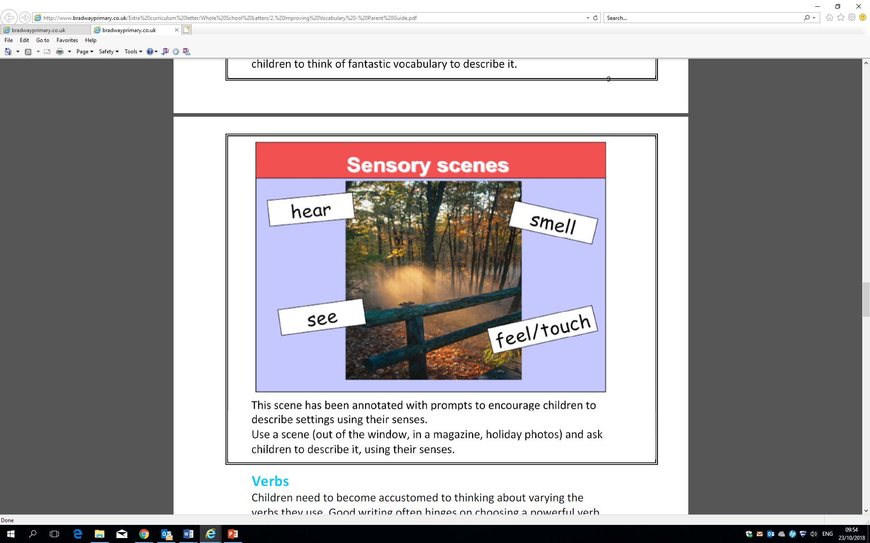

**St Mark’s Primary School**



**Strategies for Improving Vocabulary**

***Adjectives***

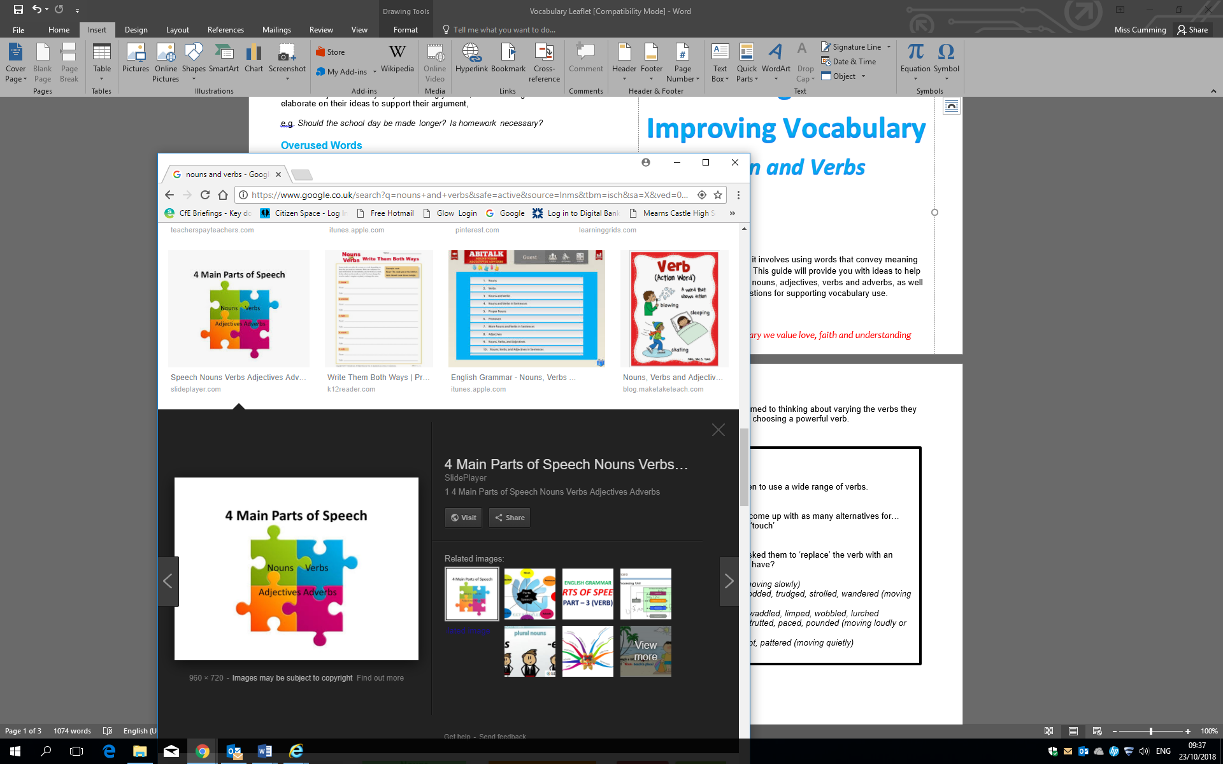

Skilful writing is not easy; it involves using words that convey meaning vividly but also accurately. This guide will provide you with ideas to help develop your child’s use of nouns, adjectives, verbs and adverbs, as well as general suggestions for supporting vocabulary use.

*In St Mark’s Primary we value love, faith and understanding*

**To Describe a Person or Personality**

aggressive, ambitious, angelic, brainy, breathless, busy, calm, capable,

careless, cautious, cheerful, clever, concerned, crazy, curious, deep,

delightful, determined, different, diligent, energetic, erratic, evil,

exuberant, famous, fearless, fragile, frank, functional, gabby, generous,

gifted, helpful, hesitant, innocent, inquisitive, insane, jaunty, macho,

modern, mushy, naughty, odd, old, open, powerful, puzzled, restless,

rich, righteous, romantic, rustic, ruthless, sassy, secretive, sedate, shy,

sleepy, sombre, stingy, swanky, tame, terrific, uninterested, vague,

vivacious, wild

**How can you help?**

Play games that require children to use a wide range of adjectives.

For example:

**Name the noun**

Ask children to think of a noun. They must use adjectives (descriptive

language) to help you visualise, and then guess, what they are thinking

of.

**Descriptive settings**

This scene has been annotated with descriptive words, a simile and a

metaphor.

Use a scene (out of the window, in a magazine, holiday photos) and ask

children to think of fantastic vocabulary to describe it.

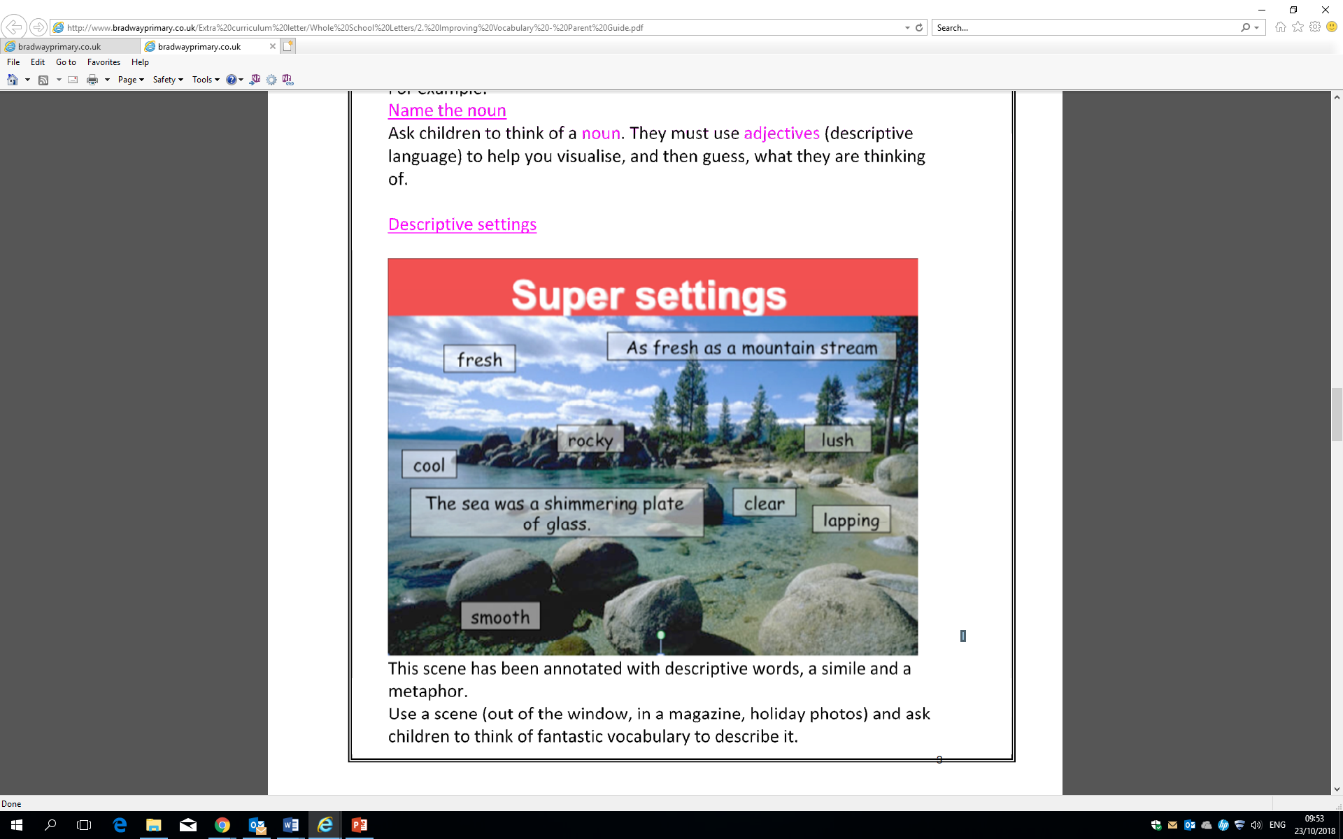

**Adjectives**

Adjectives add information and detail to a noun. They can make our writing clear and interesting. However, children need to begin to use them discerningly, as they can also make our writing confusing, cluttered and less likely to have an effect.

**To Describe Taste**

bitter, bland, delicious, fruity, gingery, minty, pickled, salty, sour, spicy,

sweet, tangy, tasty, yummy

**To Describe Touch:**

boiling, breezy, bumpy, chilly, cold, cool, damaged, damp, dirty, dry,

dusty, filthy, flaky, fluffy, freezing, fuzzy, greasy, hard, hot, icy, loose,

melted, painful, plastic, prickly, rough, sharp, silky, slick, slimy, slippery,

smooth, soft, solid, steady, sticky, tender, tight, uneven, warm, wet

**To Describe Sound**

blaring, deafening, faint, high-pitched, hissing, hoarse, hushed, husky,

loud, melodic, moaning, muffled, mute, noisy, purring, quiet, raspy,

resonant, screeching, shrill, silent, soft, squeaking, squealing,

thundering, voiceless, whispering

**To Describe Colour**

azure, black, blue, bright, brown, crimson, dark, drab, dull, gold, grey,

green, indigo, lavender, light, magenta, multi-coloured, mustard, orange,

pink, pinkish, purple, red, rosy, scarlet, silver, turquoise, violet, white,

yellow

**To Describe Size**

abundant, fat, giant, gigantic, great, huge, immense, jumbo, large, little,

long, majestic, mammoth, massive, miniature, petite, puny, scrawny,

short, small, tall, teeny, thin, tiny, vast

**To Describe Shape**

blobby, broad, circular, crooked, curved, cylindrical, deep, distorted, flat,

fluffy, globular, hollow, low, narrow, oval, rotund, round, skinny, square,

steep, straight, triangular, wide

**To Describe an Amount**

all, ample, astronomical, bountiful, considerable, copious, countless,

enough, every, few, full, heavy, hundreds, large, light, limited,

little, many, measly, mere, multiple, myriad, numerous, paltry,

plentiful, profuse, several, sizable, some, sparse, substantial, teeming