**St Mark’s Primary School**

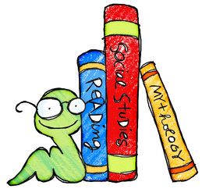

**Reading Skills**

The following are questions on the different reading skills we are teaching in school. These questions are only suggestions and can help your child understand what he/she is reading at a deeper level. They also offer the opportunity to open up a discussion on different themes.

**MAIN IDEA**

What is the main idea or plot? Can we sort the story into beginning/middle/end? Is it a good title? Let’s make up a new one.

**SUPPORTING DETAILS**

What Other details help us understand the main idea> Can we sort the different ideas, thoughts and events in the passage? Can you find the areas of conflict or problems in the passage?

**SEQUENCING**

In what order did the events happen in the story? What did the character think of first? Can you find the words that tell where and when the story/action/setting happened? Can you tell me, in order, everything the main character did in each place he went? Have fun making up a new character who could have changed the sequence of events!

**LITERAL COMPREHENSION**

What Happened to the character? Why do you think this happened? What words tell us about when things happened? Discuss how the story began/ended.

**CHARACTER ANALYSIS**

What events caused the character to do certain things? How did the character make these choices? Was he right? Why do you think this? If he made another decision what could have happened? How would this have affected the rest of the story and characters?

**PERSONAL EXPERIENCE/OPINIONS**

Do we know anyone else who has gone through the same problems or situation? Have you ever felt the same as this character? What happened? When? How did you feel? Why?

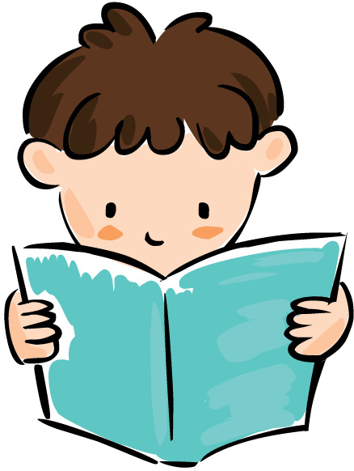



**How can I help my child become a Thinking Reader?**

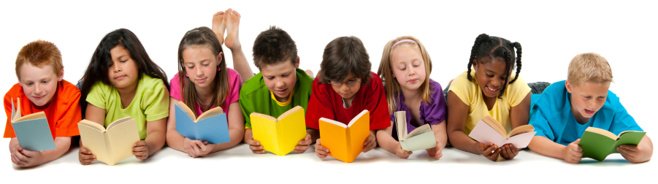

*In St Mark’s Primary we value love, faith and understanding*



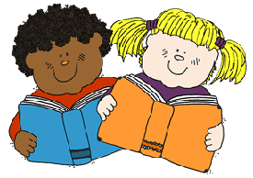

There are different levels of understanding. Often these are checked by asking different types of questions.

**Right there!** – The answer is right there in the text

* Read the question
* Look for key words in the question.
* Use these to find the correct section of the text.
* Read to find the answer.
* Write the answer

**Think and Search!** – There are some clues in the text but you have to think.

* Scan the text to find the right section – Skating eyes. Important to scan for key words then read carefully around the words.
* Find clues in the text.
* Think about the question.
* Use clues in the text and what you know about the subject.

**On your own!** – The answer isn’t in the text.

* Scan the text to find the right section.
* Use what you know about the subject to answer the question.

**How can I help my child at home?**

* Encourage your child to read as much as possible.
* If your child is having difficulty understanding what they are reading, suggest using one of the strategies listed.
* Children need general knowledge to understand what they are reading. Talk to your child about different subjects, encouraging them to find out information from the internet or books.
* Homework is to practise and reinforce class work. Don’t give your child the answer. If s/he cannot find the answer, write a note to the teacher explain this. The teacher will explain the answer in class.
* Do paired reading.

**How do children become ‘Thinking Readers’?**

Reading involves two key skills:

* ***Reading words***

We use knowledge of sounds, words we know by sights, clues from the picture or text to tackle new words

* ***Understanding what we are reading***

It is possible to read the words without understanding what they mean. Even as an adult you can read a page of a book and realise you haven’t understood it.

**Before Reading**

* Don’t open the book straight away….Look at the front/back cover and blurb. What is this about?
* Look at the picture/title
* Skim the first few lines
* Think about what you already know
* Think of good questions

**During Reading**

* Stop! Check! Am I understanding what I am reading?
* Read back, read on
* Check news words in a dictionary
* What do I know already?
* Look for clues in text/picture