**Multi-Sensory Spelling Activities**

These activities are a great way to help your child spell and form letters. These are a super way of lowering the stress of homework and making learning more fun!

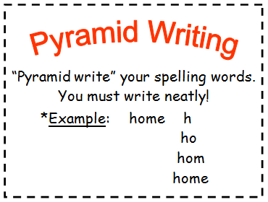 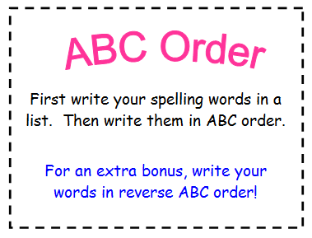

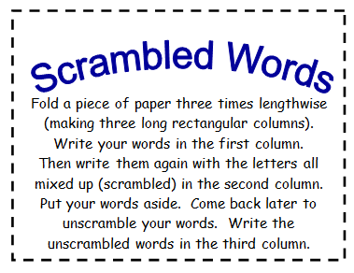 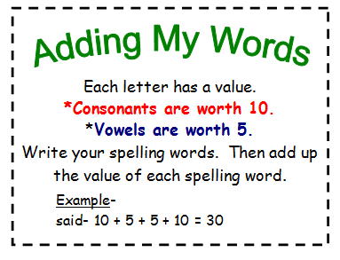

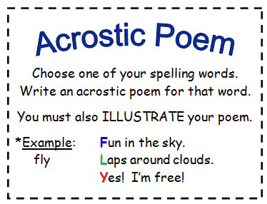 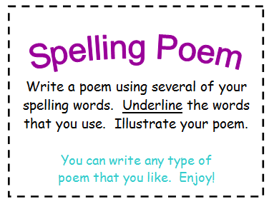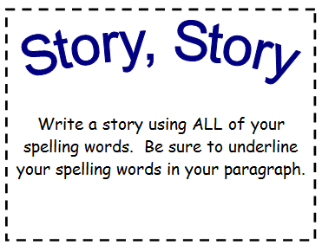

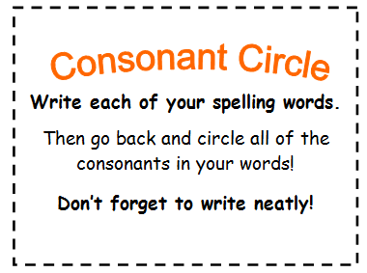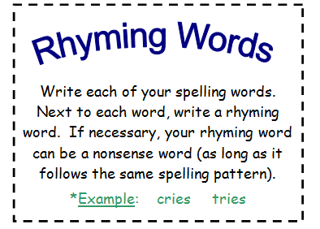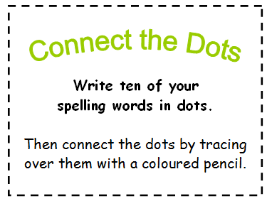

**St Mark’s Primary School**



**How can I help my child with**

**?**

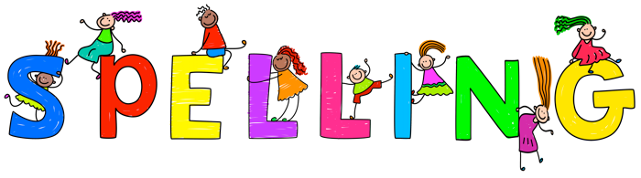

*In St Mark’s Primary we value love, faith and understanding*

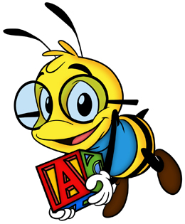

**How do children learn to spell?**

It is essential that your child does not copy the word. This does not help them to learn to spell the word as children look at individual letters, rather than remembering what the word looked like.

They should :

* **Look** at the word
* **Say** the word
* **Cover** the word
* **Write** the word
* **Check** the word. Is it correct?

**This ensures children have to think about the word. This process means that they are more likely to remember it.**

We teach the children sounds (or phonemes) to help them read and spell. These phonemes are taught in groups. It is vital children learn these so, for example, you can help by asking them the three ways of making the ‘A’ sound (as in rain) etc.

|  |  |  |  |
| --- | --- | --- | --- |
| ai – rain  ay – play  a-e - make | Ie – tie  i-e- line  igh – night  y - cry | oa – goal  ow – low  o-e - bone | al –also  au- August  aw - claw |
| ee – feet  ea - meat | qu – queen  y - story | ir – girl  ar – car  er – river  or - fork | th - them |
| sh - shop | oo – book  ue - blue | wh - when | u-e - cube  ew - few |
| ou – out  ow - cow | oi – boil  oy - toy |  |  |

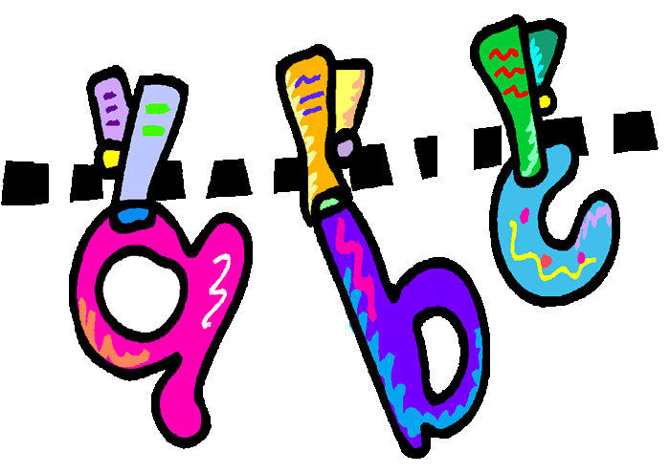

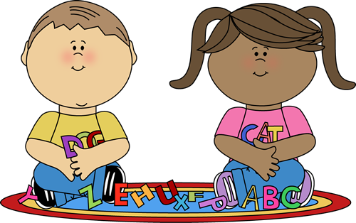

**Common Words**

The children also have to learn the most ‘Common Words’. These are in sets and are the most difficult to learn as they are often irregular words. You can help by practising these words with your child. Make it a game – How many words can you spell correctly? Can you beat your previous score?

Common Words 1

|  |  |  |  |  |
| --- | --- | --- | --- | --- |
| a | and | he | I | in |
| is | it | my | of | that |
| the | to | was | we | went |
| own name |  |  |  |  |

Common Words 2

|  |  |  |  |  |
| --- | --- | --- | --- | --- |
| all | are | as | at | be |
| but | for | had | have | him |
| his | not | on | one | said |
| so | they | then | with | you |
| name of brother | name of sister | name of friend |  |  |

Common Words 3

|  |  |  |  |  |
| --- | --- | --- | --- | --- |
| an | been | best | big | by |
| came | can | day | friend | from |
| go | good | has | her | here |
| if | like | little | made | me |
| more | new | our | out | see |
| some | there | them | this | today |
| two | up | when | which | will |
| days of the week | colour names | number names | own address |  |

If you child has to write a sentence for a word, they should write a simple sentence showing that they understand the meaning of the word. The child should make up the sentence then have a go at writing the words, spelling them using these strategies:

* Are there sounds (phonemes) in the word that I know?
* If there are, which way of making the sound is it?
* Do I know a word that rhymes with the word I have to spell?
* Does it help me spell the word?