Fairtrade Meeting Agenda
Date__6th June 2018__
Present
Miss Mckay, Ross, Daniel, Megan, Emily, Reece, Jay, William, Emma, Luke, Ava, Leah, Ebony, Ciaran, Thomas, Liam, Jordon, Summer, Erin, Anna
Absent -

Topic | Points Discussed | Comments/Actions
Fairtrade baking | - Pupils discussing every role before baking  - Baking the muffins  - Following a recipe | Erin – leading baking group 1  Jordan, Ava, Ciaran, Emma, Ross, Reece  Summer – leading baking group 2  Liam, Ebony, Luke, Daniel, Jay  Anna – leading baking group 3  Thomas, Leah, Megan, Emily, William
End of year evaluation | - Looking back at tasks over the year, evaluating our progress | See below  Summer and Anna completed with groups using chromebooks, Anna completed on the whiteboard
Next Year | - Ideas for activities next year | See below
AOCB

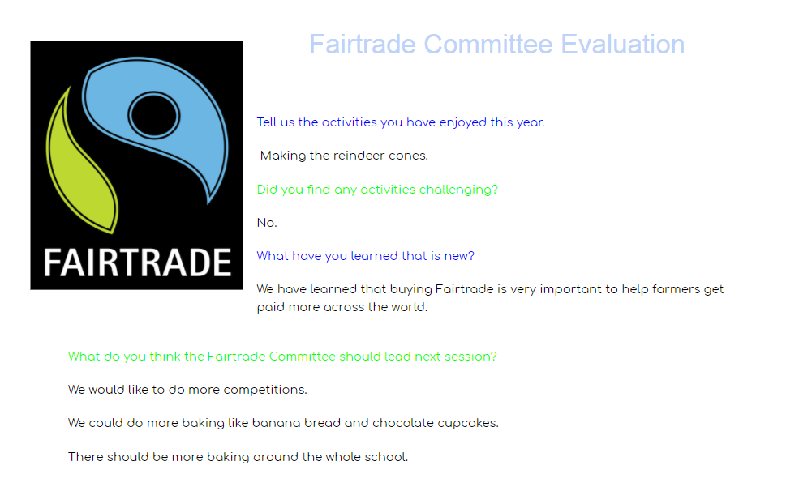
Led by Summer Turnbull P6 and Anna Wilson P7
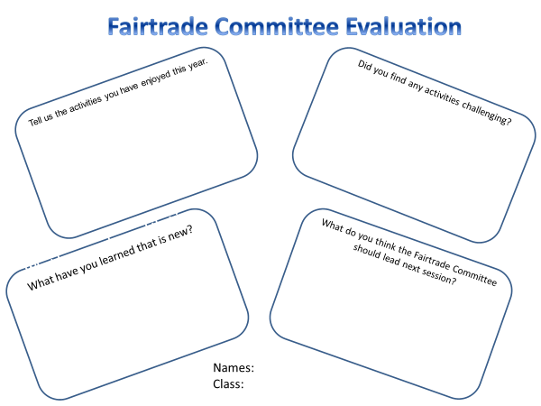
Question one
Speaking at assembly, making the reindeer cones, scooping the hot chocolate, selling the reindeers, drew pictures of Fairtrade products, liked the minion with bananas, drawing posters for the Fayre
Question two
Measuring the hot chocolate powder, getting ready for assembly, speaking at assembly, supporting the Primary 1’s when painting
Question three
Plants can sometimes grow, bananas grow on trees, Fair trade is real, how to work with younger and older children
Question four
Paper aeroplanes with fairtrade facts, special hot chocolates, frozen hot chocolate, make our own chocolate, visit as chocolate factory- Cocoabean,

