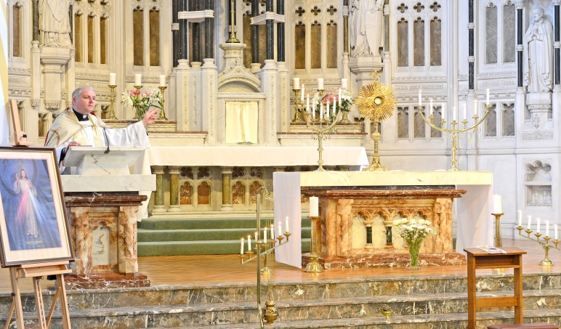 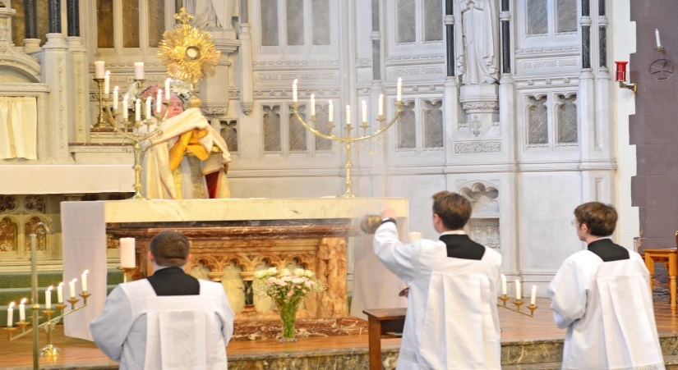

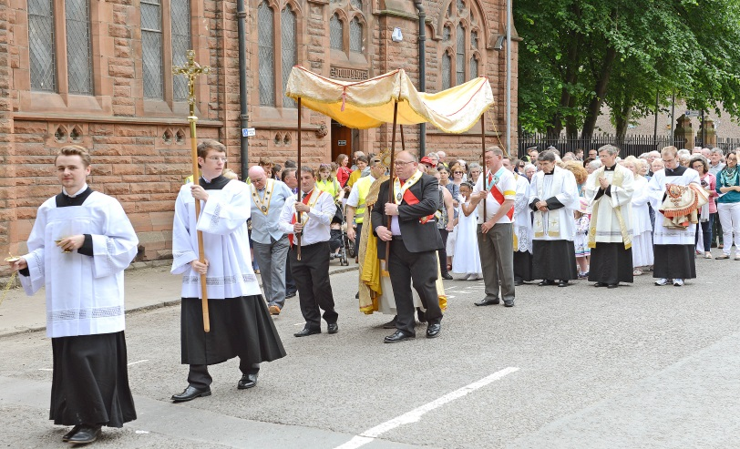

**The first annual Corpus Christi**

Procession will take place on Saturday 17th June 2017

**Will YOU Join us on SATURDAY 17th June 2017   
Father Stephen Baillie will be leading us in a Holy Hour at 3 p.m. St Charles, Paisley. We will then process to St Mirin’s where Fr Frank Hannigan will celebrate Holy Mass. Refreshments in Hall afterwards.  
 **