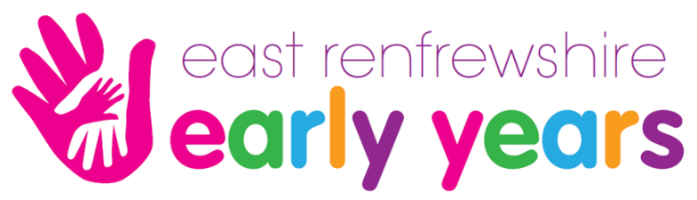

Are you in need of a little bit of help?
Do you have a concern?
Then maybe we can support you!

Family First is a free confidential advice and information resource in East Renfrewshire.
From time to time families can run into difficulties, emotionally, financially or even physically, stopping them from doing even the simplest of things.
Do you have a child aged 0-8 and require a little bit of help? The Family First team would be happy to talk to you about how they can support you and your family.
We have an informal friendly approach and can support you with issues around:
- School
- Health
- Home
- Money
- Parenting
- Confidence
- Other

School

- Applying for school clothing grants
- Help with homework
- Applying for and receiving free school meals
- Planning for the school day
- Information on nursery places/childcare

Health

- Navigate you to the right service
- Eating well
- Keeping fit
- Making/attending appointments

Home

- Budgeting and money
- Preparing healthy meals and snacks
- Establishing good family routines
- Building positive relationships

Money

- Benefits advice
- Debt advice
- Dealing with bank statements and letters
- Advice on saving

Parenting

- Behaviour
- Breastfeeding groups
- Mother and baby/toddler groups
- Parenting classes

Confidence

- Advice on reading, writing and maths for all ages
- Assistance with filling in forms
- Advice on applying for, and filling in job applications
- Help and advice on joining groups within the local community
Roslyn Graham – Call/Text 07800 712388

Email – Roslyn.graham@eastrenfrewshire.gov.uk

Pop in to: St Marks Primary School or Arthurlie Family Centre.

