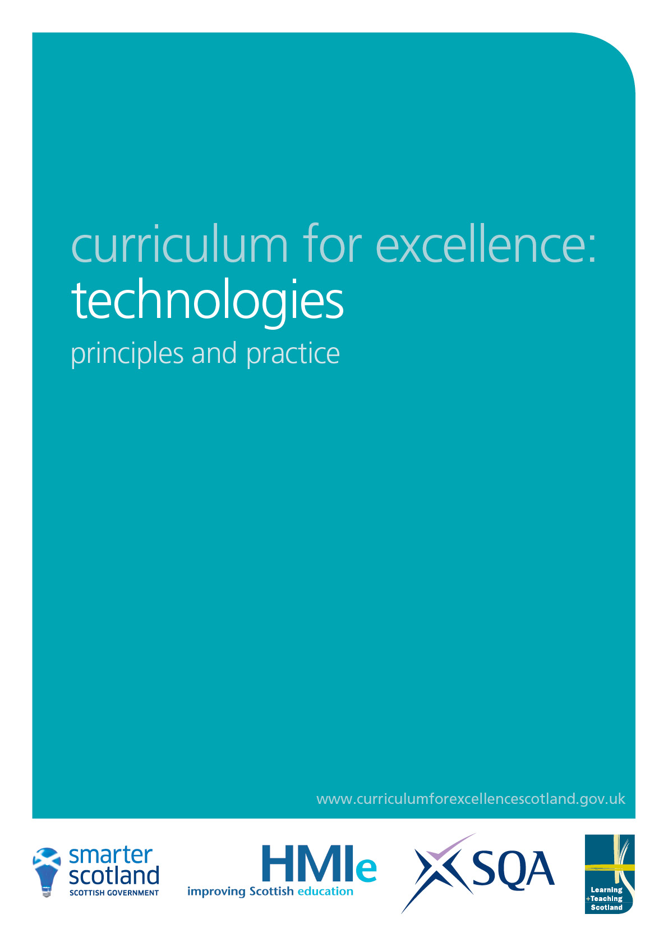

Technologies
Principles and practice

What does learning in the technologies enable children and young people to do?

Technology – the application of knowledge and skills to extend human capabilities and to help satisfy human needs and wants – has had profound effects on society.

Scotland has a strong tradition of excellence and innovation in technological research. This is especially true in areas such as engineering, electronics, optoelectronics, biomedical research, genomics and cell engineering. Scotland’s people need to be skilled in technologies and to be aware of the impact of technologies on society and the environment, now and in the future. Learning in the technologies provides a strong foundation for the development of skills and knowledge which are, and will continue to be, essential in maintaining Scotland’s economic prosperity.

Within Curriculum for Excellence, the technologies curriculum area relates particularly to contexts that provide scope for developing technological skills, knowledge, understanding and attributes through creative, practical and work-related activities. For this reason, the framework provides experiences and outcomes which can be applied in business, computing science, food, textiles, craft, design, engineering, graphics and applied technologies. These experiences and outcomes offer a rich context for the development of all of the four capacities and for developing the life skills that are recognised as being important for success in the world of work. They also offer an excellent platform for a range of technology-related careers.

The technologies framework offers challenging activities which involve research, problem solving, exploration of new and unfamiliar concepts, skills and materials, and the rewarding learning which often results from creating products which have real applications. It provides progression in cognitive skills. Children and young people will develop their creativity and entrepreneurial skills and be encouraged to become innovative and critical designers of the future. These attributes are essential if, in the future, our children and young people are to play a major part in the global economy and embrace technological developments in the 21st century.

What are the main purposes of learning in the technologies?

Learning in the technologies enables children and young people to be informed, skilled, thoughtful, adaptable and enterprising citizens, and to:

- develop understanding of the role and impact of technologies in changing and influencing societies
- contribute to building a better world by taking responsible ethical actions to improve their lives, the lives of others and the environment
- gain the skills and confidence to embrace and use technologies now and in the future, at home, at work and in the wider community
- become informed consumers and producers who have an appreciation of the merits and impacts of products and services
- be capable of making reasoned choices relating to the environment, to sustainable development and to ethical, economic and cultural issues
- broaden their understanding of the role that information and communications technology (ICT) has in Scotland and in the global community
- broaden their understanding of the applications and concepts behind technological thinking, including the nature of engineering and the links between the technologies and the sciences
- experience work-related learning, establish firm foundations for lifelong learning and, for some, for specialised study and a diverse range of careers.

How are the technologies experiences and outcomes organised?

The technologies framework has been organised to offer opportunities for personalisation and choice using diverse contexts for learning.

The technologies framework has six organisers, namely:

- technological developments in society
- ICT to enhance learning
- business
- computing science
- food and textiles
- craft, design, engineering and graphics.

The final four organisers are contexts for developing technological skills and knowledge.

These organisers recognise the special contribution made by each context for learning, whilst enabling teachers to plan opportunities to reflect individual and local needs. The important purposes of the technologies depend upon effective interdisciplinary working through connections across and between subject boundaries. It is important that teachers do not feel constrained by the organisers but view them as opportunities for children and young people to experience the differing contexts for learning.

In secondary schools, teachers of business education, computing, home economics and technical education will recognise how they can make their specialist contributions within the framework. Schools and teachers will plan different combinations of the experiences and outcomes to provide programmes that meet young people’s needs and provide a sound basis for more advanced study within an area of specialism. As in other curriculum areas, the fourth level experiences and outcomes provide possibilities for choice: it is not intended that any individual young person’s programme of learning would include all of the fourth level outcomes.

Teachers in their planning will use the framework to ensure that children and young people develop their understanding of important themes such as the impact of technology, informed attitudes to technology, sustainability, and social, economic and ethical issues. These will underpin and continually reinforce learning within the technologies.

The framework contains some statements which span two levels. These provide space for teachers to plan for progression over an extended period of time, enabling children and young people to explore contexts in increasing depth and develop their creativity through independent learning.

The framework allows opportunity for personalisation and choice, depth and relevance. The level of achievement at the fourth level has been designed to approximate to that associated with SCQF level 4. The technologies framework offers children and young people opportunities to develop a set of skills that can be utilised in Skills for Work programmes.

What skills are developed in the technologies?

The technologies provide frequent opportunities for active learning in creative and work-related contexts. Learning in the technologies thus provides opportunities to continually develop, use and extend skills that are essential components for life, work and learning, now and in the future, including planning and organisational skills. Learning in the technologies therefore makes a strong contribution to achieving the aim clearly articulated in Skills for Scotland: a Lifelong Learning Strategy of ‘…ensuring that Curriculum for Excellence provides vocational learning and the employability skills needed for the world of work and is the foundation for skills development throughout life’.

Well-designed practical activities in the technologies offer children and young people opportunities to develop:

- curiosity and problem solving skills, a capacity to work with others and take initiative
- planning and organisational skills in a range of contexts
- creativity and innovation, for example though ICT and computer aided design and manufacturing approaches
- skills in using tools, equipment, software and materials
- skills in collaborating, leading and interacting with others
- critical thinking through exploration and discovery within a range of learning contexts
- discussion and debate
- searching and retrieving information to inform thinking within diverse learning contexts
- making connections between specialist skills developed within learning and skills for work
- evaluating products, systems and services
- presentation skills.

What learning and teaching approaches are useful in the technologies?

The experiences and outcomes are intended to tap into children’s and young people’s natural inventiveness and their desire to create and work in practical ways. They act as a motivation for progressively developing skills, knowledge, understanding and attitudes, and so maximise achievement. Effective learning and teaching will draw upon a wide variety of approaches to enrich the experience of children and young people, particularly through collaborative and independent learning.

The experiences and outcomes are well suited for learning beyond school: in colleges, in the voluntary sector and in partnership with businesses, where children and young people may experience learning activities that are relevant to employment or future vocational learning.

Proficiency in ICT is an ideal vehicle for shared learning between and amongst children, young people and teachers. Many teachers may need to build their own knowledge and confidence, often learning with and from children and young people, in this area of continually evolving developments.

What does ICT mean within this framework?

ICT refers to forms of technology that are used to transmit, store, create, display, share or exchange information by electronic means. This broad definition of ICT currently includes such technologies as media, telecommunications, and computer hardware and software; it also includes equipment and services associated with these technologies, such as videoconferencing, email and blogs.

How can ICT enhance learning and teaching?

In the words of the HMIE publication Improving Scottish Education: ICT in Learning and Teaching (2007),
‘… staff in pre-school centres and in primary schools recognised that learners developed awareness of the world in which they live more effectively when this included engagement with the world through ICT.’

Being skilled in using ICT is essential if children and young people are to be effective contributors able to communicate and interact on a global scale. Across the curriculum, skills in ICT will be developed in the context of the learning and teaching as appropriate to the child or young person’s maturity. All teachers, in all sectors, in all departments and in all settings, have opportunities to apply, reinforce and extend ICT skills within and across curriculum areas to equip children and young people with the learning and employability skills required for the 21st century.

Several curriculum areas including the technologies provide opportunities for children and young people to consider security aspects associated with ICT, for example keeping personal data secure, and the important consequences of these for individuals. It is important for children and young people to recognise security risks when handling information across the curriculum, and act accordingly.

What is the difference between computing and ICT?

ICT, as defined here, brings together different forms of technologies and applies them to communication and learning, whereas computing, as an area of specialised study, provides deeper theoretical and practical understanding of how hardware and software can be developed and applied in a range of contexts. This area of specialist study has particular relevance in preparing children and young people for the challenges of rapidly changing digital technologies. It will enable learners to prepare for more advanced specialised study and careers within computing science.

What is the significance of the italicised experiences and outcomes in ICT?

Within the technologies framework, the ICT experiences and outcomes identified in italics promote the development of those skills required for everyday life and work. Although these form part of the technologies framework, all teachers will contribute and reinforce them throughout learning.

What are broad features of assessment in technologies?

Assessment in the technologies will focus on practical, problem-solving and collaborative activities which enable children and young people to show that they know, understand and can use technological skills and concepts across all the contexts for learning in the technologies.

Teachers can gather evidence as part of children and young people’s day-to-day learning, and specific assessment tasks will also contribute to assessing progress. From the early years through to the senior stages, children and young people can demonstrate progress in their skills in making models and preparing food, in planning and carrying out practical investigations and solving problems, in discussing and debating ideas with peers and adults, and in recording and presenting their thinking in different ways, including using ICT.

Approaches to assessment should identify the extent to which children and young people can apply these skills and use them creatively in their learning and their daily lives and in preparing for the world of work. For example:

- How well do they contribute ideas and suggestions and develop team working skills?

- How well do they collaborate and independently participate in learning activities which lead to products with real uses?

Children and young people can show progress by responding enthusiastically to more demanding and challenging concepts in technologies, showing increasing depth of understanding in their explanations, and applying knowledge and skills in more demanding or unfamiliar contexts. They can also demonstrate progress through their increasing independence and confidence when carrying out tasks and their increasing resilience in facing challenges. Progress includes increasingly well-structured explanations and well-argued opinions and conclusions, including developing informed views on environmental, ethical and economic issues. Assessment should also link with other areas of the curriculum, both within and outside the classroom, and in the context of the world of work.

How can I make connections within and beyond the technologies?

Technologies are connected strongly with all other areas of the curriculum, through extending and applying the specialist knowledge and understanding developed in the sciences, through the creative use of technology in the expressive arts, through interdisciplinary learning, for example linking mathematics, science and technologies in an engineering context, and through the use of technologies to enhance learning.

In order to foster deeper, more enjoyable and active learning, the technologies experiences and outcomes enable clear links to be made with all other curriculum areas. For example, design, creative thinking and aesthetics are central to both the technologies and the expressive arts and can provide a platform for planning exciting interdisciplinary working as well as presenting rich contexts for reinforcing the four capacities. Such connections mutually enhance the application and interpretation of designing, offering learners opportunities to become independent in designing solutions to meet real-life needs and challenges, and adept at solving problems of increasing scale and complexity. They extend the creative process, building on the interests of children and young people to provide enjoyable learning opportunities and enhance self-esteem, for example the relationship and interaction of engineering with technologies and with science. In a wider context, the experiences and outcomes have the capacity to link with fundamental concepts, including those of engineering, mathematics and science.

Through planning and self-evaluation, establishments and departments will need to ensure an appropriate balance of learning and teaching approaches, progression in skills, and effective use of interdisciplinary work to deepen and extend learning and reinforce themes.

In planning, it is important to recognise that experiences and outcomes should not be considered as requiring particular amounts of time. Many are very open, allowing the opportunity for exploration and depth.

