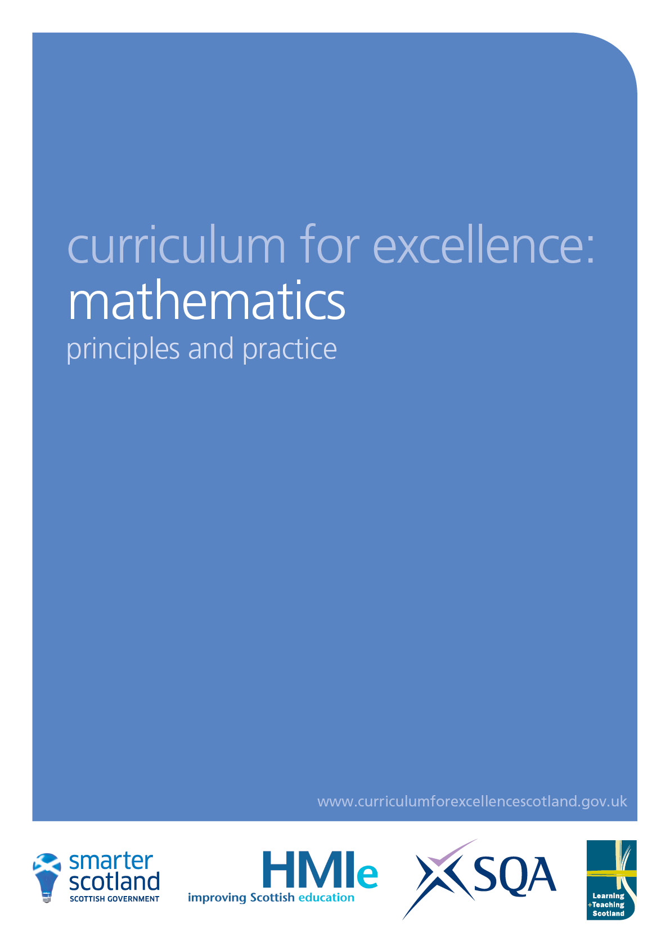
Mathematics
Principles and practice

What can learning in mathematics enable children and young people to achieve?

Mathematics is important in our everyday life, allowing us to make sense of the world around us and to manage our lives. Using mathematics enables us to model real-life situations and make connections and informed predictions. It equips us with the skills we need to interpret and analyse information, simplify and solve problems, assess risk and make informed decisions.

Mathematics plays an important role in areas such as science or technologies, and is vital to research and development in fields such as engineering, computing science, medicine and finance. Learning mathematics gives children and young people access to the wider curriculum and the opportunity to pursue further studies and interests.

Because mathematics is rich and stimulating, it engages and fascinates learners of all ages, interests and abilities. Learning mathematics develops logical reasoning, analysis, problem-solving skills, creativity and the ability to think in abstract ways. It uses a universal language of numbers and symbols which allows us to communicate ideas in a concise, unambiguous and rigorous way.

To face the challenges of the 21st century, each young person needs to have confidence in using mathematical skills, and Scotland needs both specialist mathematicians and a highly numerate population.
Building the Curriculum 1

Mathematics equips us with many of the skills required for life, learning and work. Understanding the part that mathematics plays in almost all aspects of life is crucial. This reinforces the need for mathematics to play an integral part in lifelong learning and be appreciated for the richness it brings.

How is the mathematics framework structured?

Within the mathematics framework, some statements of experiences and outcomes are also identified as statements of experiences and outcomes in numeracy. These form an important part of the mathematics education of all children and young people as they include many of the numerical and analytical skills required by each of us to function effectively and successfully in everyday life. All teachers with a responsibility for the development of mathematics will be familiar with the role of numeracy within mathematics and with the means by which numeracy is developed across the range of learning experiences. The numeracy subset of the mathematics experiences and outcomes is also published separately; further information can be found in the numeracy principles and practice paper.

The mathematics experiences and outcomes are structured within three main organisers, each of which contains a number of subdivisions:

Number, money and measure
- Estimation and rounding
- Number and number processes
- Multiples, factors and primes
- Powers and roots
- Fractions, decimal fractions and percentages
- Money
- Time
- Measurement
- Mathematics – its impact on the world, past, present and future
- Patterns and relationships
- Expressions and equations.

Shape, position and movement
- Properties of 2D shapes and 3D objects
- Angle, symmetry and transformation.

Information handling
- Data and analysis
- Ideas of chance and uncertainty.

The mathematics framework as a whole includes a strong emphasis on the important part mathematics has played, and will continue to play, in the advancement of society, and the relevance it has for daily life.

A key feature of the mathematics framework is the development of algebraic thinking from an early stage. Research shows that the earlier algebraic thinking is introduced, the deeper the mathematical understanding will be and the greater the confidence in using mathematics.

Teachers will use the statements of experiences and outcomes in information handling to emphasise the interpretation of statistical information in the world around us and to emphasise the knowledge and skills required to take account of chance and uncertainty when making decisions.

The level of achievement at the fourth level has been designed to approximate to that associated with SCQF level 4.

What are the features of effective learning and teaching in mathematics?

From the early stages onwards, children and young people should experience success in mathematics and develop the confidence to take risks, ask questions and explore alternative solutions without fear of being wrong. They will enjoy exploring and applying mathematical concepts to understand and solve problems, explaining their thinking and presenting their solutions to others in a variety of ways. At all stages, an emphasis on collaborative learning will encourage children to reason logically and creatively through discussion of mathematical ideas and concepts.

Through their use of effective questioning and discussion, teachers will use misconceptions and wrong answers as opportunities to improve and deepen children’s understanding of mathematical concepts.

The experiences and outcomes encourage learning and teaching approaches that challenge and stimulate children and young people and promote their enjoyment of mathematics. To achieve this, teachers will use a skilful mix of approaches, including:

- planned active learning which provides opportunities to observe, explore, investigate, experiment, play, discuss and reflect
- modelling and scaffolding the development of mathematical thinking skills
- learning collaboratively and independently
- opportunities for discussion, communication and explanation of thinking
- developing mental agility
- using relevant contexts and experiences, familiar to young people
- making links across the curriculum to show how mathematical concepts are applied in a wide range of contexts, such as those provided by science and social studies
- using technology in appropriate and effective ways
- building on the principles of Assessment is for Learning, ensuring that young people understand the purpose and relevance of what they are learning
- developing problem-solving capabilities and critical thinking skills.

Mathematics is at its most powerful when the knowledge and understanding that have been developed are used to solve problems. Problem solving will be at the heart of all our learning and teaching. We should regularly encourage children and young people to explore different options: ‘what would happen if...?’ is the fundamental question for teachers and learners to ask as mathematical thinking develops.

How will we ensure progression within and through levels?

As children and young people develop concepts within mathematics, these will need continual reinforcement and revisiting in order to maintain progression. Teachers can plan this development and progression through providing children and young people with more challenging contexts in which to use their skills. When the experience or outcome spans two levels within a line of development, this will be all the more important.

One case in point would be the third level outcome on displaying information. The expectation is that young people will continue to use and refine the skills developed at second level to display charts, graphs and diagrams. The contexts should ensure progression and there are clear opportunities to use other curriculum areas when extending young people’s understanding.

What are broad features of assessment in mathematics?
(This section should be read alongside the advice for numeracy.)

Assessment in mathematics will focus on children and young people’s abilities to work increasingly skilfully with numbers, data and mathematical concepts and processes and use them in a range of contexts. Teachers can gather evidence of progress as part of day-to-day learning about number, money and measurement, shape, position and movement and information handling. The use of specific assessment tasks will be important in assessing progress at key points of learning including transitions.

From the early years through to the senior stages, children and young people will demonstrate progress in their skills in interpreting and analysing information, simplifying and solving problems, assessing risk and making informed choices. They will also show evidence of progress through their skills in collaborating and working independently as they observe, explore, experiment with and investigate mathematical problems.

Approaches to assessment should identify the extent to which children and young people can apply their skills in their learning, in their daily lives and in preparing for the world of work. Progress will be seen as children and young people demonstrate their competence and confidence in applying mathematical concepts and skills. For example:

- Do they relish the challenge of number puzzles, patterns and relationships? Can they explain increasingly more abstract ideas of algebraic thinking?
- Can they successfully carry out mathematical processes and use their developing range of skills and attributes as set out in the experiences and outcomes? As they apply these to problems, can they draw on skills and concepts learned previously?
- As they tackle problems in unfamiliar contexts, can they confidently identify which skills and concepts are relevant to the problem? Can they then apply their skills accurately and then evaluate their solutions?
- Can they explain their thinking and demonstrate their understanding of 2D shapes and 3D objects?
- Can they evaluate data to make informed decisions?
- Are they developing the capacity to engage with and complete tasks and assignments?
Assessment should also link with other areas of the curriculum, within and outside the classroom, offering children and young people opportunities to develop and demonstrate their understanding of mathematics through social studies, technologies and science, and cultural and enterprise activities.

How can I make connections within and beyond mathematics?

Within mathematics there are rich opportunities for links among different concepts: a ready example is provided by investigations into area and perimeter which can involve estimation, patterns and relationships and a variety of numbers. When children and young people investigate number processes, there will be regular opportunities to develop mental strategies and mental agility. Teachers will make use of opportunities to develop algebraic thinking and introduce symbols, such as those opportunities afforded at early stages when reinforcing number bonds or later when investigating the sum of the angles in a triangle.

There are many opportunities to develop mathematical concepts in all other areas of the curriculum. Patterns and symmetry are fundamental to art and music; time, money and measure regularly occur in modern languages, home economics, design technology and various aspects of health and wellbeing; graphs and charts are regularly used in science and social studies; scale and proportion can be developed within social studies; formulae are used in areas including health and wellbeing, technologies and sciences; while shape, position and movement can be developed in all areas of the curriculum.

